# Business Intelligence Solutions –

# Décor interiors

# A Project Report

# Submitted in partial fulfilment of the

# Requirements for the award of the Degree of

# BACHELOR OF SCIENCE (INFORMATION TECHNOLOGY)

# By

# Pratham Sapra

# A032

# Under the esteemed guidance of

# Prof. PRASHANT JADHAV

# &

# Prof. ANUPAMA JAWALE

# DEPARTMENT OF INFORMATION TECHNOLOGY

# SVKM’s

# NARSEE MONJEE COLLEGE OF COMMERCE & ECONOMICS.

# (Autonomous)

# Affiliated To University of Mumbai

# Mumbai – 400 056

**2022-2023**

## DEPARTMENT OF INFORMATION TECHNOLOGY

### CERTIFICATE

This is to certify that the project entitled, **"** **Business Intelligence solutions –**

**Décor interiors "**, is bonafide work of **Pratham Sapra** bearing SAP. No: 45207200015 submitted in partial fulfilment of the requirements for the award of degree of BACHELOR OF SCIENCE in INFORMATION TECHNOLOGY from University of Mumbai.

**Internal Guide Head of Department**

**(Information Technology)**

**External Examiner**

**Date: 06-03-23 College Seal**

**ABSTRACT**

The aim of this project is to create an e-commerce website that sells tiles, marble, ply, and sunmica online, while also having an offline market through an Excel-based application. The project also incorporates data visualization using Power BI and performance testing using JMeter.

The e-commerce website will provide an easy and accessible platform for customers to purchase their desired products, which will be categorized and presented in a user-friendly manner. In addition, the website will provide information on the products available, such as descriptions, sizes, and prices, to assist customers in making informed decisions.

The offline application developed using Visual Basic will be used to manage the offline market and will serve as an alternative for customers who prefer to purchase their products in person. The application will have a similar layout to the e-commerce website and will be used by sales representatives to manage the orders, payments, and inventory of the offline store.

The use of Power BI will enable users to visualize data from both the online and offline markets in a manner that is both informative and easy to understand. This will provide insights into the performance of both markets and will assist in identifying trends and patterns that could impact the business.

JMeter will be used to conduct performance testing on the website, which will help identify any issues with website speed, responsiveness, and scalability. This will assist in ensuring that the website can handle a large volume of traffic and will provide a smooth shopping experience for customers.

In conclusion, the project will provide an integrated solution for managing both online and offline markets for a business selling tiles, marble, ply, and sunmica. By incorporating features such as an e-commerce website, an offline application, data visualization using Power BI, and performance testing using JMeter, the project aims to provide an effective and efficient solution that is beneficial for both the business and its customers.

**ACKNOWLEDGEMENT**

I would like to express my deepest gratitude to the principal, Dr. Parag Ajgaonkar, and the vice-principals, Dr. Nirmala Chavan and Ms. Heena Bhuva, of Narsee Monjee College of Commerce and Economics for creating a conducive learning environment that has enabled me to develop and showcase my skills. Their commitment to providing quality education and opportunities to their students is truly inspiring.

Additionally, I would like to express my sincerest appreciation and gratitude to Prof. Prashant Jadhav for his invaluable guidance and support in the implementation of my project. Without his expertise and encouragement, this project would not have been possible. His constant feedback and suggestions helped me to improve my skills and develop my understanding of the subject matter. His dedication and commitment to my project have been truly remarkable, and I will always be grateful for his support.

Lastly, I would also like to thank our Head of Department, Prof. Anupama Jawale, for her unwavering commitment and assistance in the documentation of this project. Her efforts in organizing and compiling the project documentation have been extremely helpful, and her attention to detail has ensured that the final product is of the highest quality. Her feedback and suggestions have been invaluable throughout the project, and I am grateful for her guidance and support.

I would like to express my gratitude to both of them for their unwavering support and encouragement throughout the project. Their dedication and commitment have been instrumental in making this project a success, and I am honoured to have had the opportunity to work with them.

In addition, I would like to express my gratitude to all of the individuals who provided me with the resources and support necessary to complete this project. Their contributions have been invaluable, and I am grateful for their assistance.

Once again, I would like to extend my heartfelt appreciation to Prof. Prashant Jadhav and Prof. Anupama Jawale for their exceptional contributions to my project. Their support and guidance have been critical to my success, and I will always be grateful for their help.

**Pratham Sapra**

**DECLARATION**

I hereby declare that the project entitled, “**Business Intelligence solutions – Décor interiors**” done at **SVKM’s NARSEE MONJEE COLLEGE OF COMMERCE & ECONOMICS.**, has not been in any case duplicated to submit to any other university for the award of any degree. To the best of my knowledge other than me, no one has submitted to any other university.

The project is done in partial fulfilment of the requirements for the award of degree of

**BACHELOR OF SCIENCE (INFORMATION TECHNOLOGY) to** be submitted as a

final semester project as part of our curriculum.

**Date: Name and Signature of the Student**

## TABLE OF CONTENTS

* **Chapter 1 Introduction 09**
* Theoretical Background
* Objectives of the Project
* Purpose, Scope and Applicability of the Project
* Expected Achievements
* **Chapter 2 Survey of Technologies 15**
* Description of Available Technologies
* Comparative Analysis of technologies in Chosen Area
* Chosen Project Domain
* Technologies to be used
* Reason Supporting the use of above selected technologies
* **Chapter 3 Requirements and Analysis 20**
* Problem Statement & Definition
* Requirements Specification
* Feasibility
* Planning and Scheduling
* Preliminary Product Description
* Conceptual Model
* **Chapter 4 System Design 35**
* Basic Modules
* Data Design
* Procedural Design
* User Interface Design
* Security Issues
* Dataset
* **Chapter 5 Implementation and Testing 51**
* Implementation Approaches
* Coding Details and Code Efficiency
* Testing Approach
* Test Cases
* Modification and Expected Improvements
* **Chapter 6 Results and Declaration 83**
* Test Reports
* User Documentation
* Cost Estimation
* **Chapter 7 Conclusions 88**
* Conclusion
* Limitations
* Future Scope of the Project
* **References 92**
* **Annexure 93**

**LIST OF TABLES**

* **Comparative Analysis of Technologies in Chosen Area 17**
* **Test Cases (User Module) 75**
* **Test Cases (Admin Module) 76**
* **Test Reports 84**

### LIST OF FIGURES

* **Gantt Chart 25**
* **Pert Chart 26**
* **Use case diagram 30**
* **Activity diagram 31**
* **Class diagram 32**
* **Sequence diagram 33**
* **E-R model 34**
* **Schema design 43**
* **User Interface 47**
* **Visual Basic Application (VBA)** **53**
* **Power BI 54**
* **JMeter 57**
* **Décor Interiors 59**
* **Admin Interface 77**

#### CHAPTER 1: INTRODUCTION

* 1. **Theoretical Background**

In order to develop a successful e-commerce website, it is important to choose the right technology. While choosing the wrong technology can result in significant costs, having sufficient experience in the technology can help to ensure that the website is developed to meet the needs of the business and its customers. To make informed decisions about website design and development, a survey of the tools and technologies used in the world of website development is necessary.

HTML (Hypertext Markup Language) is the standard language used to create web pages, while CSS (Cascading Style Sheets) is used to control the layout and appearance of those pages. JavaScript is a scripting language that is used to create interactive effects, such as drop-down menus and pop-up windows. PHP (Hypertext Pre-processors) is a server-side scripting language that is used to create dynamic web pages, while MySQL is a relational database management system that is used to store and retrieve data.

In addition to these technologies, other tools and technologies can be used to improve the performance and functionality of e-commerce websites. For example, AJAX (Asynchronous JavaScript and XML) can be used to update parts of a web page without the need to reload the entire page. jQuery is a JavaScript library that simplifies HTML document traversing, event handling, and animating. These technologies can help to create a more user-friendly and efficient e-commerce website that meets the needs of both the business and its customers.

Offline shopping can be time-consuming, exhausting, and frustrating for both consumers and shopkeepers. The process of searching for products in crowded markets, dealing with bulk purchases, and attending to multiple customers simultaneously can lead to confusion and dissatisfaction. Online shopping provides a solution to these problems by allowing customers to easily find the products they need from the comfort of their own homes, while also providing shopkeepers with an efficient and convenient way to manage their business.

Therefore, the development of an online platform that provides a convenient and comprehensive shopping experience for customers can help to improve customer satisfaction and boost business growth. This requires the use of appropriate technologies to create a user-friendly and efficient e-commerce website that meets the needs of both the business and its customers. PowerBI can be used to analyse the data collected from both online and offline sales, while Jmeter can be used to test the performance of the website.

* 1. **Objectives of the Project**
* To study and analyse the existing system of various shopping websites such as mytiles.com.
* To design and develop a complete user interface that is user-friendly, interactive, and easy to navigate for sales and purchase of construction materials.
* To present visual analytics of sales data for better understanding of the sales patterns, customer preferences, and market trends.
* To provide the best services to customers and satisfy all their needs by allowing them to find products according to their convenience with a choice of size, colours, and even number of items they want.
* To attract builders and groundworkers who would provide the materials to the end consumer.
* To provide customers with a convenient and user-friendly platform to browse, purchase, and plan their home renovation projects.
* To provide a secure and reliable platform for online transactions, with multiple payment options for customers.
* To allow customers to view detailed information about each product, including price, availability, specifications, and customer reviews.
* To implement a responsive design that ensures the website is accessible and easy to use on all devices, including desktops, tablets, and mobile phones.
* To provide customers with personalized recommendations based on their browsing and purchase history, to enhance their shopping experience.
* To implement a search functionality that allows customers to easily find products by keywords, categories, or other filters.
* To provide customers with the ability to create and save Wishlist’s, compare products, and share products with friends and family.
* To allow customers to track their orders, view order history, and receive notifications about order status updates.
* To implement a customer support system that provides timely and helpful assistance to customers with any queries or issues.
* To create an effective marketing strategy that promotes the website and drives traffic and sales through various channels, such as social media, email marketing, and search engine optimization.
* To continuously gather customer feedback and data, and use that information to improve the website and enhance the overall customer experience.
  1. **Purpose, Scope & Applicability of the Project**

1. Purpose:

The purpose of this project is to develop an e-commerce website for selling tiles, marble, ply, and sunmica online to customers. The project also includes an offline component that allows the client to record data of people who buy the same products from the shop. The data from both online and offline components will be analyzed using PowerBI to gain insights into customer behaviour and preferences. Additionally, JMeter will be used to test the performance of the website.

1. Scope:

The scope of this project includes the development of an e-commerce website using HTML, AJAX, CSS, JQUERY, JAVASCRIPT, PHP, and MySQL. The website will be accessible to customers via Google Chrome. The offline component will be developed using Visual Basic Application using Excel.

* Limitation

The limitations of the project include the fact that the website will only sell tiles, marble, ply, and sunmica, and it will only be accessible to customers with an internet connection. The offline component will only record data for customers who purchase products in the physical store.

* Accessibility

The accessibility of the website will be limited to customers who have internet access and a device that can connect to the internet. The offline component will be accessible to the client using a computer running Excel.

1. Applicability:

The applications of this project are both direct and indirect. The direct application is that it will provide customers with a convenient and easy way to purchase tiles, marble, ply, and sunmica online. The indirect application is that it will enable the client to gain insights into customer behaviour and preferences, which can help them improve their marketing strategies and increase sales.

The project will be helpful to the world by providing customers with a user-friendly online platform for purchasing building materials. This will not only save them time but also provide them with a wider selection of products to choose from. The insights gained from the data analysis can also be used by other businesses to improve their marketing strategies, which can ultimately lead to increased sales and customer satisfaction.

* 1. **Expected Achievements**
* Documentation of the project through a research paper that discusses the design, implementation, and testing of the e-commerce website, as well as the analysis of data using PowerBI and the results of the performance testing using JMeter. The research paper will provide a comprehensive record of the project and could be published in relevant technical or academic forums.
* Writing a blog post to document the project, which could be shared on the client's website or social media channels. The blog post will provide an overview of the project and highlight its key features and achievements in a more accessible and less technical language. This could also help attract potential customers or clients by showcasing the client's technical abilities and their commitment to innovation and customer satisfaction.
* A responsive and user-friendly website that provides an easy and secure checkout process, with multiple payment options for customers. An offline component that accurately records data of customers who purchase products from the physical store, including details like their name, contact information, and purchased products.
* Effective data analysis using PowerBI to provide insights into customer behaviour, preferences, and trends. This will include metrics like most purchased products, most popular payment methods, and customer demographics.
* Performance testing using JMeter to ensure that the website can handle a large number of transactions, without slowing down or crashing. Implementation of effective SEO strategies to improve the website's visibility and ranking on search engines, resulting in increased website traffic and customer acquisition.
* Integration of customer feedback and review system to help customers make informed decisions and also to help the client to improve their product offerings and customer service.
* The successful completion of the project within the allocated budget and timeframe, meeting the client's requirements and specifications.

The end goal of this project is to successfully develop an e-commerce website for selling tiles, marble, ply, and sunmica online and an offline component for recording data of people who buy the same products from the shop. Additionally, the data from both online and offline components will be analyzed using PowerBI to gain insights into customer behaviour and preferences. Lastly, JMeter will be used to test the performance of the website.

* 1. **Organisation of Report**

The report is organized into seven chapters, starting with an introduction that includes:

Chapter 1 theoretical background, objectives of the project, purpose, scope, and expected achievements, followed by the organization of the report.

Chapter 2 provides a survey of available technologies, comparative analysis of technologies in the chosen area, the chosen project domain, technologies to be used, and reasons supporting their use.

Chapter 3 covers the problem statement and definition, requirements specification, feasibility, planning and scheduling, preliminary product description, and conceptual model.

Chapter 4 details the system design, including basic modules, data design, procedural design, user interface design, security issues, and dataset.

Chapter 5 covers the implementation and testing, including implementation approaches, coding details, testing approach, test cases, modifications, and expected improvements.

Chapter 6 presents the results and discussions, including test reports, user documentation, and cost estimation.

Finally, Chapter 7 concludes the report with the conclusion, limitations, and future scope of the project.

followed by a reference section.

#### CHAPTER 2: SURVEY OF TECHNOLOGI

**2.1 Description of Available Technologies**

1. HTML: A markup language used for creating web pages and applications. It is the foundation of most websites and is used to create the structure and content of a webpage.
2. AJAX: A set of web development techniques used for creating asynchronous web applications. AJAX allows web pages to be updated dynamically without the need for a full page reload.
3. CSS: A style sheet language used for describing the presentation of a web page. CSS is used to control the layout, colors, and fonts of a webpage.
4. jQuery: A fast, small, and feature-rich JavaScript library used to simplify HTML document traversal and manipulation, as well as event handling, and animation.
5. JavaScript: A high-level programming language used to create interactive web pages and applications. JavaScript is used for adding dynamic functionality to a webpage.
6. PHP: A server-side scripting language used for creating dynamic web pages and applications. It is commonly used for web development and can be embedded into HTML.
7. MySQL: A popular open-source relational database management system. It is commonly used for web development and is used for storing and retrieving data.
8. XAMPP: A free and open-source cross-platform web server solution stack. It includes Apache, MySQL, PHP, and other tools that are commonly used for web development.
9. Power BI: A business analytics service by Microsoft that provides interactive visualizations and business intelligence capabilities. It is used for data analysis and can connect to a wide range of data sources.
10. Visual Basic Application: A user interface design tool used for creating graphical user interfaces. It is commonly used for creating Windows-based applications.
11. Excel: A spreadsheet software developed by Microsoft. It is commonly used for data analysis, calculations, and creating charts and graphs.
12. JMeter: An open-source software used for load testing and performance measurement of websites and web applications. It can simulate a heavy load on a server, network or object to test its strength or to analyse overall performance under different load types.
    1. **Comparative Analysis of Technologies in Chosen Area**

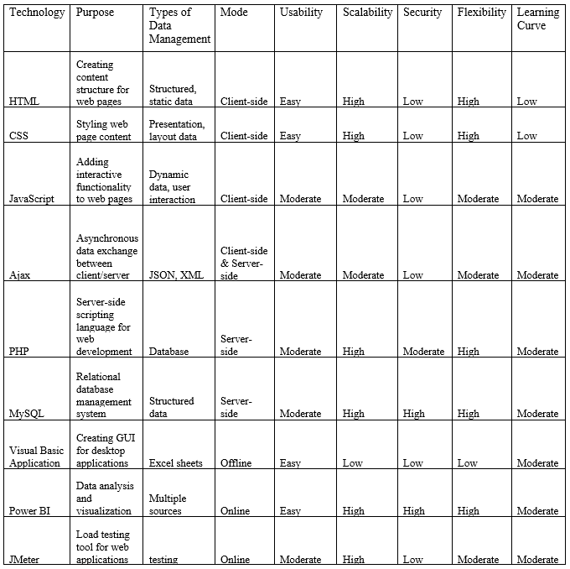Table no 2.2

**2.3 Chosen Project Domain**

The chosen project domain is the development of an e-commerce website for selling building materials, including tiles, marble, ply, and sunmica, as well as an offline component for recording data of customers who buy the same products from the shop. The domain involves the integration of various technologies to ensure the smooth operation of the website, efficient data management, and effective analysis of customer behaviour and preferences.

The development of the e-commerce website will require the implementation of HTML, CSS, JavaScript, and Ajax technologies to design and create a user-friendly interface. The website will also require the use of PHP technology for server-side scripting to ensure that the website can handle transactions and provide secure payment options. The use of MySQL technology will be crucial for efficient data management and seamless transactions on the website.

The offline component of the project will involve the use of Visual Basic Application and Excel to record data of customers who buy products from the shop. This will enable the client to gain insights into customer behaviour and preferences and improve their marketing strategies to increase sales and profitability.

The data from both the online and offline components of the project will be analyzed using Power BI to provide insights into customer behaviour and preferences. The use of Jmeter will also be crucial to ensure that the website can handle a large number of customers and transactions without any issues.

**2.4 Technologies to be used**

1. Front End

* HTML / CSS / JavaScript

1. Back End

* PHP
* MySQL

1. Framework

* Bootstrap

1. Other Development Tools

* Visual Basic Application (VBA) & Microsoft Excel (for data entry)
* Power BI (for data visualization)
* Jmeter

**2.5 Reason Supporting the use of above selected technologies**

* HTML, CSS, and JavaScript are widely used web development technologies that allow for creating user interfaces and interactive web pages.
* Bootstrap is a popular front-end framework that helps create responsive and mobile-first websites with minimal effort.
* PHP is a popular server-side scripting language that can be embedded into HTML and used to build dynamic websites and web applications.
* MySQL is a widely-used open-source database management system that provides fast, reliable, and scalable data storage and retrieval.
* Visual Basic Application (VBA) & Microsoft Excel are commonly used for data entry and analysis, and can help automate repetitive tasks.
* Power BI is a powerful data visualization tool that enables interactive data exploration and analysis, and can help gain insights from complex data sets.
* JMeter is a tool used for performance testing and can help identify bottlenecks in web applications and ensure they can handle high traffic loads.

#### CHAPTER 3: REQUIREMENTS & ANALYSIS

##### 3.1 Problem Statement and Problem Definition

Problem Statement:

In modern times, everyone aims to organize their homes according to their needs and requirements. However, there are only a few websites that focus solely on the products that cater to these needs, and a lot of time is wasted in visiting multiple stores to find the right product. The problem to be solved is to create a website that not only offers a wide range of products but also provides relevant information on them, making it easier for customers to make informed decisions.

Problem Definition:

The problem is to create a user-friendly website that offers a variety of products, including marble, wood, and other multimedia products. The website should provide customers with the necessary information about each product to make an informed decision. Additionally, the website should include a rating and review system to increase the importance of products that are highly recommended by customers. The website should also provide a feature for customers to save time and money by offering an online shopping experience that is convenient and efficient.

##### 3.2 Requirements Specification

Requirements analysis is a systematic process of identifying and documenting the needs and expectations of stakeholders for a proposed system or solution. The requirements should be well-defined, clear, and unambiguous, and should provide a comprehensive understanding of the needs of the stakeholders. The requirements should also be actionable, measurable, testable, traceable, and related to identified business needs or opportunities, and defined to a level of detail sufficient for system design.

For the proposed system for organizing and selling home products, the following requirements are identified:

1. Functional Requirements:

* The website should have a user-friendly interface for easy navigation and use.
* The website should have a product search feature to help users find specific products easily.
* The website should display product details such as price, description, images, and reviews.
* The website should provide the ability for users to create an account, log in, and save products for later.
* The website should allow users to add products to a cart and proceed to checkout to make purchases.
* The website should provide order confirmation and tracking information to users.
* The website should provide users with the ability to leave feedback and reviews.

1. Non-Functional Requirements:

* The website should be responsive and compatible with different devices and web browsers.
* The website should have a fast page load time to ensure a smooth user experience.
* The website should be secure and protect user data from unauthorized access.
* The website should be scalable and able to handle a large number of concurrent users and transactions.
* The website should comply with relevant laws and regulations related to online shopping and e-commerce.

1. Business Requirements:

* The website should increase the visibility and accessibility of home products to potential customers.
* The website should provide a platform for sellers to reach a larger audience and increase sales.
* The website should provide a positive and convenient user experience to build customer loyalty and retention.
* The website should provide a competitive advantage in the home products market.

1. User Requirements:

* The website should be easy to navigate and user-friendly.
* The website should have a simple and elegant design.
* The website should provide detailed information about the products.
* The website should allow users to search for products by different parameters.
* The website should have a shopping cart feature to allow users to purchase multiple items at once.
* The website should allow users to create accounts and save their shopping history.
* The website should have a secure payment gateway for online transactions.
* The website should have customer support options such as a live chat or email support.

1. Software Requirements:

* Front-End: HTML, CSS, JavaScript, Bootstrap
* Back-End: PHP, MySQL
* Data Entry Software: Visual Basic Application (VBA) & Microsoft Excel
* Data Visualization Software: Power BI
* Testing Software: JMeter

1. Hardware Requirements:

* Minimum 4GB RAM
* Minimum 32GB hard drive space
* High-speed internet connectivity

###### 3.3 Feasibility

A feasibility study would be an essential step in determining whether the proposed e-commerce platform is viable and worth pursuing. The feasibility study should cover several aspects, including operational, technical, and economic feasibility.

1. Operational Feasibility:

* Evaluate how well the proposed e-commerce platform solves the problems it aims to address.
* Consider the advantages of the proposed solution and how well it meets the specified requirements.
* Assess the affordability of the platform, the producibility of the product, and its sustainability.
* The specific factors that will be considered may vary depending on the nature and scope of the project.

1. Technical Feasibility:

* Focus on evaluating the current technical resources of the organization and how they can be applied to meet the requirements of the proposed system.
* Consider the availability of the necessary technical expertise and resources needed to develop and maintain the e-commerce platform.
* Assess the compatibility of the proposed platform with existing systems, the required hardware and software, and the necessary technical expertise.

1. Economic Feasibility:

* Demonstrate the net benefit of the proposed e-commerce platform.
* Take into account the benefits and costs to the organization, other state agencies, and the general public as a whole.
* Evaluate the financial data related to the proposed system, such as the costs of development, maintenance, and operation, as well as the potential revenue streams.
* Consider any legal requirements and tax obligations that may apply.

###### 3.4 Planning and Scheduling

What is planning?

Planning involves defining the objectives, goals, and requirements of the project, as well as identifying the tasks, resources, and timelines needed to accomplish these goals. It helps to create a roadmap for the project by establishing the sequence of activities, their dependencies, and the duration of each task. The planning phase helps to ensure that the project will be completed within the given timeline and budget.

What is scheduling?

Scheduling, on the other hand, is the process of determining when each task will be performed and how long it will take to complete it. It involves creating a detailed timeline for the project, including start and end dates for each task, as well as identifying the critical path, which is the sequence of tasks that must be completed on time to ensure the project's success. Scheduling helps to allocate resources, such as people and equipment, to ensure that the project is completed on time and within budget.

##### a. Gantt Chart

Figure 3.4.1

##### b. Pert Chart

##### 

Figure 3.4.2

###### 3.5 Preliminary Product Description

The proposed project is an e-commerce website that allows customers to purchase various building materials such as tiles, marble, ply, and sunmica online. The website will be built using HTML, AJAX, CSS, JQUERY, JAVASCRIPT, PHP, MySQL, XAMPP, and will be accessible through Google Chrome. Customers will be able to browse through the available products, select the desired quantity, and make payments using online payment systems. In addition to the online platform, an offline Visual Basic form using Excel will be used to record data of customers who make purchases from the physical store. This data will be used for record-keeping, inventory management, and customer relationship management. PowerBI will be used for data analysis, to represent the data of both online and offline sales, providing insights into customer behaviour, product performance, and trends. The data collected will be used to make informed decisions about inventory management, product selection, and pricing strategies. Lastly, Jmeter will be used to test the performance of the website, ensuring that it can handle a large volume of traffic without any performance degradation. This will help to provide a seamless experience for customers and improve the overall reliability of the website.

To achieve the project objective, the following requirements must be met:

1. Develop an e-commerce website using HTML, AJAX, CSS, JQUERY, JAVASCRIPT, PHP, MySQL, XAMPP, and Google Chrome.
2. Provide a user-friendly interface for customers to browse and purchase building materials online.
3. Develop an offline Visual Basic Form using Excel for recording data of customers who make purchases from the physical store.
4. Utilize PowerBI to analyze and represent data of both online and offline sales.
5. Ensure the website can handle a large volume of traffic without performance degradation using Jmeter for testing.
6. Implement robust security measures to protect sensitive customer information.
7. Provide reliable and secure online payment options for customers to make transactions.
8. Incorporate inventory management system for efficient tracking and updating of product stocks.
9. Implement a customer relationship management system to improve the customer experience and customer satisfaction.

**3.6 Conceptual Model**

###### a. Process Model

###### 

* + Name of Process Model: Agile Development Model
  + Brief Overview of the Process Model: Agile Development Model is a software development approach that emphasizes flexibility and continuous improvement throughout the development process. It involves breaking down a project into smaller, manageable chunks and completing them in an iterative manner, with constant feedback and collaboration between the development team and stakeholders.
  + Design of the Process Model: Here is a diagram of the Agile Development Model:

[Diagram of Agile Development Model]

* + Reasons for Choosing Agile Development Model: Agile Development Model was chosen for this project because it is well-suited for e-commerce websites, which require a flexible and adaptive approach to development. It also allows for constant feedback and collaboration, which is essential for delivering a high-quality product that meets the needs of both the client and the end-users.
  + Application of Agile Development Model: The Agile Development Model will be applied to the entire project, from the initial planning and requirements gathering to the final testing and deployment. The project will be broken down into smaller, more manageable sprints, with each sprint focusing on delivering a specific set of features or functionality. Regular feedback and collaboration between the development team and stakeholders will be emphasized throughout the process.
  + Advantages of Agile Development Model: The advantages of using the Agile Development Model include increased flexibility, faster time to market, higher quality end-products, increased stakeholder satisfaction, and improved team collaboration and communication.
  + Disadvantages of Agile Development Model: The disadvantages of using the Agile Development Model include the potential for scope creep, increased complexity in managing multiple sprints, and a greater need for active stakeholder involvement throughout the development process.

b**.** The goals of a process model are to be:

* Descriptive

The process model in your project should be descriptive in nature, as it should be able to track and document all the activities and tasks that take place in the e-commerce website, offline market, and analysis processes. This will help in understanding how the processes are executed and where the bottlenecks lie. For example, the process model should describe the flow of activities from when a customer places an order on the website to when the order is fulfilled.

* Prescriptive

The process model should also be prescriptive in nature as it defines how the processes should be performed. It should outline the best practices and procedures for carrying out each activity, to ensure that the processes are efficient and effective. For instance, the process model should provide guidelines for how to handle order cancellations, refunds, and returns.

* Explanatory

Lastly, the process model should be explanatory in nature as it provides the rationale behind the processes. It should explain why each activity is performed, the benefits of performing it in a particular way, and the risks associated with not doing it correctly. For example, the process model should explain why it is important to track and analyze data from both online and offline sales channels in order to make informed business decisions.

1. **Diagrams to be included in the design phase are as follows:** 
   1. **Use case diagram**

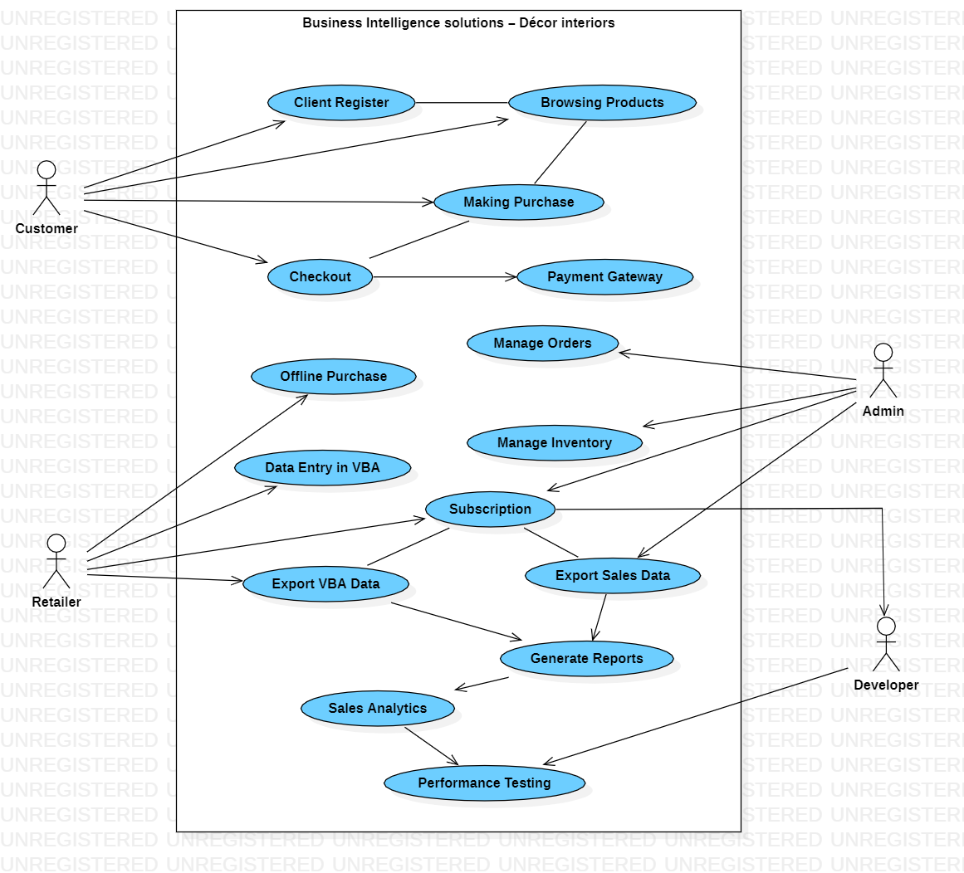

Figure 3.6.1

* 1. **Activity diagram**

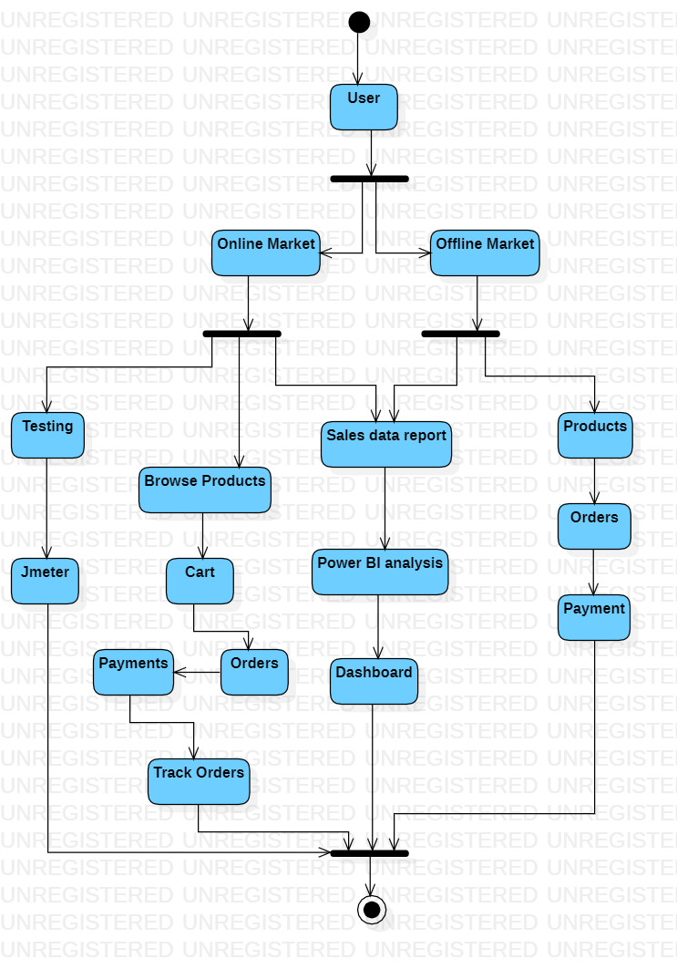

Figure 3.6.2

* 1. **Class diagram**

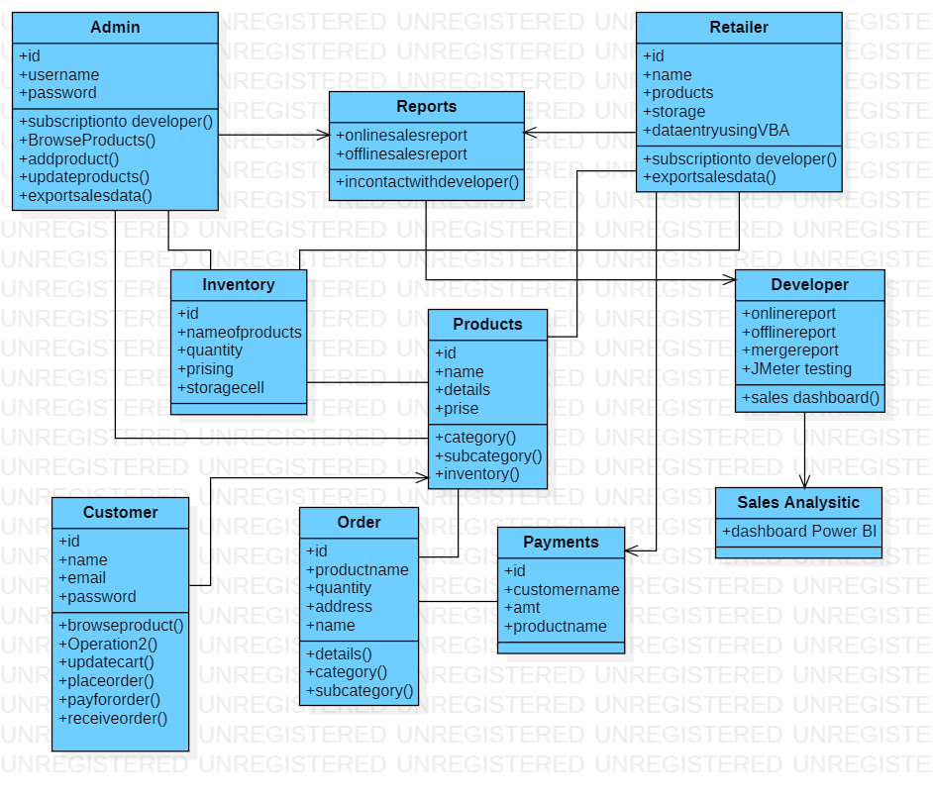

Figure 3.6.3

* 1. **Sequence diagram**

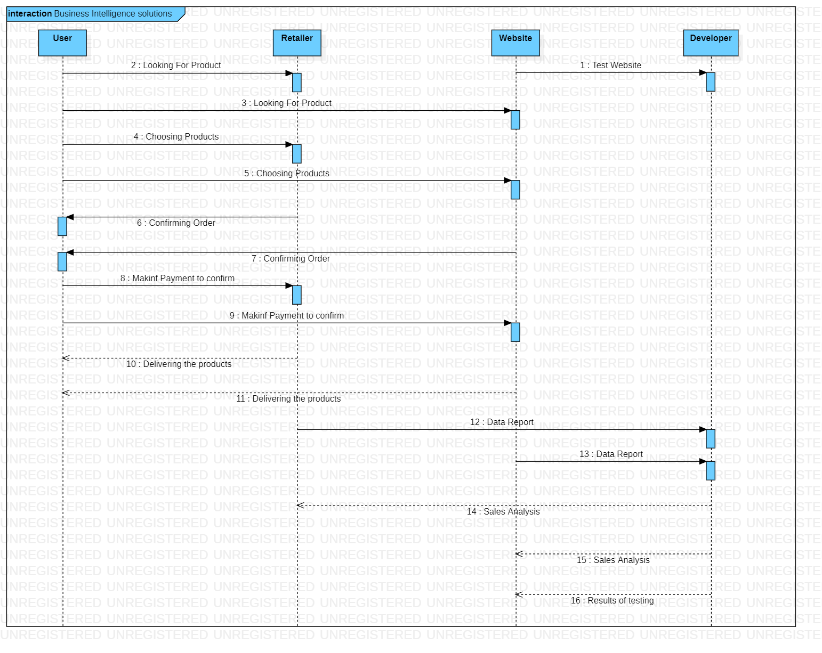

Figure 3.6.4

* 1. **E-R model**

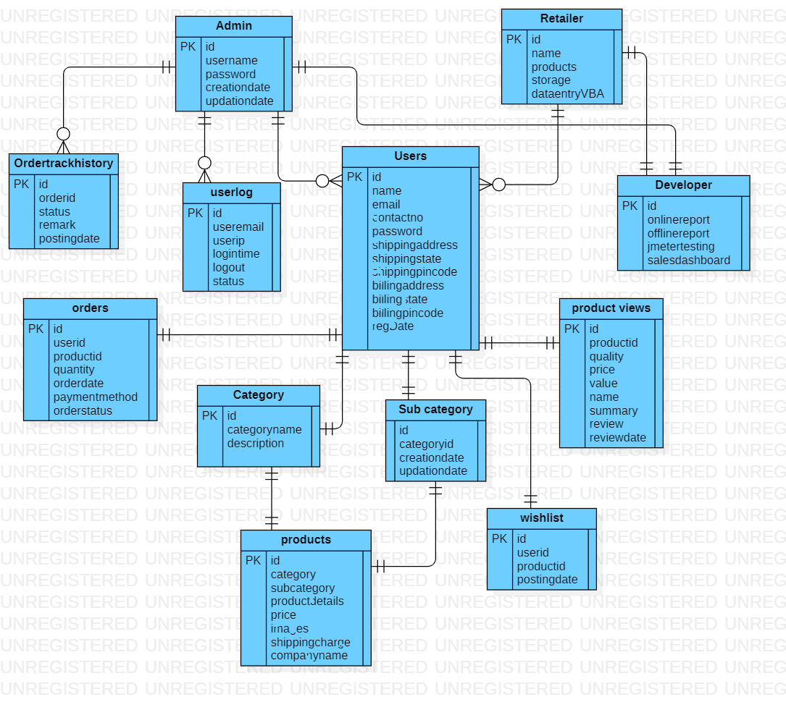

Figure 3.6.5

#### CHAPTER 4: SYSTEM DESIGN

**4.1 Basic Modules**

1. Description of Desired Modules
   1. ONLINE WEBSITE
      1. User Registration: Allows users to create and manage their accounts, login, logout, reset and recover passwords, and view order history and tracking.
      2. Product Search: Enables users to search for products by name, category, or keyword and provides an advanced search with filters and auto-suggest and autocomplete features.
      3. Payment Gateway Integration: Provides secure and easy payment options, including credit/debit cards, net banking, e-wallets, and cash on delivery.
      4. Order Tracking: Allows users to track the status and delivery of their orders and view shipping details and estimated delivery time.
      5. Admin Dashboard: Provides a centralized management system for the website's products, categories, orders, and customers, as well as generates sales and inventory reports.
      6. Inventory Management: Enables tracking of stock levels and availability, auto-updating of stock levels on order placement, and receiving of low stock alerts.
      7. Customer Support: Provides 24/7 customer support and addresses customer queries and complaints through live chat, email, or phone.
      8. Reviews and Ratings: Enables customers to rate and review products, displays product ratings and reviews on product pages, and uses ratings to improve product quality and selection.
      9. Offline Sales Management: Allows management of sales made through offline channels using VBA and Excel, which includes recording customer information, product details, payment information, and generating invoices.
   2. POWER BI
      1. Dashboard Creation: Create dashboards for visualizing the sales and inventory data of both online and offline stores.
      2. Data Integration: Integrate the sales and inventory data from the online and offline stores into Power BI.
      3. Data Analysis: Analyze the sales and inventory data to gain insights into customer preferences, popular products, and overall business performance.
      4. Reporting: Generate reports based on the data analysis to present the findings to the client and the management.
   3. OFFLINE SHOP (VBA)
      1. Sales Entry Module: This module will allow the user to enter sales data into an Excel sheet, which will be used for generating various reports and analytics.
      2. Customer Management Module: This module will enable the user to manage customer data, such as contact details, orders, and order history, and to generate customer reports.
      3. Inventory Management Module: This module will manage stock levels and availability of the products in the offline shop. It will allow the user to track and maintain inventory levels and generate reports and analytics.
      4. Reporting and Analytics Module: This module will generate various reports and analytics based on the data entered in the Sales Entry, Customer Management, and Inventory Management Modules. The reports can be used for decision-making and strategy planning.
   4. JMETER
      1. Load Testing: Test the performance and scalability of the online store by simulating a high number of users and transactions.
      2. Stress Testing: Test the resilience and stability of the online store by subjecting it to extreme loads and stress conditions.
      3. Functional Testing: Test the functionality of the online store by checking the different features and modules, such as user registration, product search, payment gateway, and order tracking.
      4. Regression Testing: Test the online store after making changes or updates to ensure that the existing features and functionalities are still working as intended.
2. Description of Desired Features
   1. ONLINE WEBSITE
      1. Cart:
         1. Add/Remove products
         2. Update quantity
         3. Calculate total price
         4. Apply promo codes and discounts
         5. Save cart for future use
      2. Catalog:
         1. View product details and images
         2. Sort and filter products by category, price, and rating
         3. Add products to cart
      3. Payment Gateway Integration:
         1. Secure and easy payment options
         2. Credit/debit card, net banking, and e-wallets
         3. Cash on delivery
      4. Order Tracking:
         1. Track order status and delivery
         2. View shipping details and estimated delivery time
      5. Admin Dashboard:
         1. Manage products, categories, and inventory
         2. View and manage orders and customers
         3. Generate sales and inventory reports
      6. Inventory Management:
         1. Track stock levels and availability
         2. Auto-update stock levels on order placement
         3. Receive low stock alerts
      7. Customer Support:
         1. Provide 24/7 customer support
         2. Address customer queries and complaints
         3. Provide live chat and email support
      8. Reviews and Ratings:
         1. Enable customers to rate and review products
         2. Display product ratings and reviews on product pages
         3. Use ratings to improve product quality and selection
      9. Offline Sales Management:
         1. Record customer information, product details, and payment information for sales made through offline channels using VBA and Excel
         2. Generate invoices for offline sales
   2. POWER BI
      1. Data Visualization: Create visually appealing and interactive charts, graphs, and tables to represent the data in a meaningful way.
      2. Data Exploration: Enable users to drill down into the data to explore the details of the sales and inventory data.
      3. Real-time Data Monitoring: Provide real-time monitoring of the sales and inventory data to ensure timely restocking and to identify potential issues.
      4. Customization: Allow users to customize the dashboards and reports based on their specific needs.
      5. Collaboration: Enable multiple users to access and collaborate on the same dashboards and reports.
   3. OFFLINE SHOP (VBA)
      1. Sales Entry Module:
         1. Data Entry Form: Create a user-friendly data entry form in Excel VBA that will allow the user to enter sales data easily.
         2. Auto-Generate Invoice: Automatically generate invoices with unique IDs for each sale transaction.
         3. Auto-Calculate Sales Amount: Automatically calculate the total amount of sales based on the quantity and price of the products sold.
         4. Save and Retrieve Data: Save all sales data in an Excel sheet and retrieve it later for generating reports and analytics.
         5. Error Handling: Implement error handling to prevent incorrect data entry and to alert the user of any errors.
      2. Customer Management Module:
         1. Customer Database: Create a customer database that will store customer contact details, order details, and order history.
         2. Customer Search: Implement a customer search feature that will allow the user to search for a specific customer by name or other attributes.
         3. Customer Reports: Generate reports on customer data such as customer order history and order frequency.
      3. Inventory Management Module:
         1. Inventory Database: Create an inventory database that will store information on the stock levels and availability of the products in the offline shop.
         2. Auto-Update Inventory: Automatically update inventory levels in the database based on the sales data entered in the Sales Entry Module.
         3. Inventory Reports: Generate inventory reports that will provide information on stock levels, inventory turnover, and product popularity.
      4. Reporting and Analytics Module:
         1. Sales Reports: Generate sales reports that will provide information on the number of sales transactions, total sales revenue, and best-selling products.
         2. Customer Reports: Generate customer reports that will provide information on customer order history, order frequency, and customer demographics.
         3. Inventory Reports: Generate inventory reports that will provide information on stock levels, inventory turnover, and product popularity.
         4. Data Visualization: Use data visualization tools, such as charts and graphs, to present data in a clear and easy-to-understand format.
   4. **JMETER**
      1. Test Plan Creation: Create test plans for the different types of testing, such as load testing, stress testing, and functional testing.
      2. Test Scripting: Create test scripts to simulate user behaviour, such as browsing products, adding to cart, and checking out.
      3. Test Execution: Run the tests to collect data on the performance and functionality of the online store.
      4. Results Analysis: Analyze the test results to identify any bottlenecks, errors, or performance issues.
      5. Reporting: Generate reports based on the test results to present the findings to the client and the management.

###### 4.2 Data Design

a. Schema Design

For an e-commerce website that sells tiles, marble, ply, sunmica, and other building materials, the database schema design should be able to accommodate the various categories and subcategories of products. Here is a possible schema design for the e-commerce website:

* admin table: stores information about the website administrators such as username, password, email, and phone number.
* category table: stores information about the product categories such as category ID, name, and description.
* orders table: stores information about the orders placed by customers such as order ID, user ID, total amount, order date, and payment status.
* ordertrackhistory table: stores information about the order tracking history such as tracking ID, order ID, tracking status, and tracking date.
* productreviews table: stores information about the product reviews such as review ID, user ID, product ID, review text, and rating.
* products table: stores information about the products such as product ID, name, description, price, image, quantity, and category ID.
* subcategory table: stores information about the subcategories such as subcategory ID, name, description, and category ID.
* userlog table: stores information about the user logins such as login ID, user ID, login date and time, and logout date and time.
* users table: stores information about the website users such as user ID, name, email, phone number, password, and address.
* wishlist table: stores information about the products added to the user's wishlist such as wishlist ID, user ID, product ID, and date added.

The schema design can also include relationships between these tables, including one-to-one, one-to-many, and many-to-many relationships.

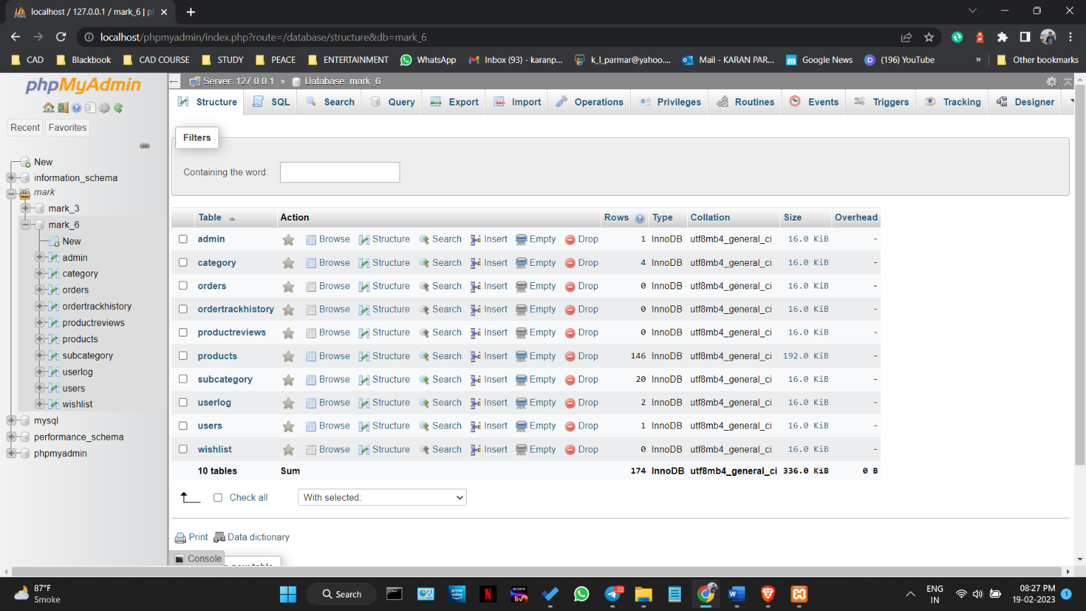Figure 4.2.1

b. Data Integrity and Constraints

* Integrity
* Primary key: Each table should have a primary key to ensure uniqueness of each record.
* Foreign key: The foreign key constraint ensures that the data in one table matches the data in another table.
* Unique key: To ensure that a column or set of columns have unique values.
* Constraints
* NOT NULL: This constraint ensures that a column cannot have null values.
* CHECK: This constraint ensures that the value in a column meets a specific condition or range of values.
* DEFAULT: This constraint ensures that a default value is inserted when no value is specified for a column.
* CASCADE: This constraint ensures that when a record is deleted or updated in one table, the change is automatically propagated to related tables.

###### 4.3 Procedural Design

a. Logic Diagram

* The logic diagram for the offline shop sales and data entry using VBA would follow a systematic flow of procedures. The process would begin with the user inputting the data of the sale or purchase into the system, which would be verified for accuracy and completeness. Once the data is validated, it will be stored in the respective tables of the database. The system will also generate receipts or invoices for the transaction. In case of any errors or exceptions, appropriate messages will be displayed to the user.
* For the online store sales, the logic diagram would involve a similar flow, with the user inputting the data online through the website, which would be validated and stored in the database. Additionally, there would be an order tracking feature that would update the status of the order and notify the customer of any changes.
* Define the systematic flow of the procedure for data collection and integration, data cleaning and transformation, data modelling and calculation, and data visualization and reporting using Power BI.
* Create a flowchart to show how data moves through each of the modules, including data sources, data transformations, and data visualizations.
* Define the systematic flow of the procedure for testing website performance using JMeter.
* Create a flowchart to show how JMeter will be used to simulate website traffic and measure website response time.

b. Data Structures

* The data structures for both the offline and online stores would involve several tables in the database, including those for product inventory, user accounts, orders, and order tracking history.
* For the offline shop sales and data entry using VBA, the data structure would include tables for products, categories, subcategories, users, orders, and order tracking history. The product table would contain information about the products, such as name, price, and stock availability, while the user table would contain information about the customers, such as name, address, and contact details. The order table would store information about each transaction, such as the date, customer details, and the products purchased. The order tracking history table would contain the status of each order, such as shipped, delivered, or cancelled.
* For the online store sales, the data structure would include similar tables for products, categories, subcategories, users, and orders, but with additional tables for reviews and wishlist. The reviews table would store reviews of products made by customers, while the wishlist table would store products that customers have saved for later purchase.
* Define the data structure that will be used for each of the modules in Power BI.
* Include information on the type of data that will be collected, stored, and visualized, as well as any calculations that will be performed.
* Define the data structure that will be used to store the results of the JMeter tests.
* Include information on the type of data that will be collected, stored, and visualized, as well as any calculations that will be performed.

c. Algorithm design

* The algorithm design for the offline shop sales and data entry using VBA would involve several steps. The algorithm would first receive the input data from the user, validate it, and store it in the appropriate tables in the database. It would then generate a receipt or invoice for the transaction and display it to the user. If there are any errors or exceptions, the algorithm would display appropriate messages to the user.
* For the online store sales, the algorithm design would involve a similar flow, with the user inputting the data online through the website, which would be validated and stored in the database. The algorithm would also update the order tracking status and notify the customer of any changes. If there are any errors or exceptions, the algorithm would display appropriate messages to the user.
* Explain the working of the algorithm for each module in Power BI.
* Provide a proper explanation regarding input, processing, core logic, and output for each module.
* Frame the algorithm in the forms of steps for each module in Power BI.
* Explain the working of the algorithm for the JMeter test.
* Provide a proper explanation regarding input, processing, core logic, and output for the JMeter test.
* Frame the algorithm in the forms of steps for the JMeter test.

###### 4.4. User Interface Design

User Tasks and Environments

* The user interface design is focused on providing a seamless experience for customers shopping online, for shopkeepers managing sales and inventory offline, and for developers using Power BI and Jmeter to visualize and analyze sales and inventory data.
* Customers can shop for products, view their order history, and manage their account details through the online store.
* Shopkeepers can manage sales, inventory, and user accounts using the VBA-based interface for the offline store.
* Developers can use Power BI and Jmeter to collect, integrate, clean, transform, model, calculate, and visualize sales and inventory data.
* Internal and External Components
* The architecture of the user interface includes both internal and external components, such as the online store website, the VBA-based interface for the offline store, and the Power BI and Jmeter software.
* The online store includes components for product browsing, ordering, and checkout, as well as features for managing user accounts and order history.
* The VBA-based interface for the offline store includes components for managing sales and inventory, as well as user account details.
* Power BI and Jmeter include components for collecting, integrating, cleaning, transforming, modelling, calculating, and visualizing sales and inventory data.
* Sample UI Design

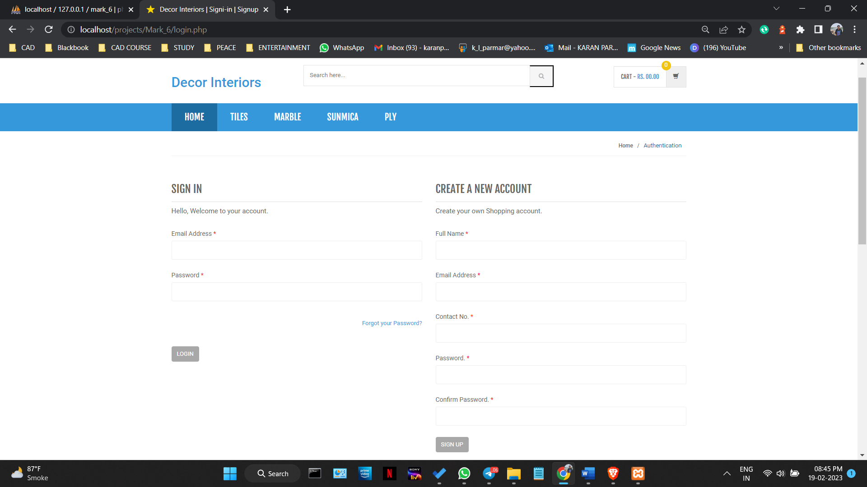

Figure 4.4.1

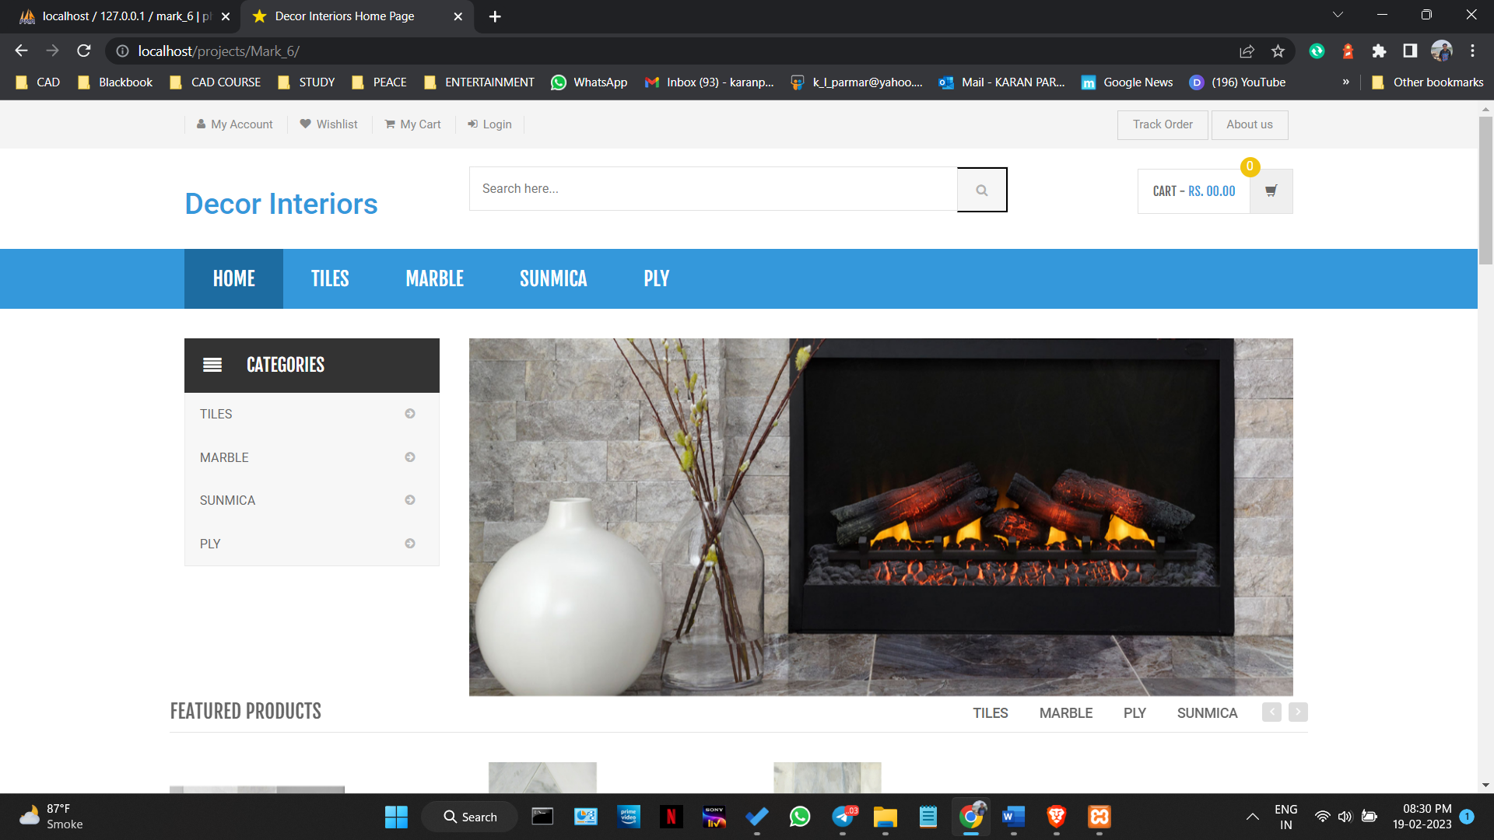

Figure 4.4.2

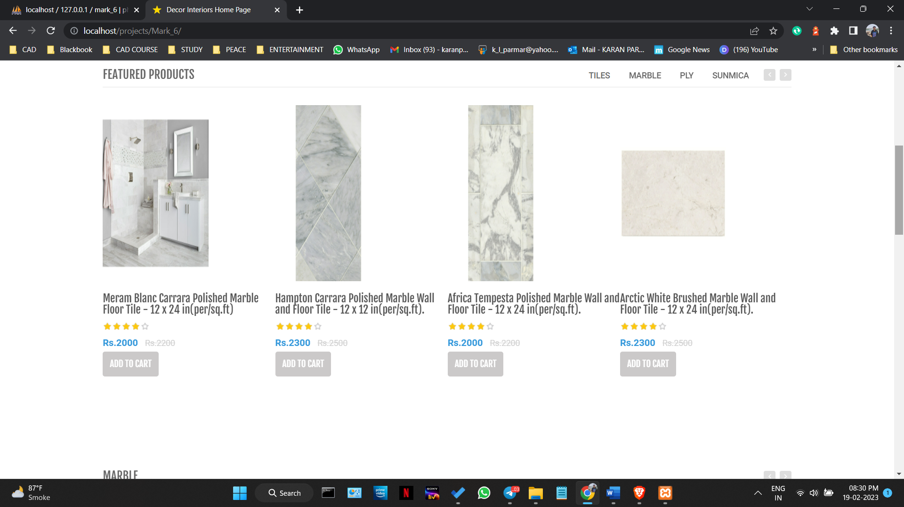

Figure 4.4.3

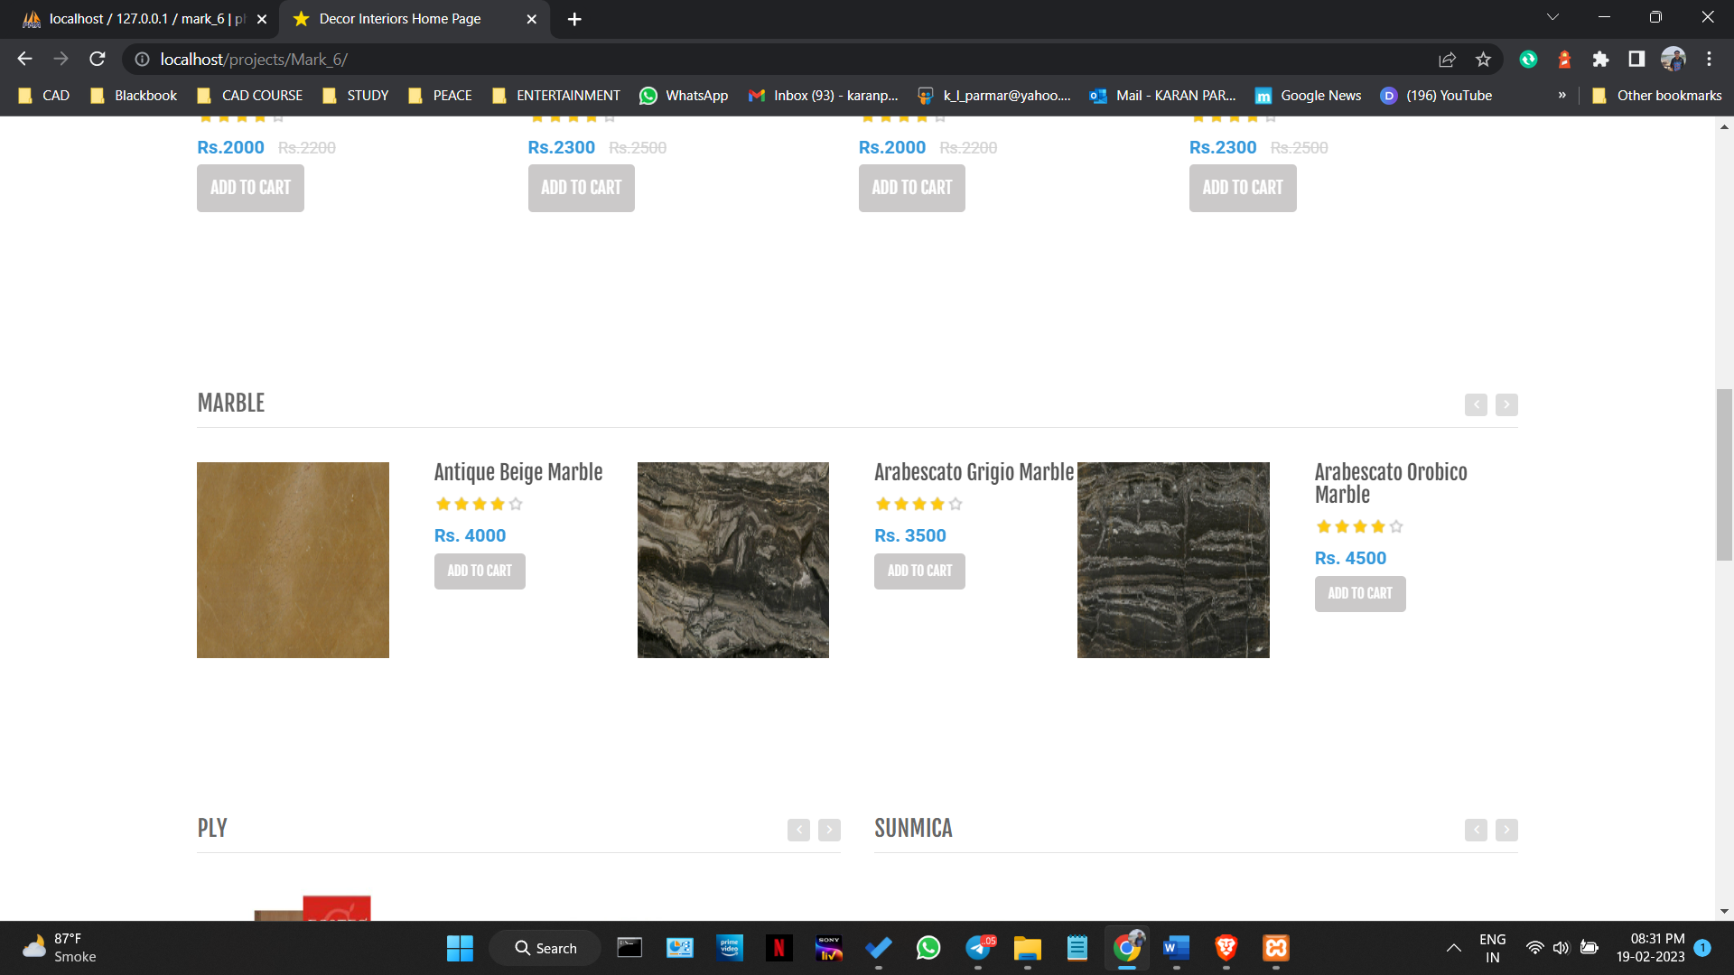

Figure 4.4.4

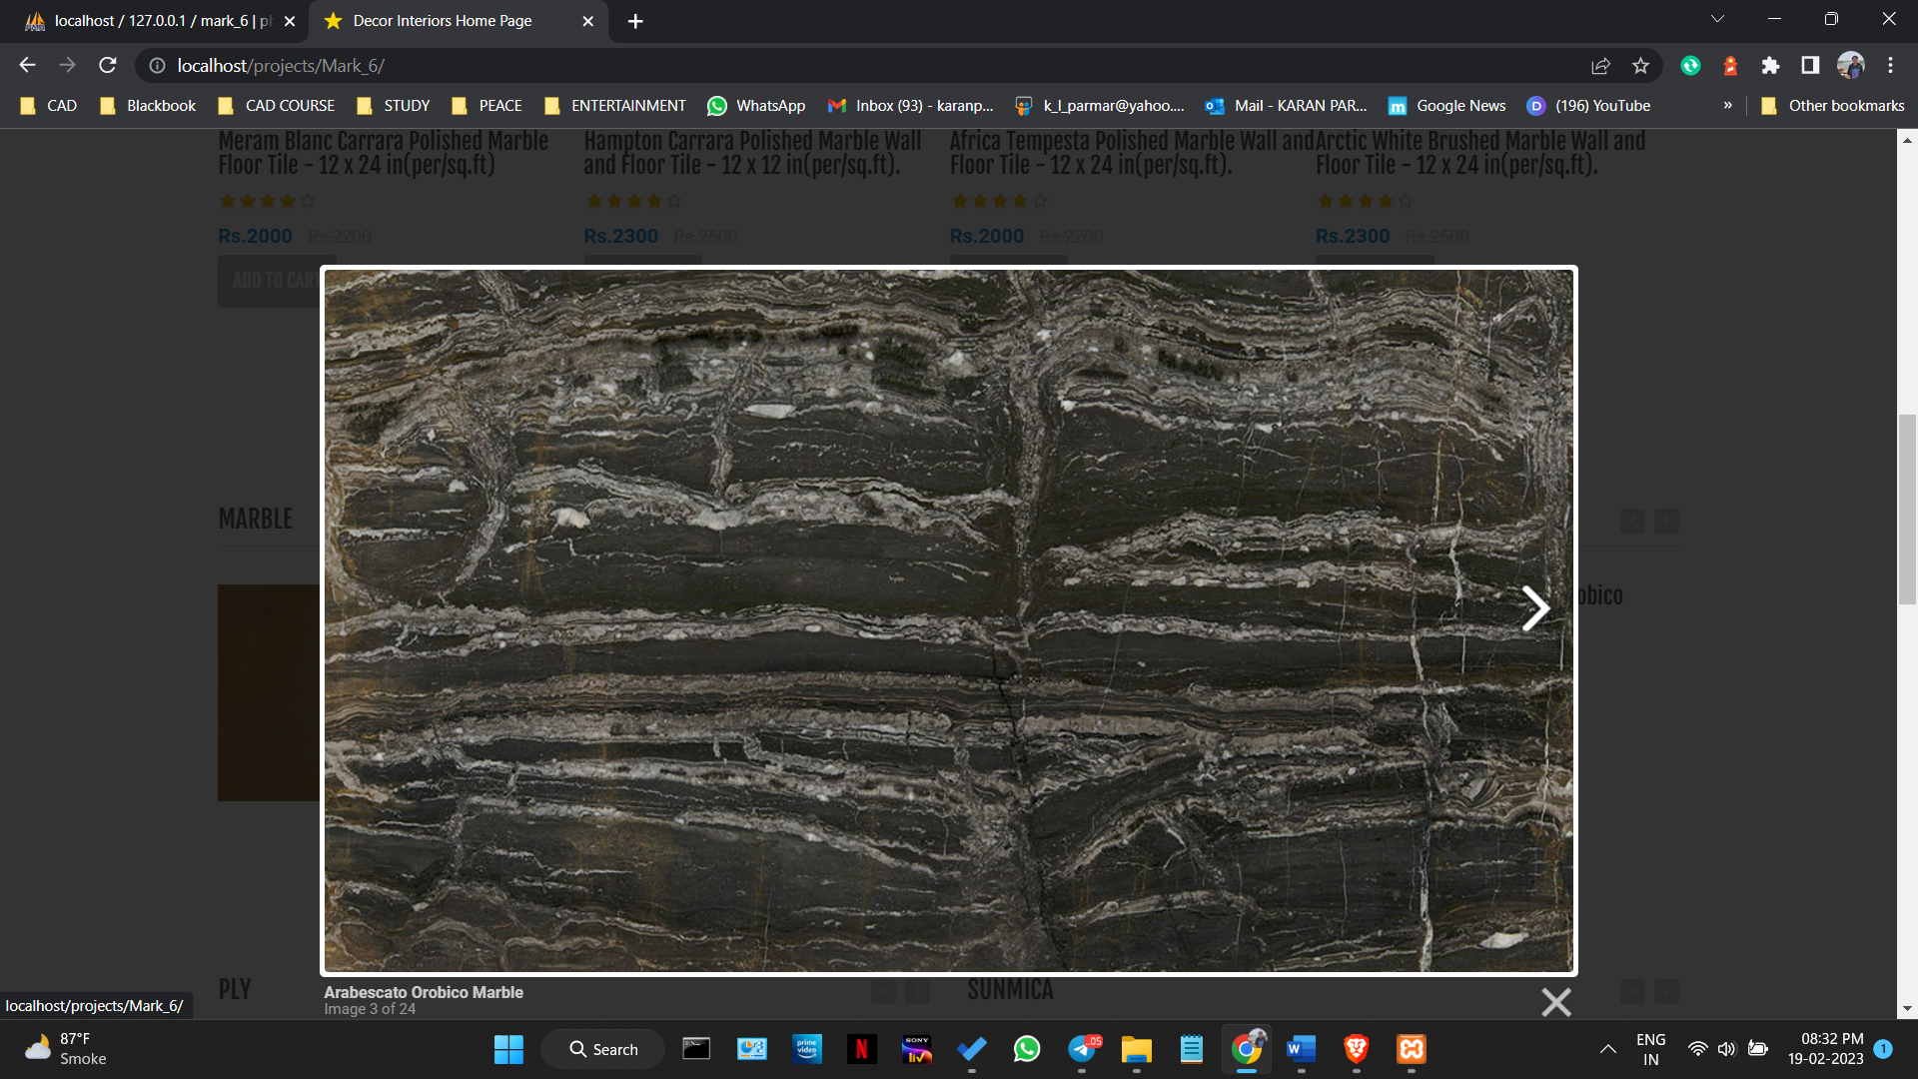

Figure 4.4.5

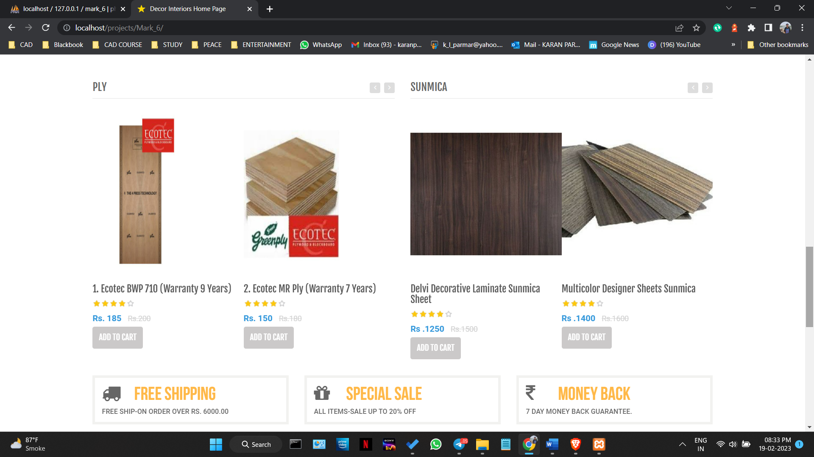

Figure 4.4.6

###### 4.5. Security Issues

Security Issues

1. Data Breaches: The possibility of data breaches always exists, where attackers can gain unauthorized access to sensitive customer and business data.
2. Malicious Attacks: There's a risk of malicious attacks, such as DDoS attacks or phishing scams, that could compromise the security of the system.
3. Unauthorized Access: Unauthorised access to the system, applications, or data can be an issue. This can occur due to weak or compromised passwords, or insecure login procedures.
4. Insider Threats: There's always a possibility of insider threats where employees or contractors can intentionally or accidentally disclose sensitive information.
5. System Vulnerabilities: Any vulnerabilities in the system or software components can be exploited by attackers to gain access to the system or its data.

II. Plan of Action

1. Data Protection: To prevent data breaches, we would ensure that all sensitive data is encrypted, and use access controls and firewalls to limit access to authorized users only. Additionally, we would regularly backup data and implement disaster recovery and business continuity plans.
2. Network Security: To prevent malicious attacks, we would implement network security measures such as intrusion detection systems, firewalls, and regular vulnerability scans.
3. Access Controls: To prevent unauthorized access, we would enforce strong password policies, two-factor authentication, and access controls to limit the scope of user access. We would also monitor login activities and logs to detect any suspicious activity.
4. Employee Training: To prevent insider threats, we would provide regular training to employees on information security and data protection. We would also implement policies to restrict access to sensitive data based on the employee's role and responsibilities.
5. Regular Security Audits: To prevent system vulnerabilities, we would regularly conduct security audits, penetration testing, and vulnerability assessments. We would also implement regular software updates and patches to fix any vulnerabilities found during the audits.

### CHAPTER 5: IMPLEMENTATION AND TESTING

**5.1 Implementation Approaches**

#### a. Define the implementation plan

The implementation plan for this project will involve the following steps:

* Development of the online e-commerce website using HTML, AJAX, CSS, JQUERY, JAVASCRIPT, PHP, MySQL, and XAMPP.
* Creation of an offline Visual Basic Form using Excel for recording data of people who buy the same products from the physical store.
* Integration of the data from the online website and offline form using PowerBI for data analysis and representation.
* Testing the performance of the website using JMeter.
* Finalizing and deploying the application on a web server.

#### b. State the standards and protocols used in implementation

The following standards and protocols will be used in the implementation of this project:

* HTML 5 and CSS 3 for creating the structure and visual design of the e-commerce website.
* JavaScript and jQuery for creating the dynamic and interactive features of the website.
* PHP for server-side scripting and interaction with the MySQL database.
* MySQL for creating and managing the database of products and user information.
* XAMPP for creating a local server environment to test the website before deployment.
* Visual Basic for creating the offline form to record data from the physical store.
* Excel for storing and managing the data recorded from the offline form.
* PowerBI for data analysis and representation of both online and offline data.
* JMeter for testing the performance of the e-commerce website.
* HTTP and HTTPS protocols for secure data transfer between the website and the user's browser.
* SQL queries for retrieving and managing data from the database.
* AJAX for making asynchronous requests to the server for dynamic content without reloading the page.
* JSON for transferring data between the website and the server.

**5.2 Coding Details and Code Efficiency**

#### a. Output of the main logic

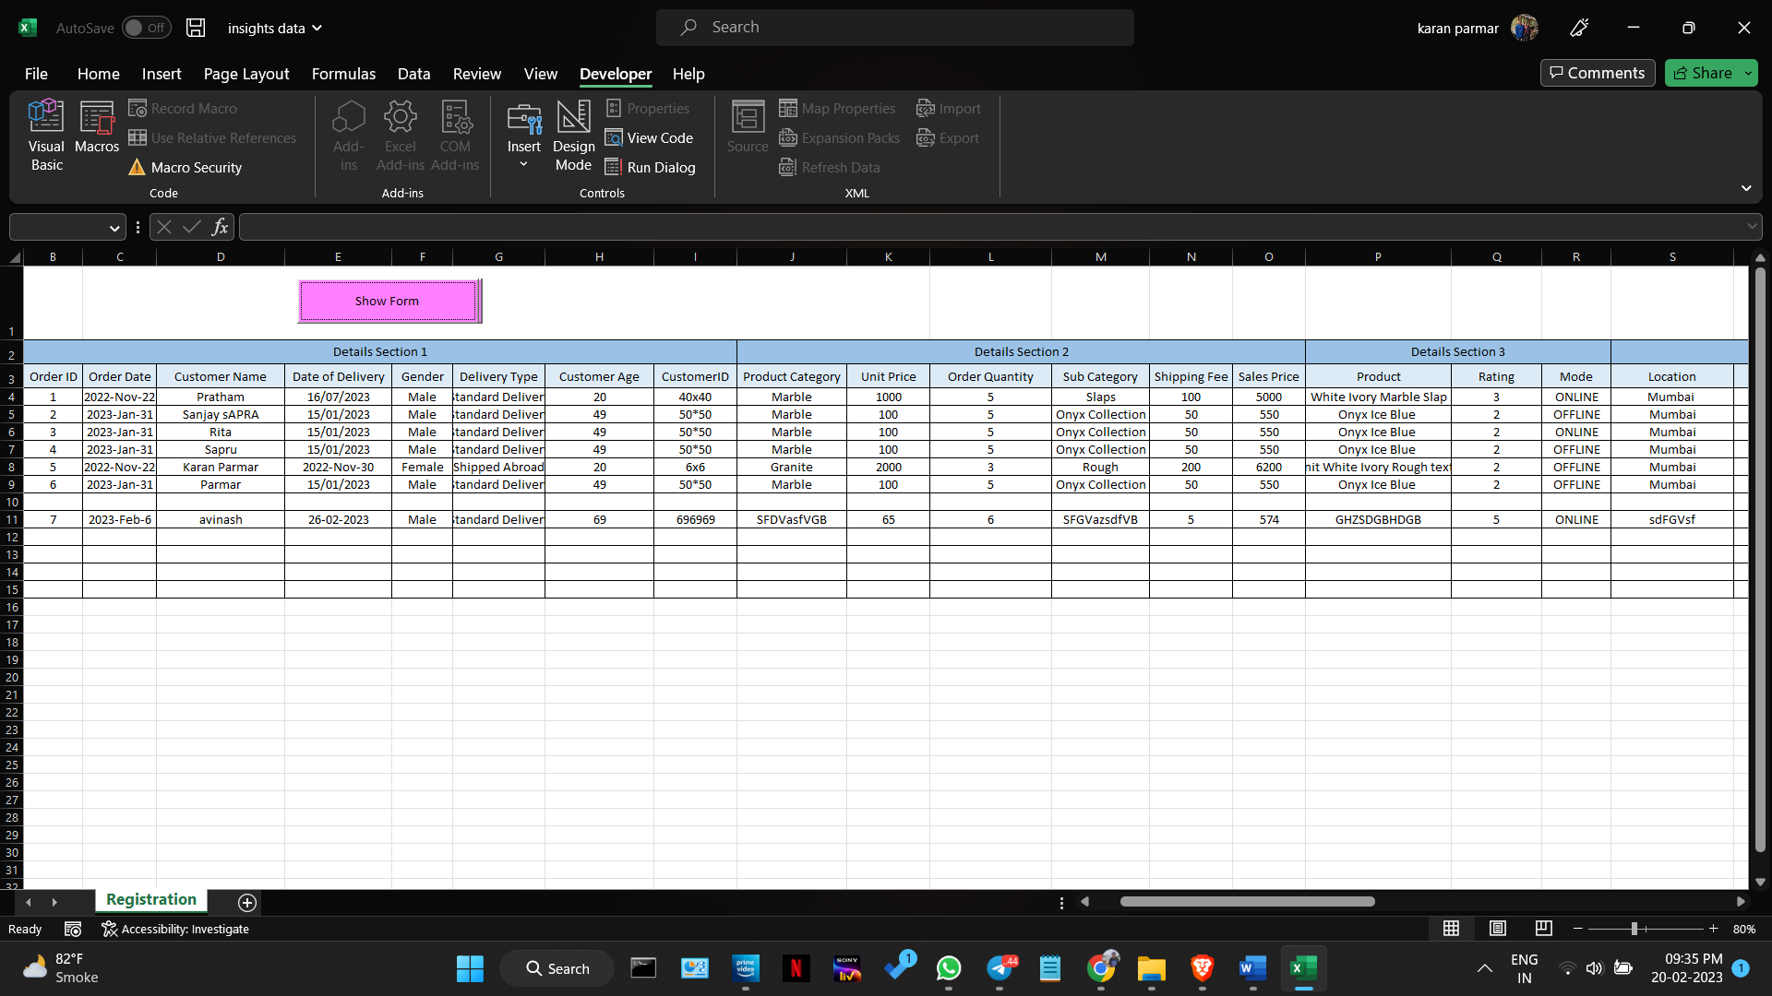 1.Visual Basic Application (VBA)

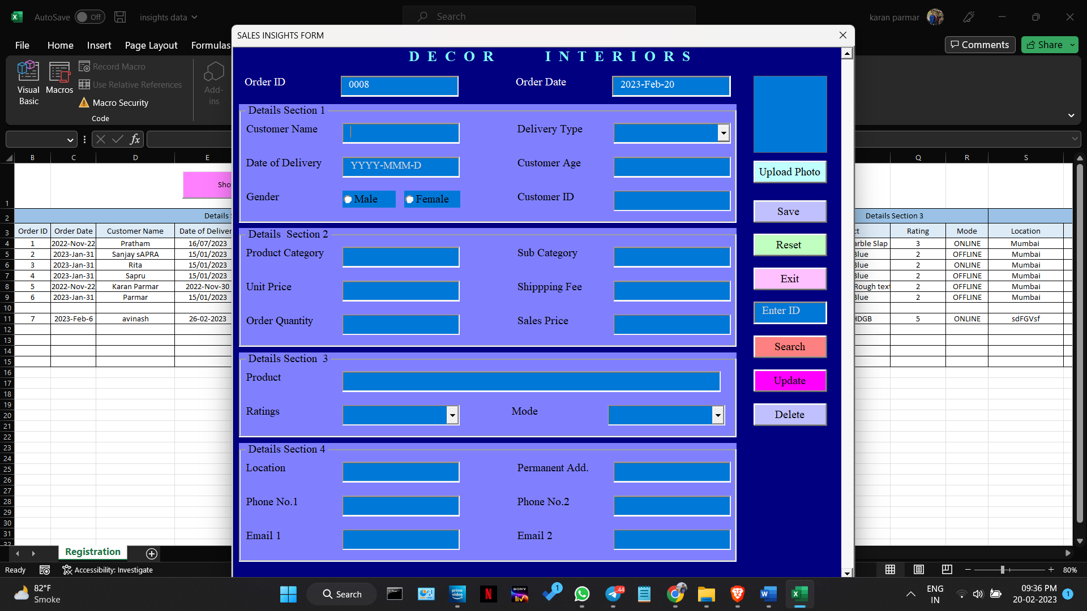Figure 5.2.1.1

Figure 5.2.1.2

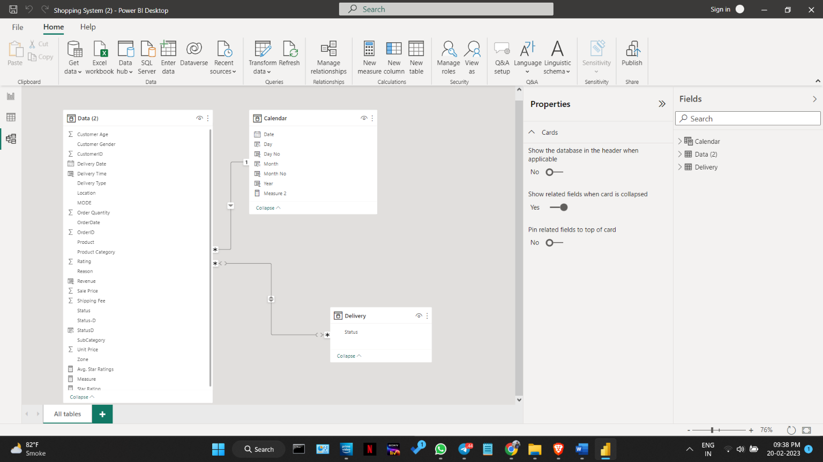2.Power BI

figure 5.2.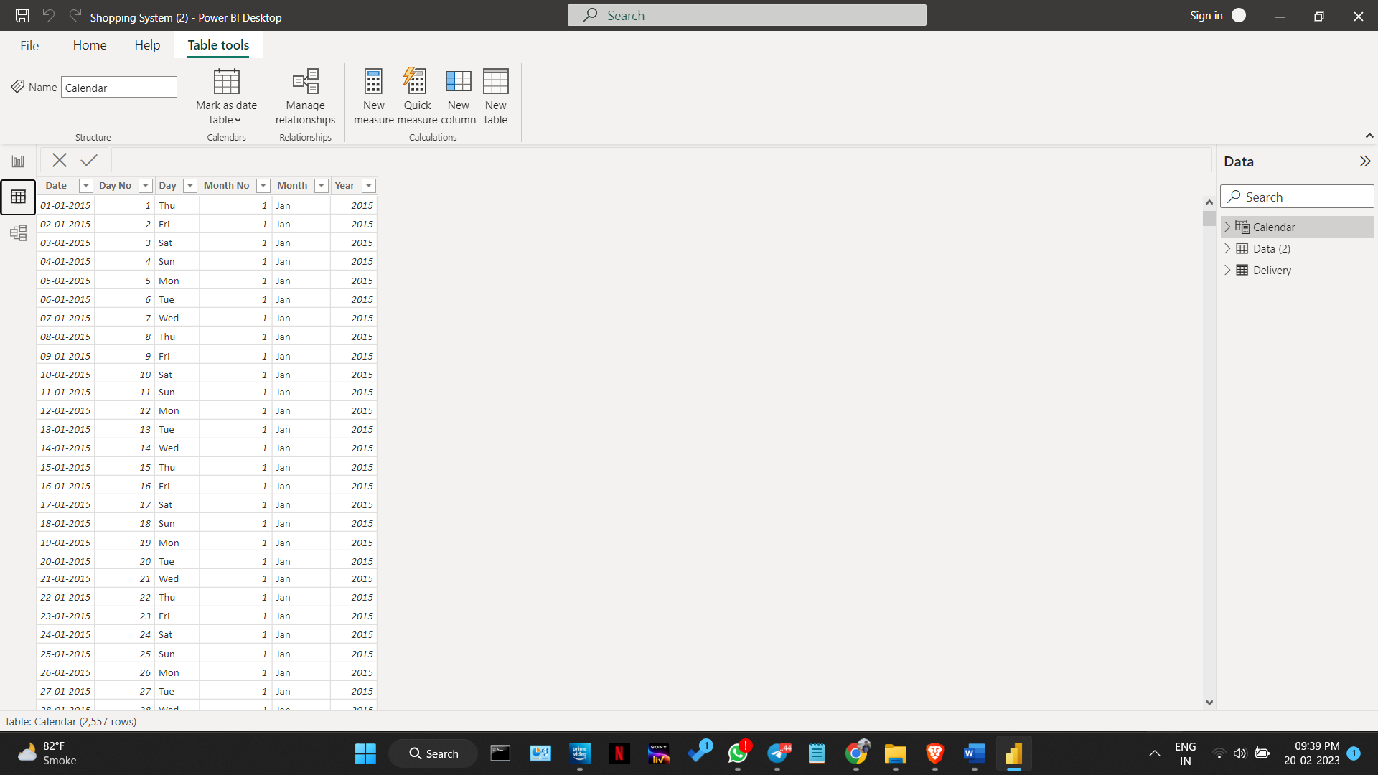2.1

figure 5.2.2.2

figure 5.2.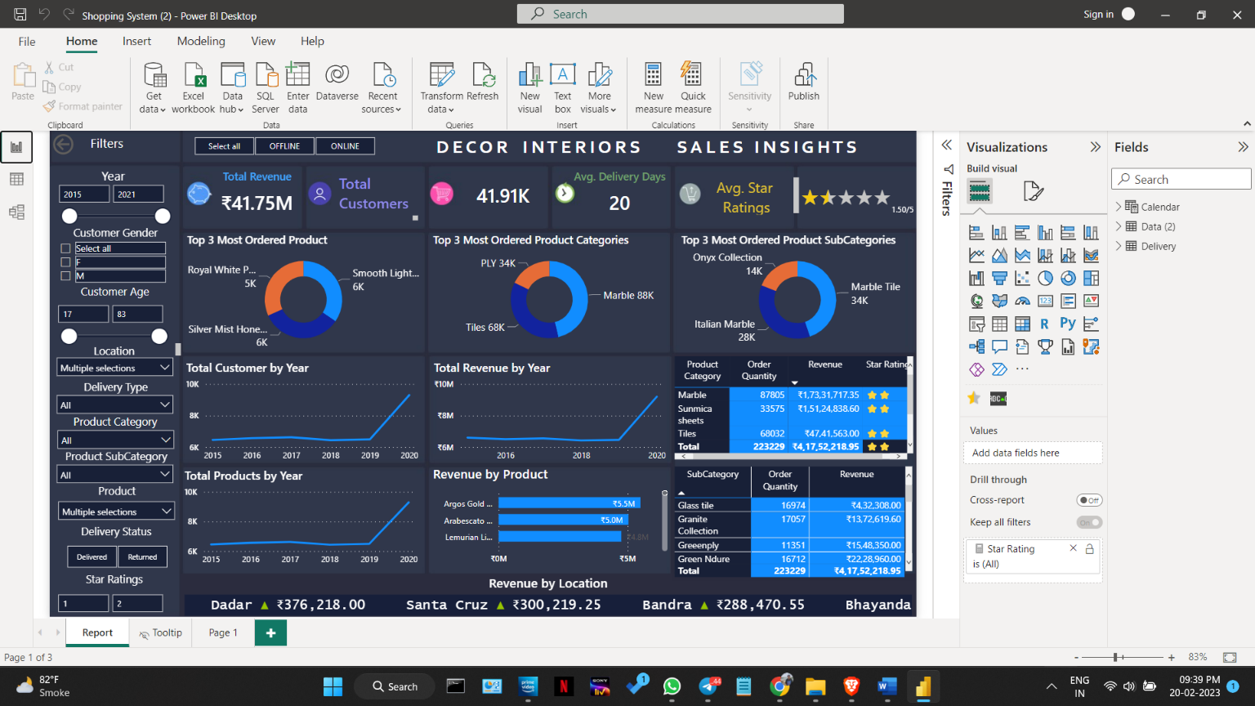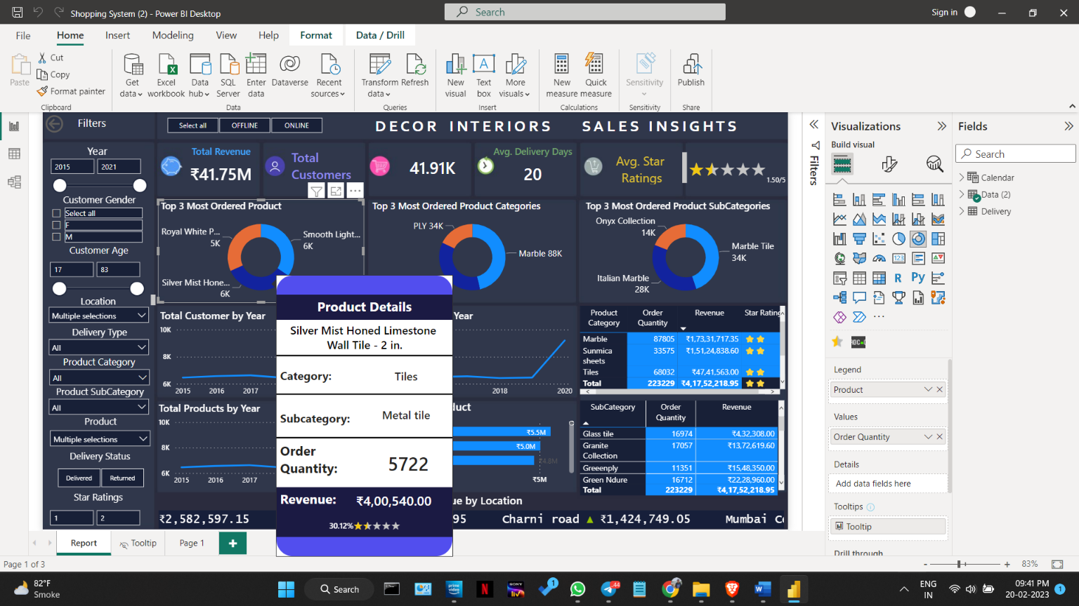2.3

figure 5.2.2.4

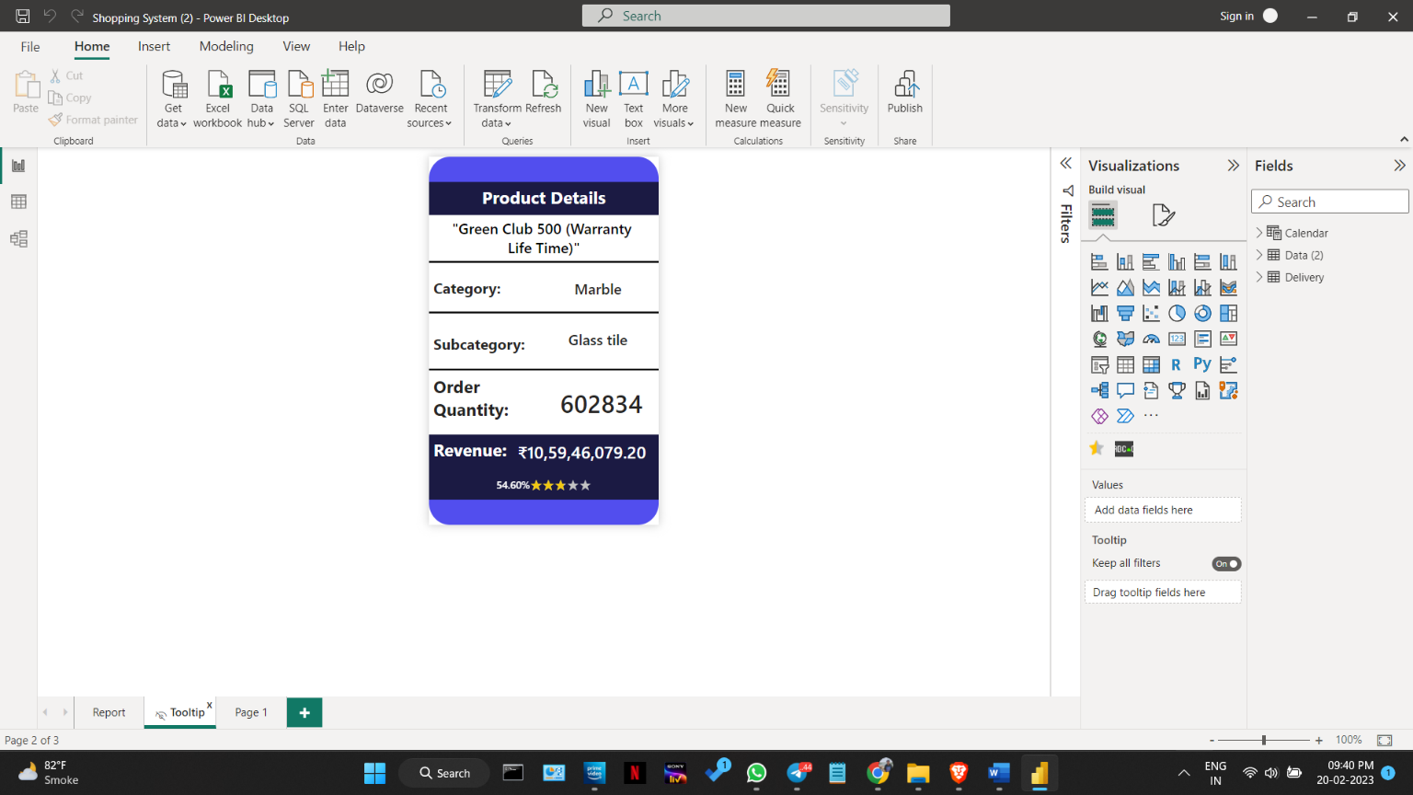figure 5.2.2.5

3.Jmeter

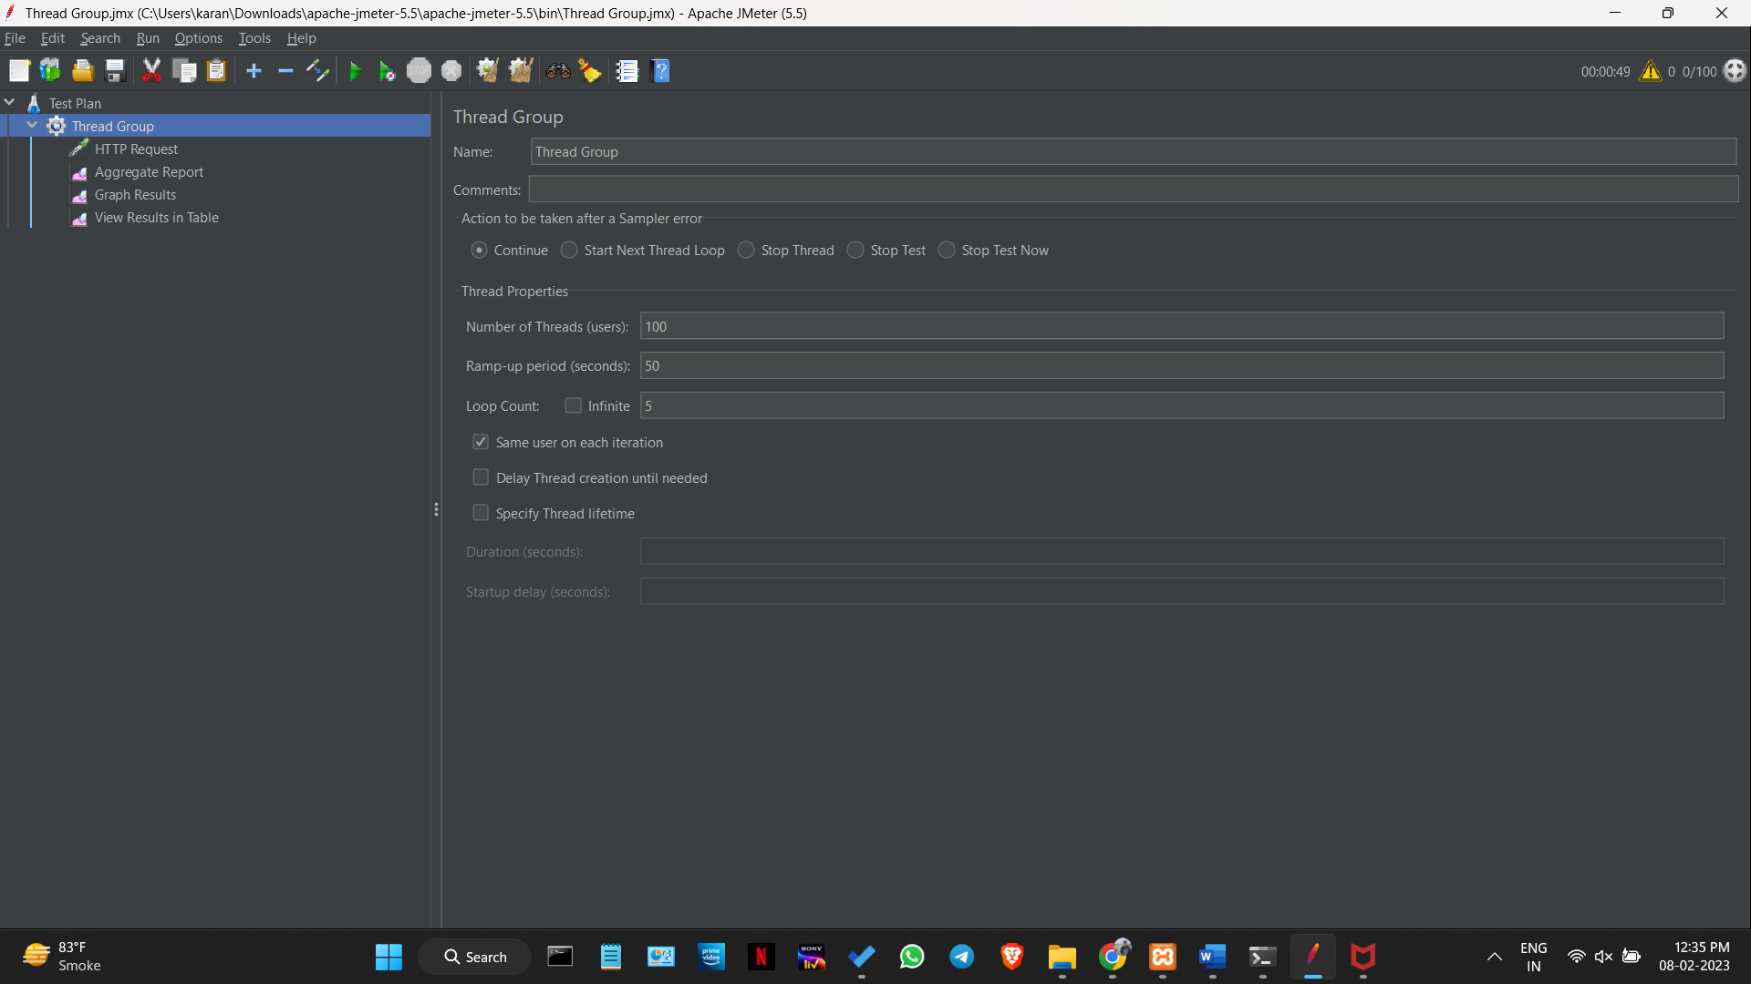

figure 5.2.3.1

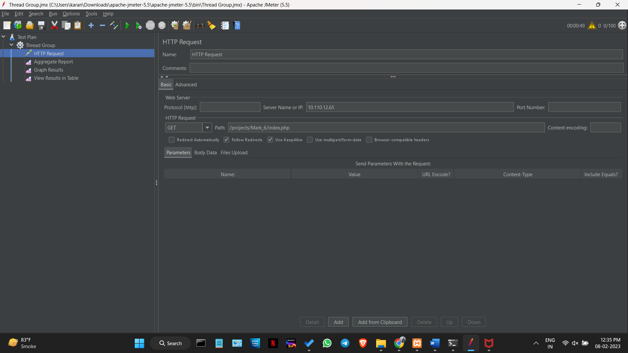

figure 5.2.3.2

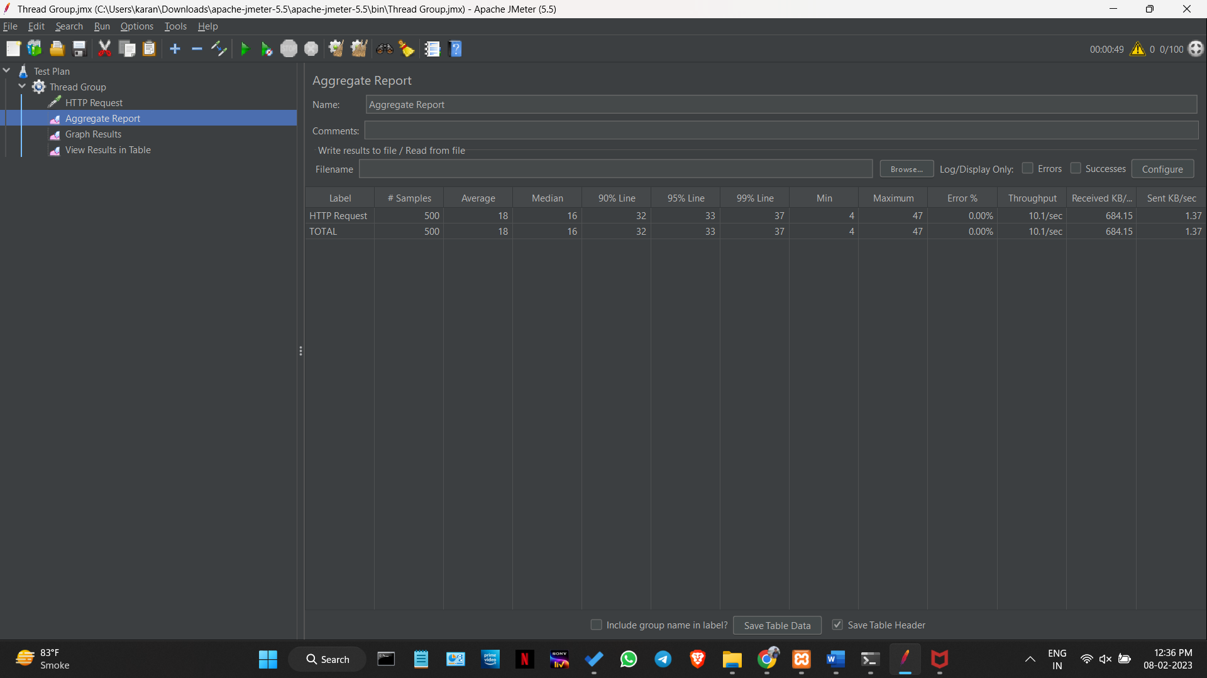

figure 5.2.3.3

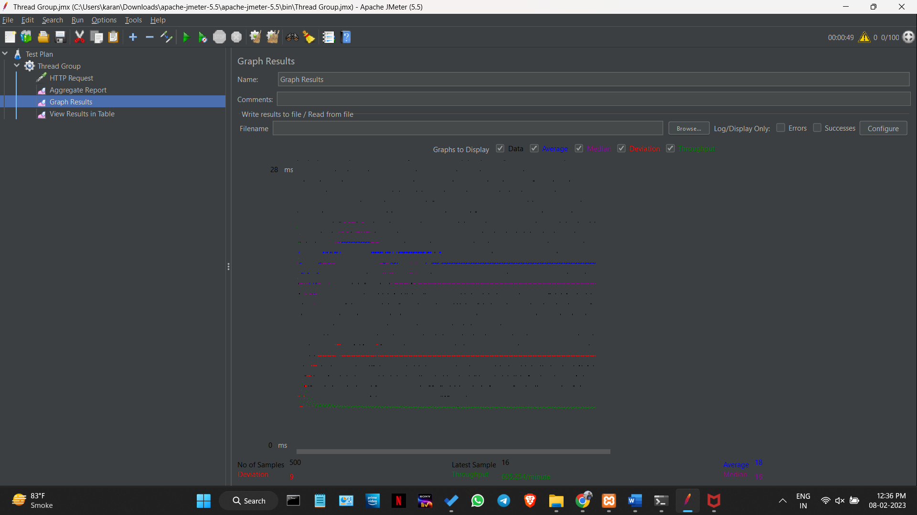

figure 5.2.3.4

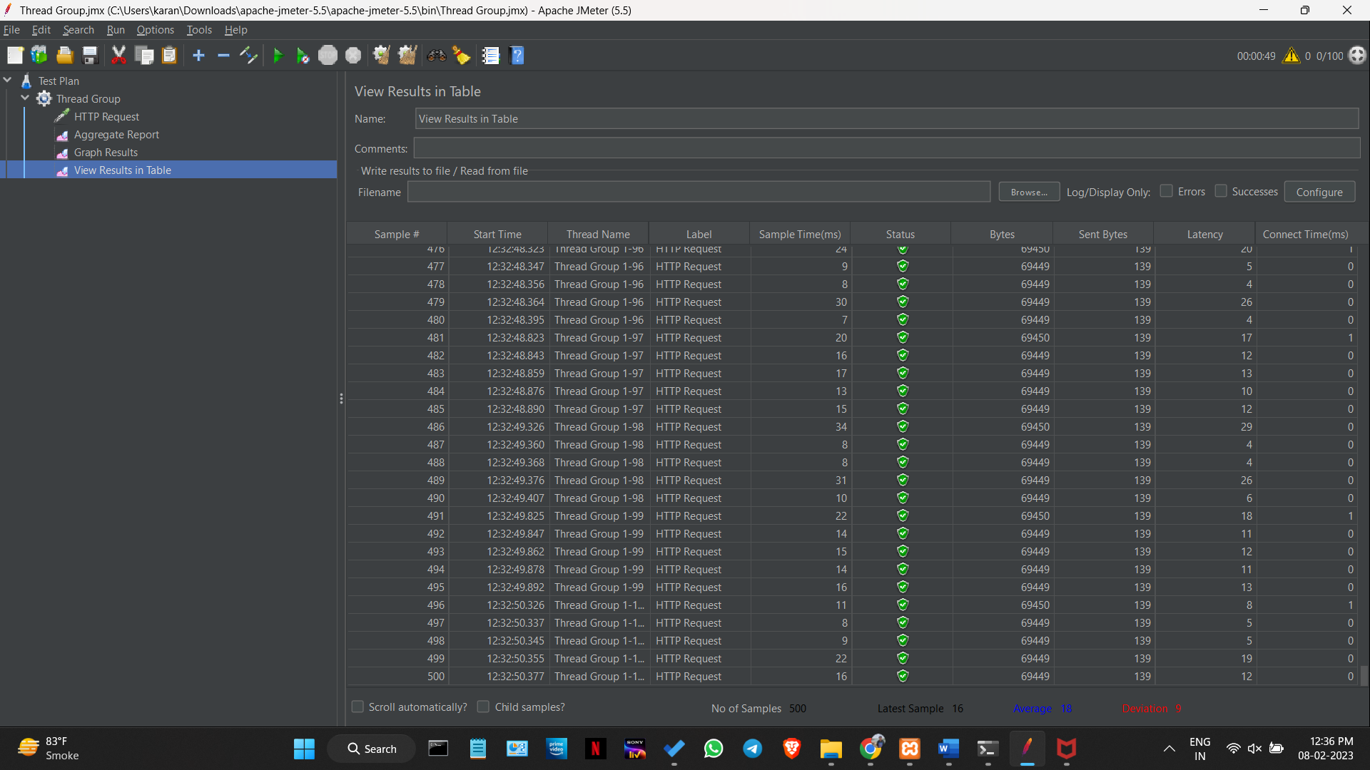

figure 5.2.3.5

4.Décor Interiors



Figure 5.2.4.1



Figure 5.2.4.2



Figure 5.2.4.3



Figure 5.2.4.4



Figure 5.2.4.5

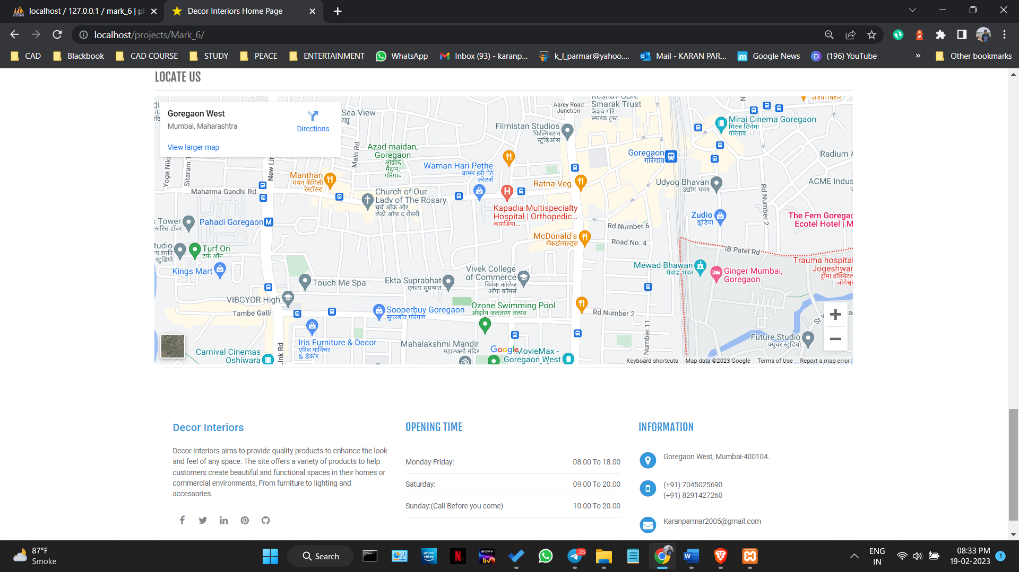

Figure 5.2.4.6

**Login.php**



Figure 5.2.4.7

**Category.php**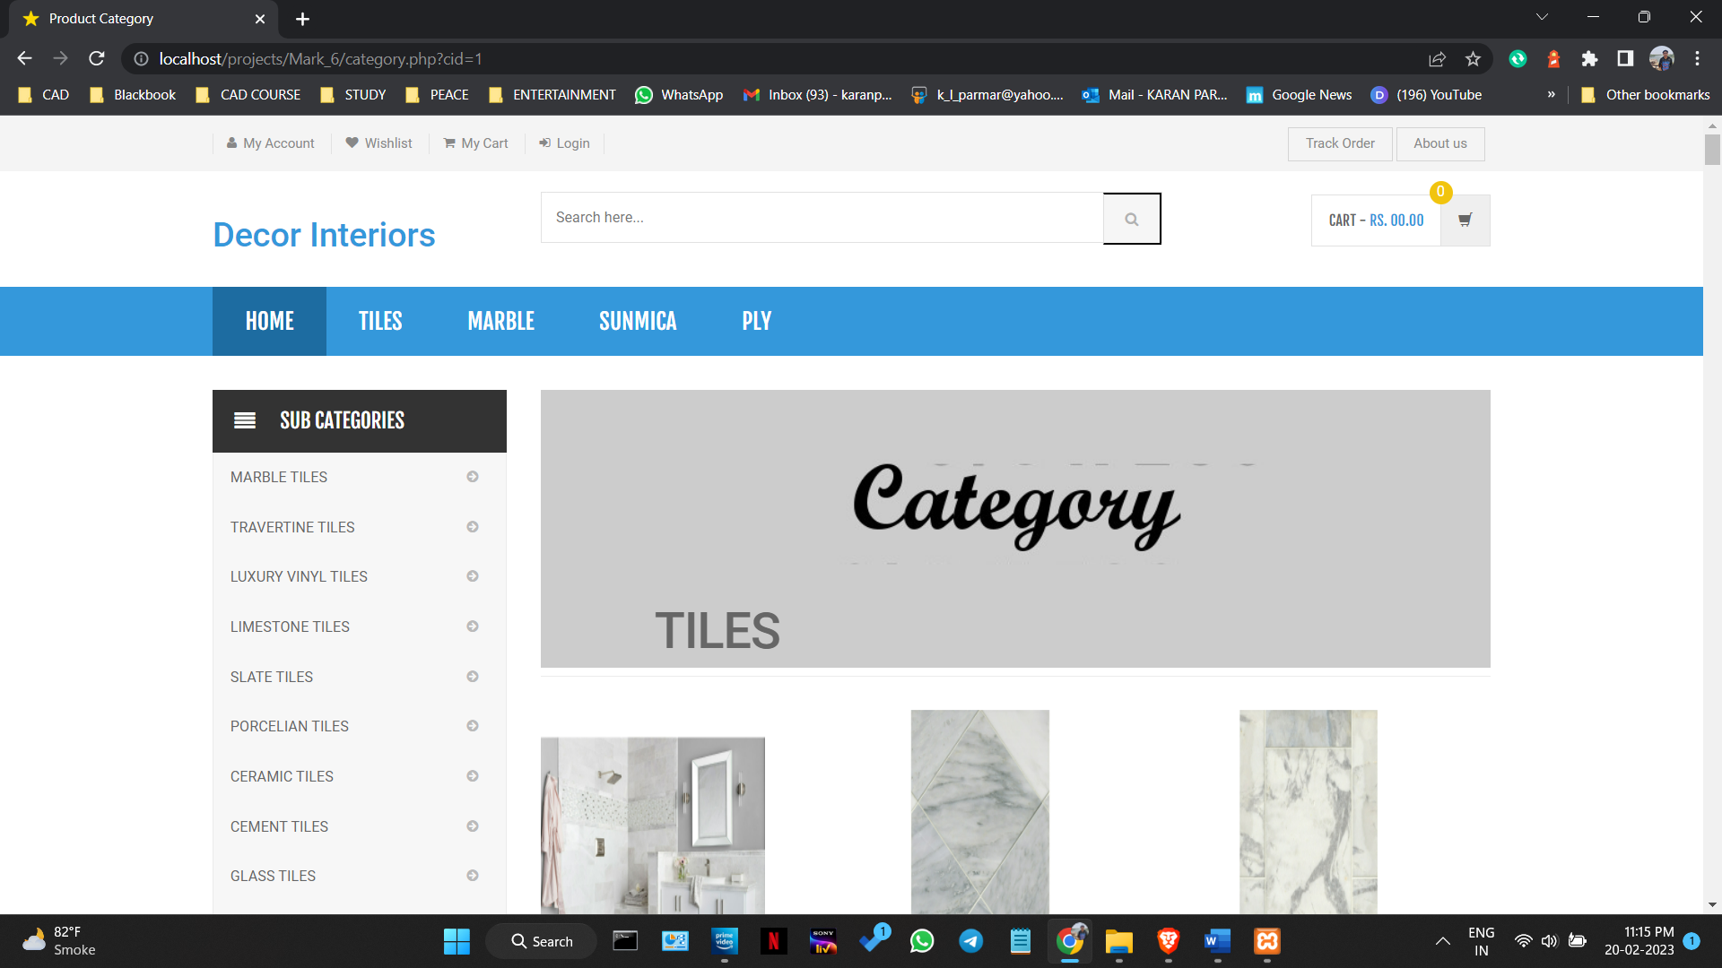

Figure 5.2.4.8

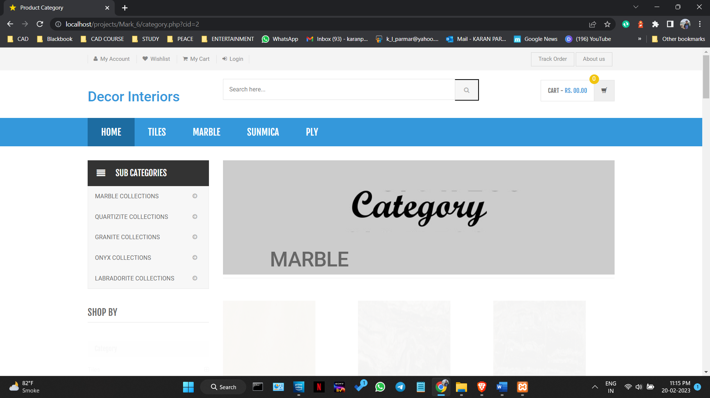

Figure 5.2.4.9

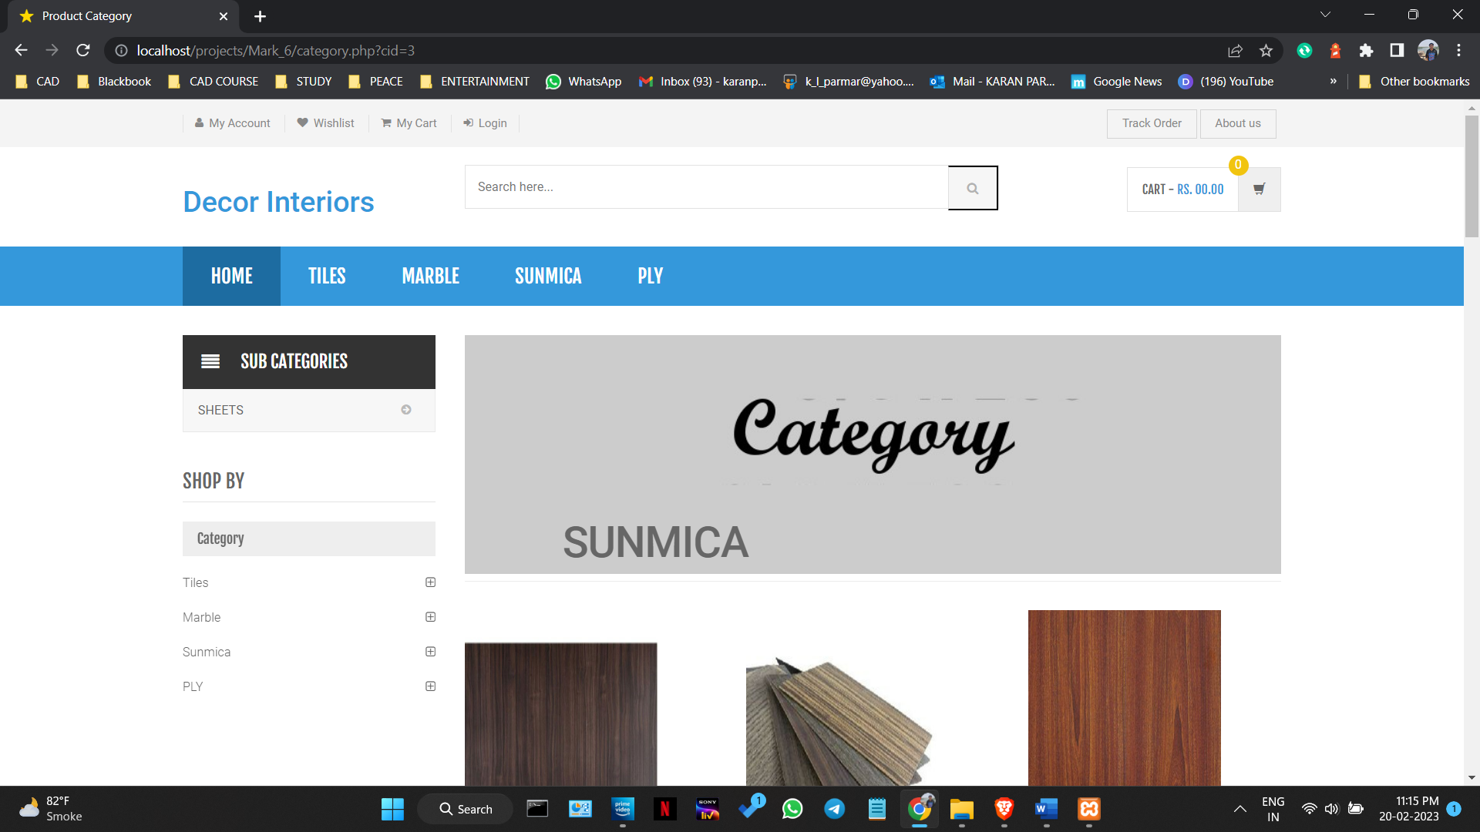

Figure 5.2.4.10

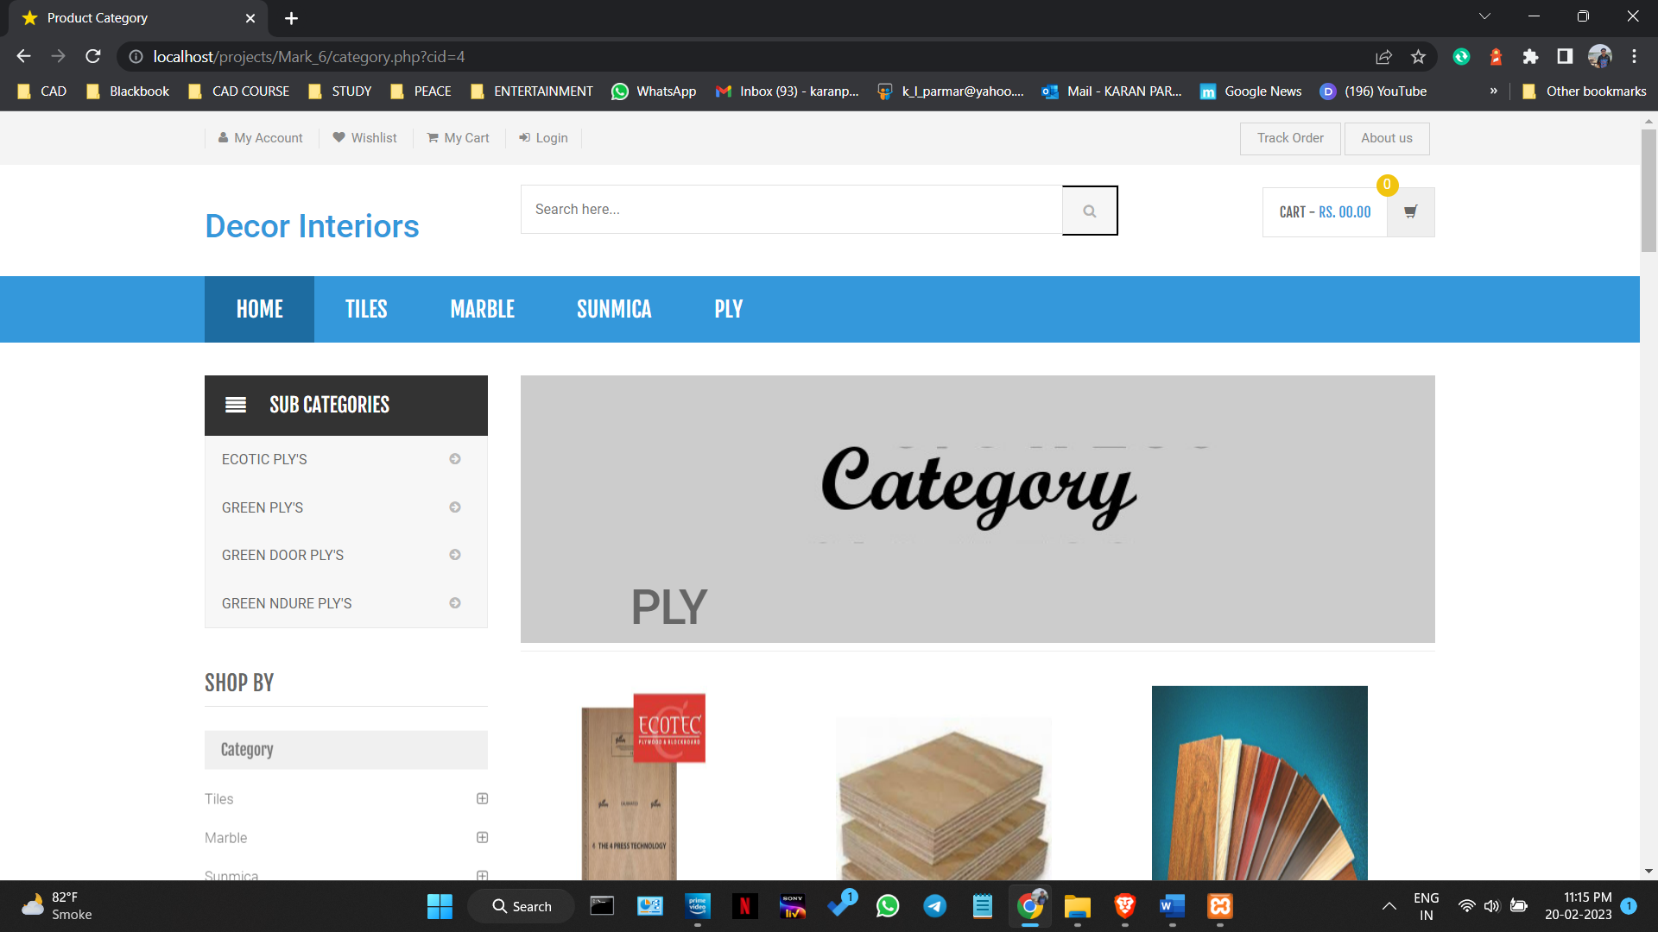

Figure 5.2.4.11

**Sub-category.php**

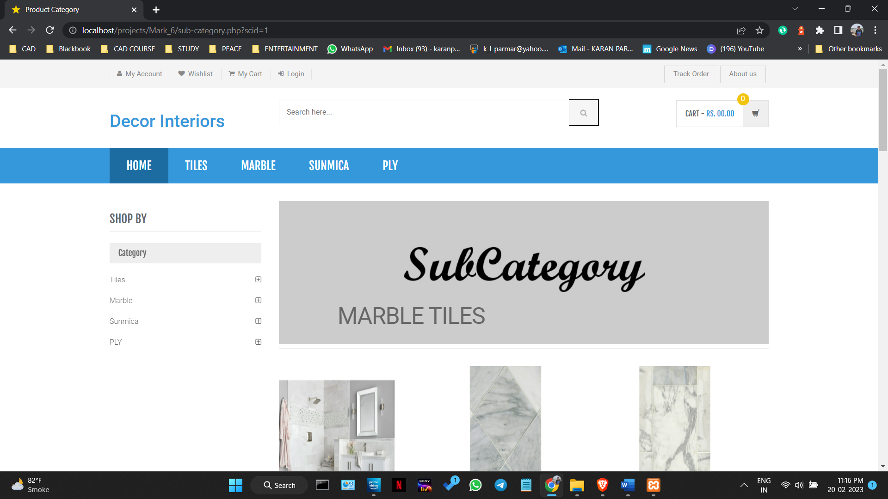

Figure 5.2.4.12

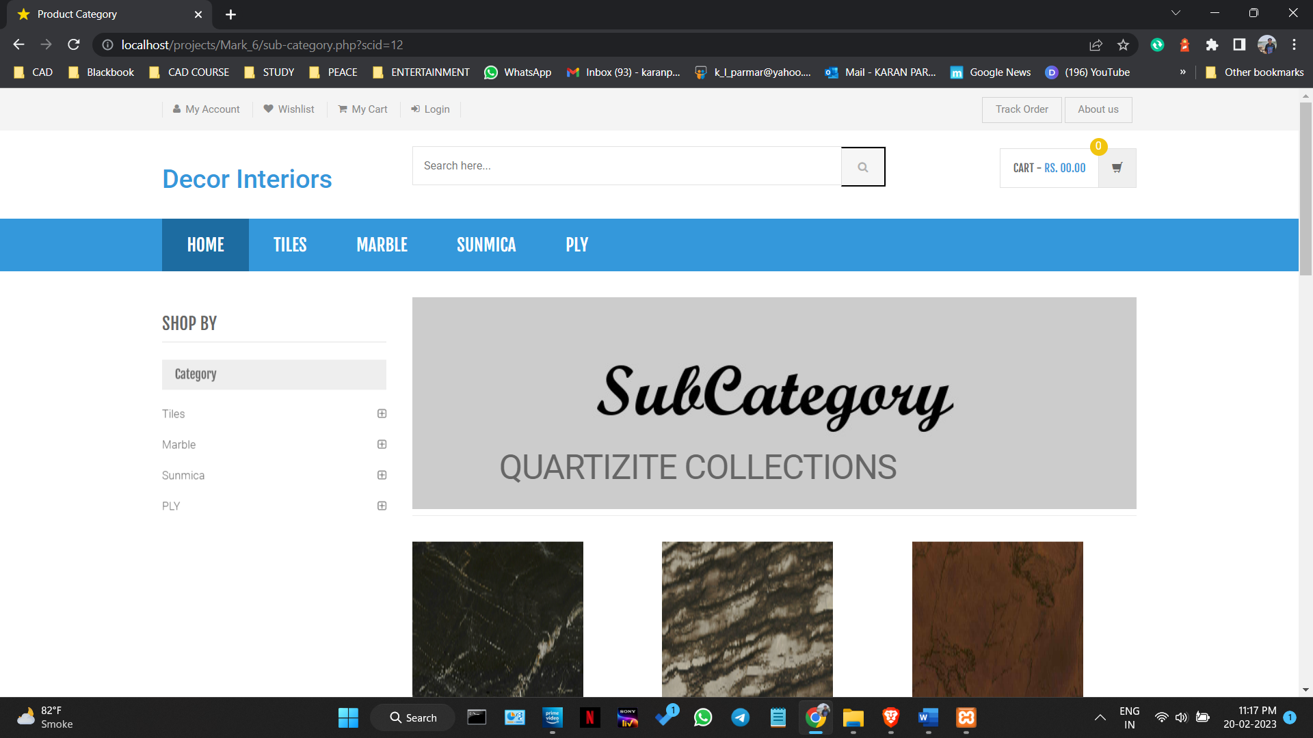

Figure 5.2.4.13

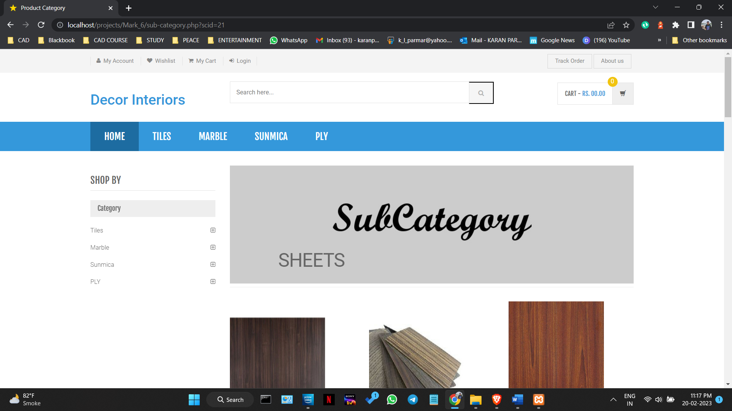

Figure 5.2.4.14

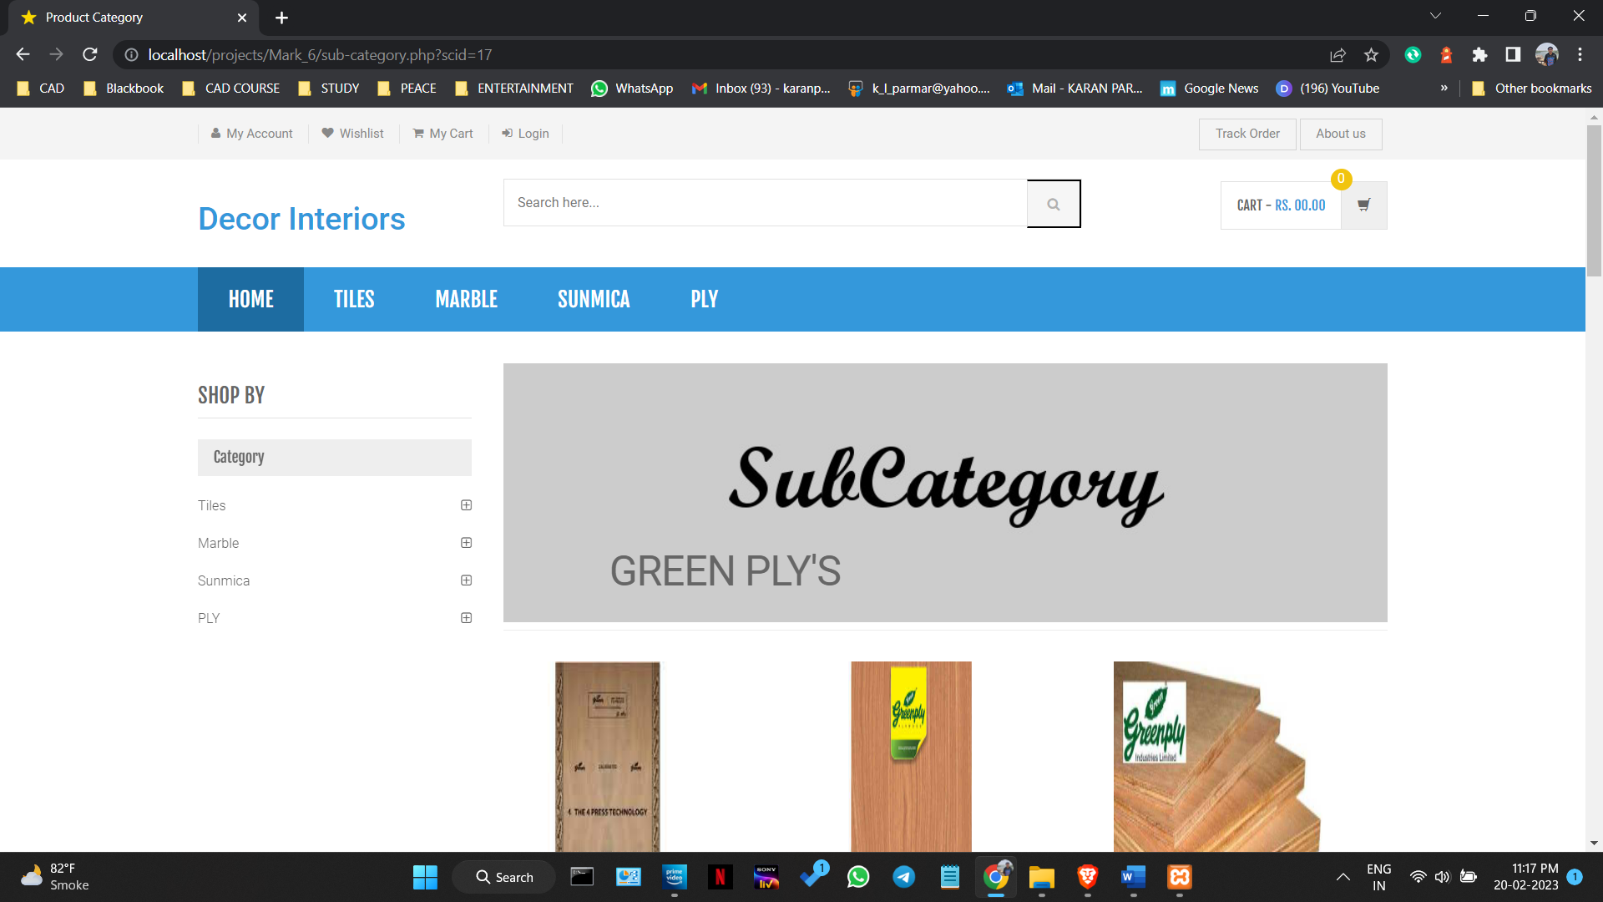

Figure 5.2.4.15

**Product-details.php**

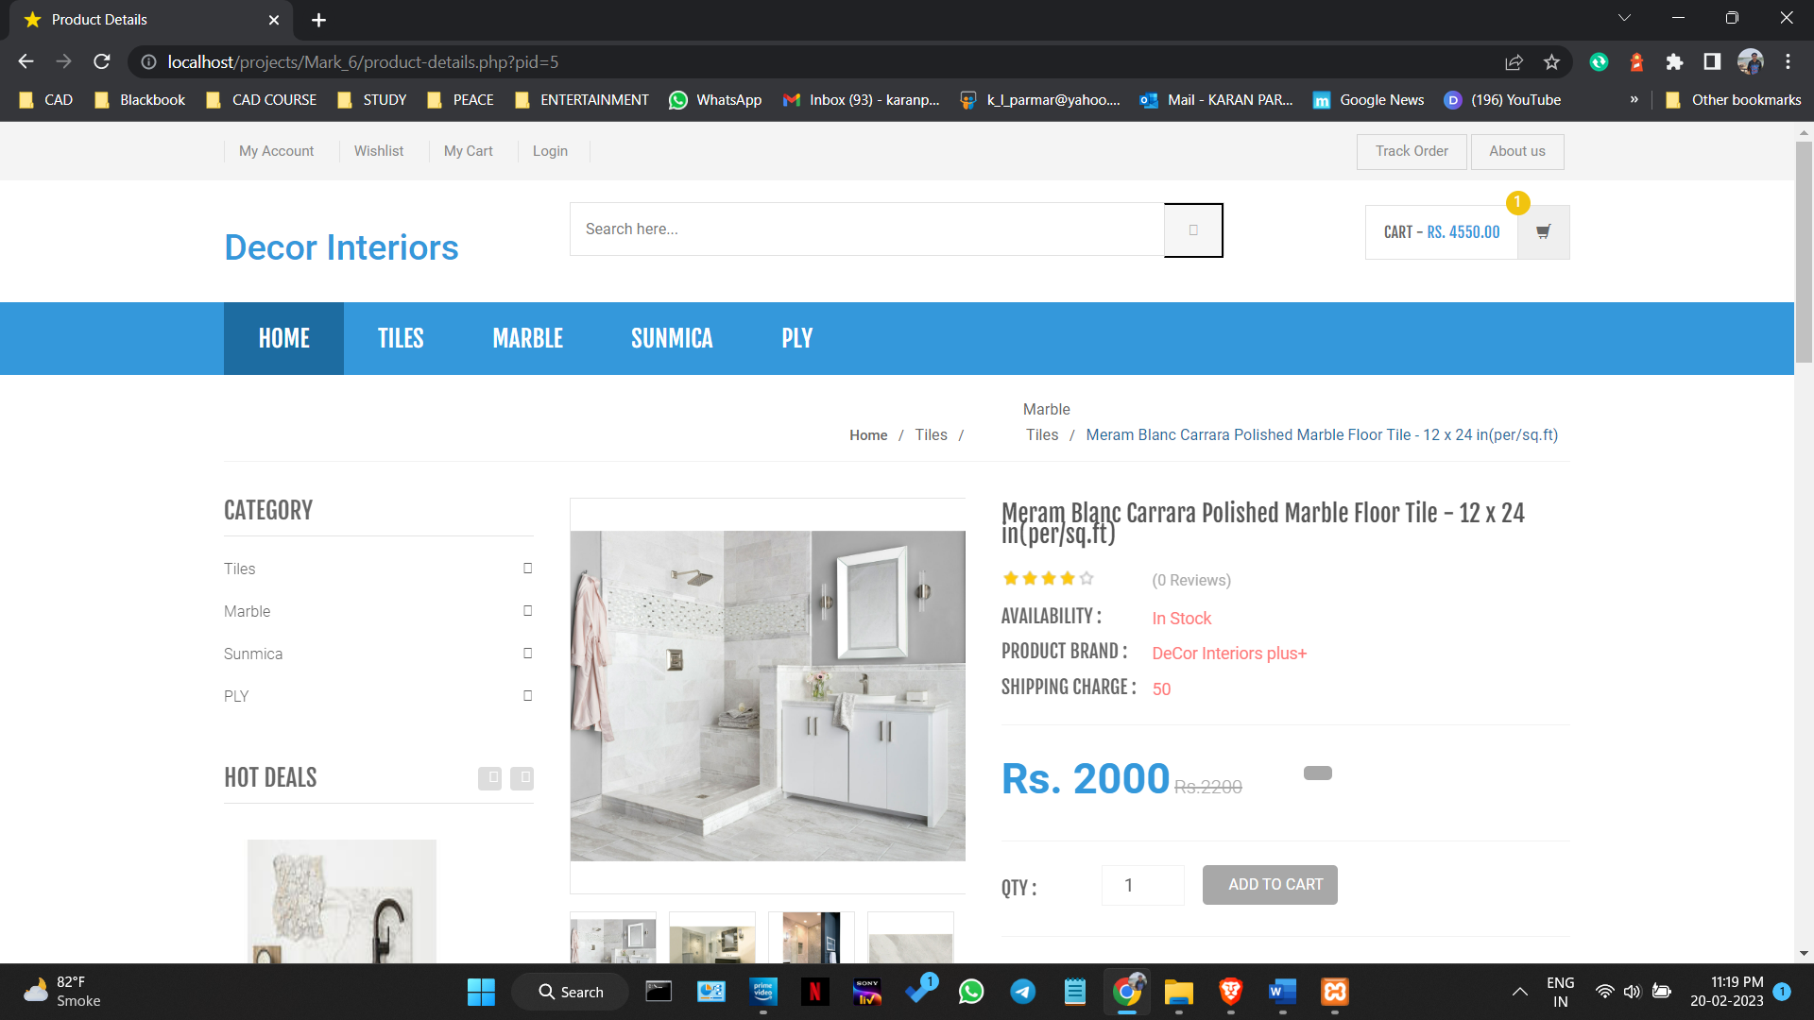

Figure 5.2.4.16

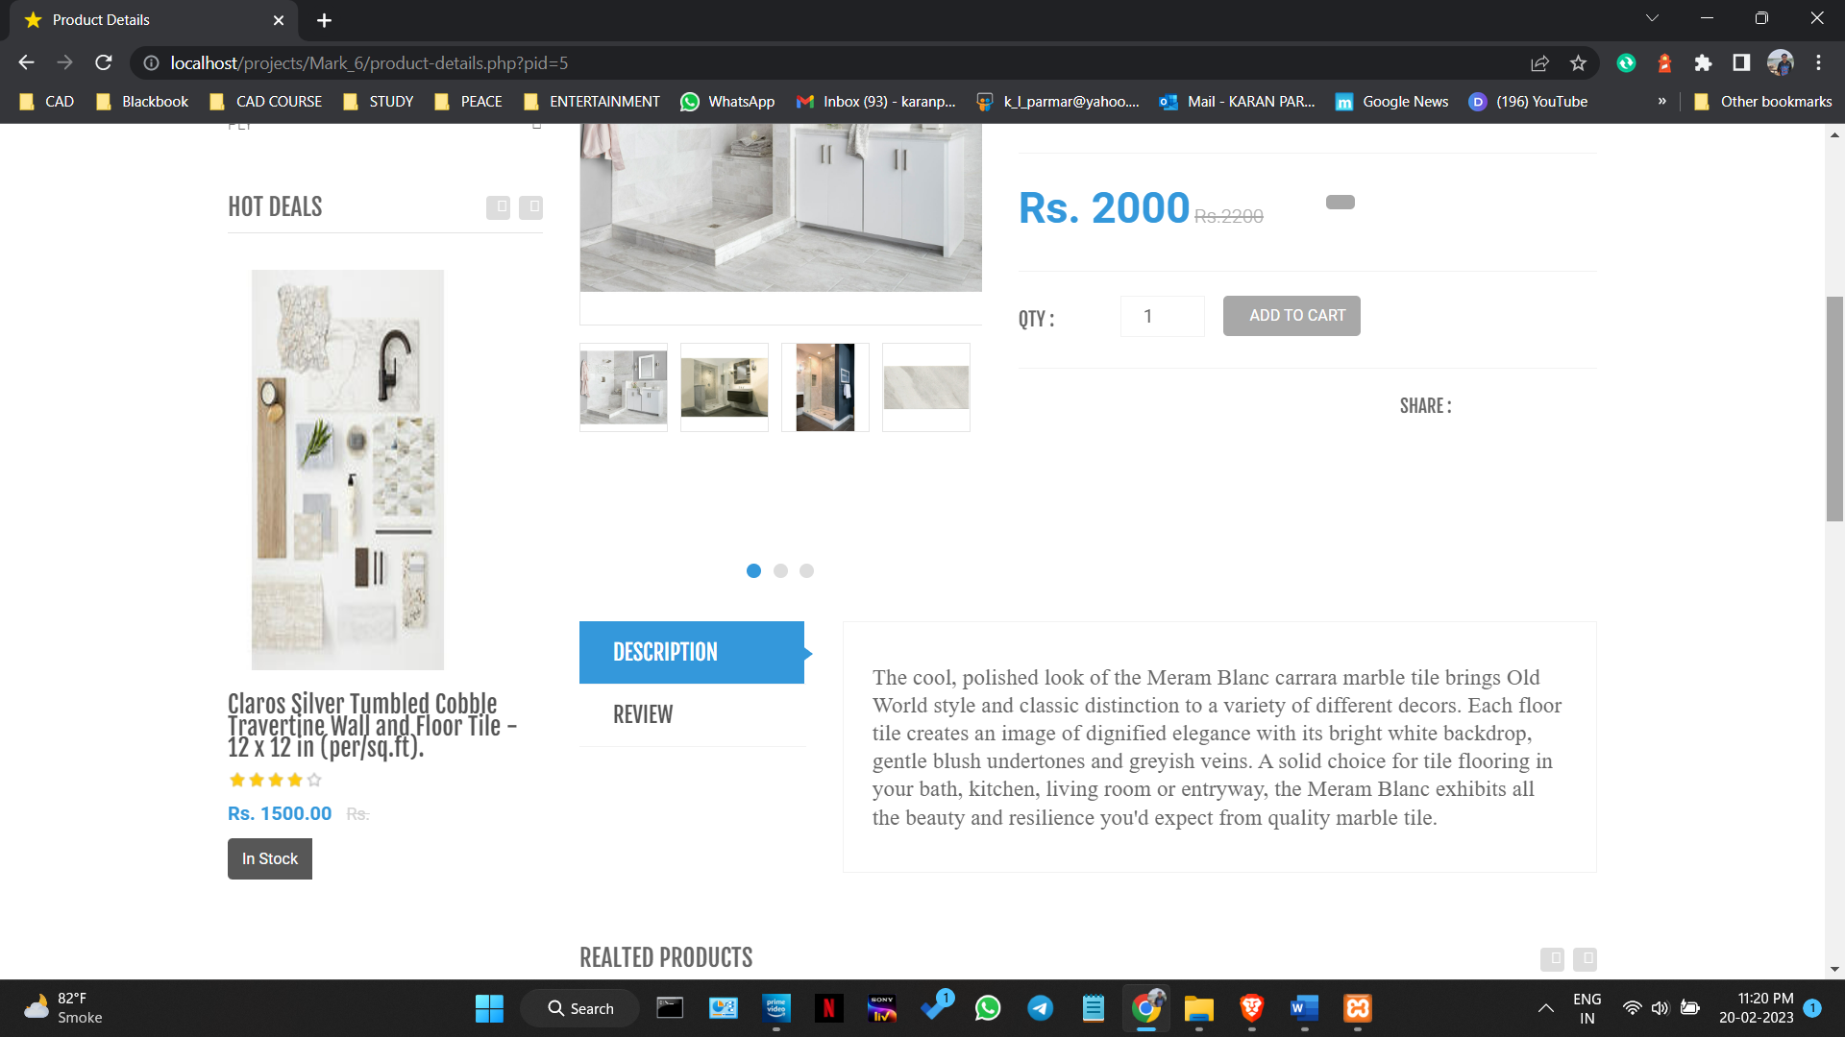

Figure 5.2.4.17

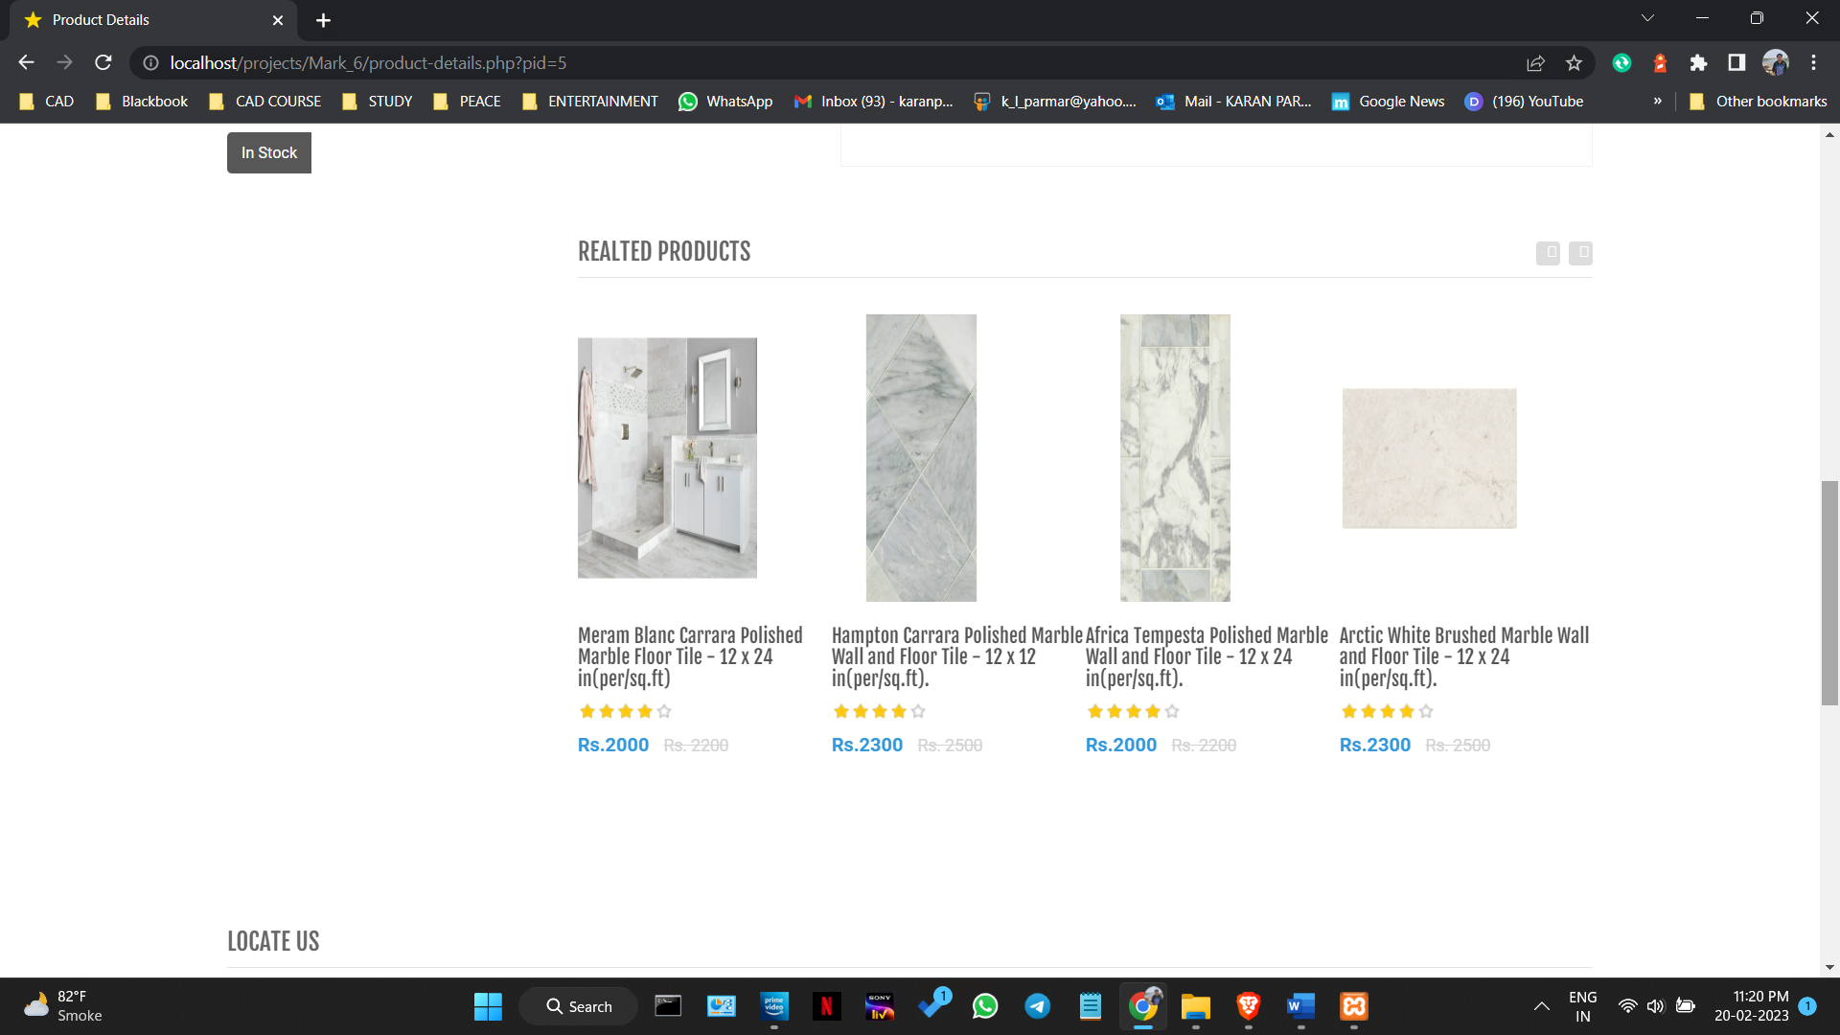

Figure 5.2.4.18

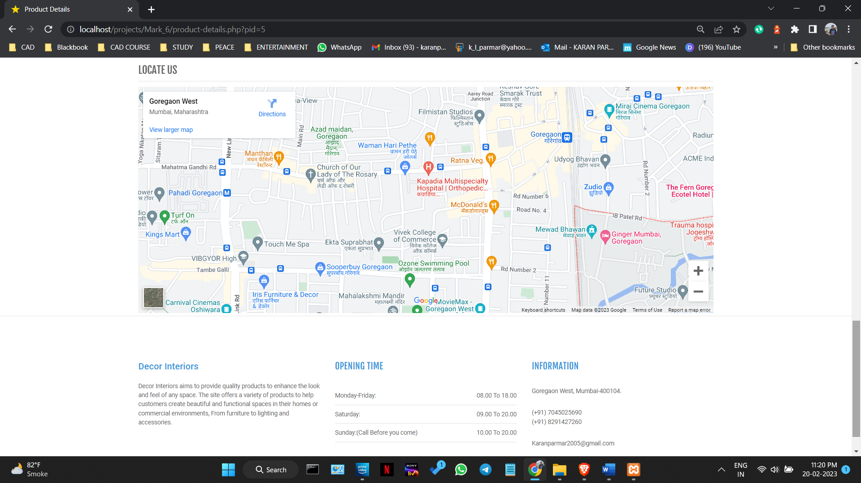

Figure 5.2.4.19

**My-cart.php**

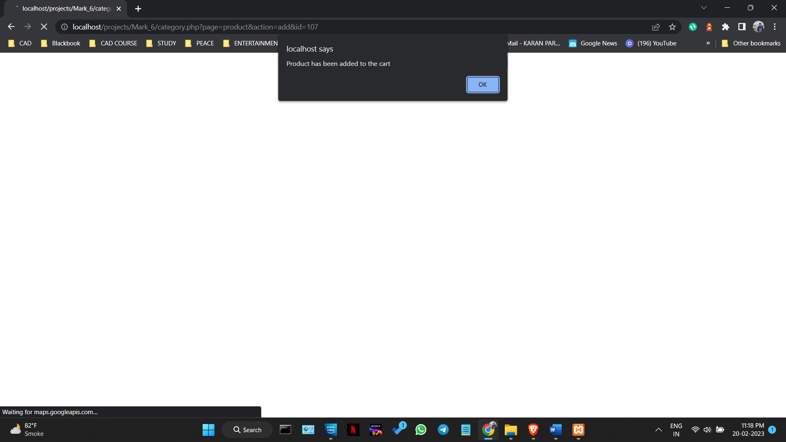

Figure 5.2.4.20

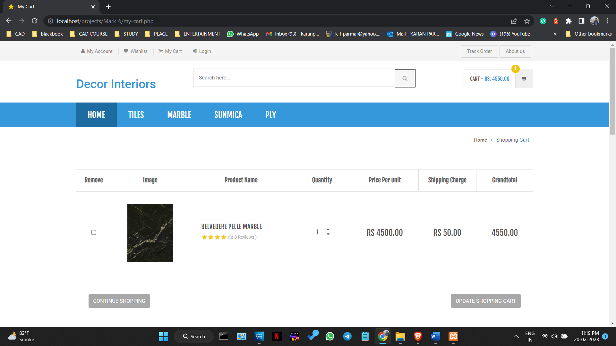

Figure 5.2.4.21

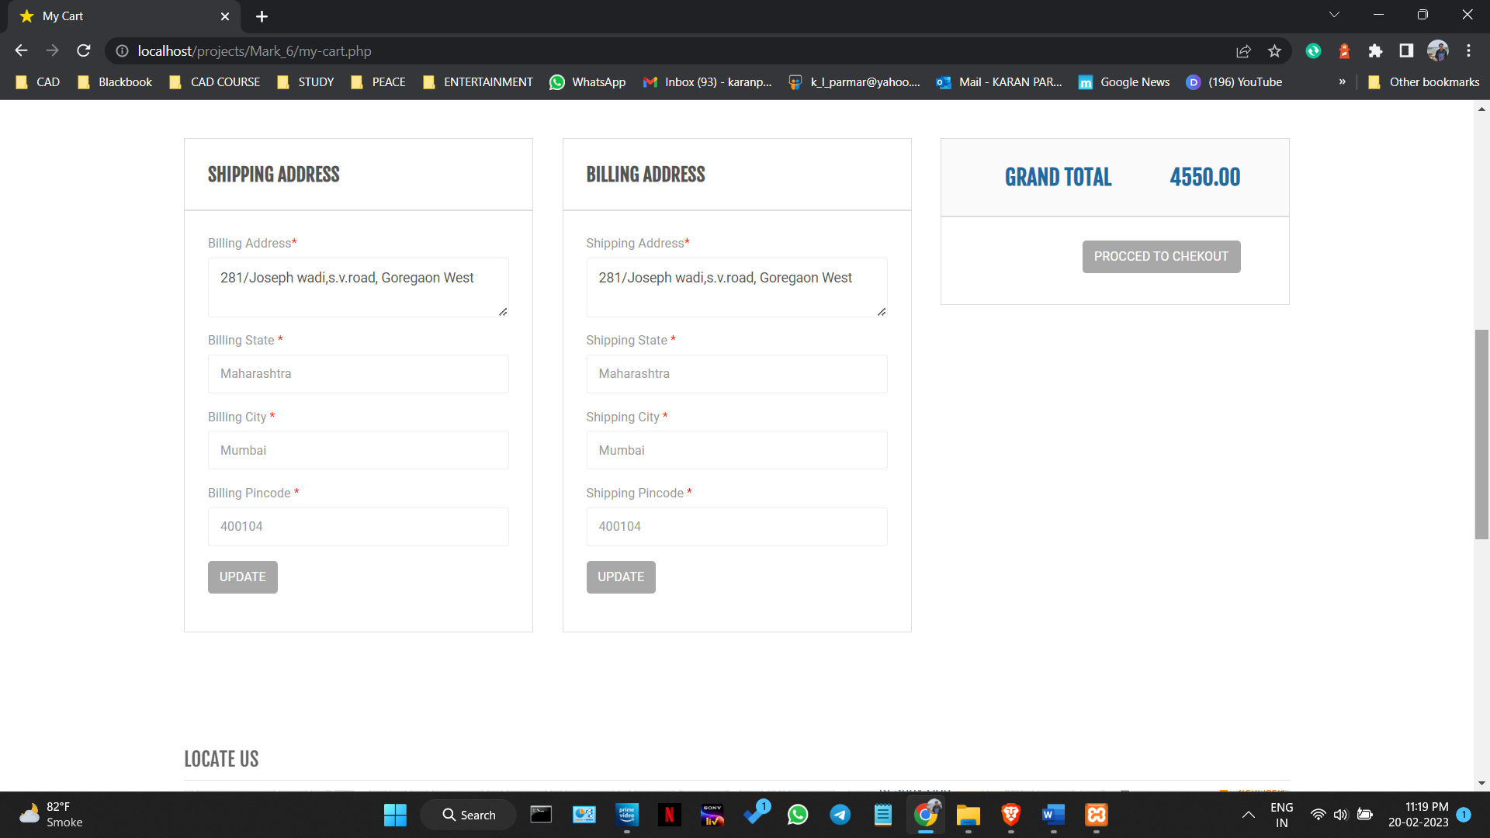

Figure 5.2.4.22

**Payment-method.php**

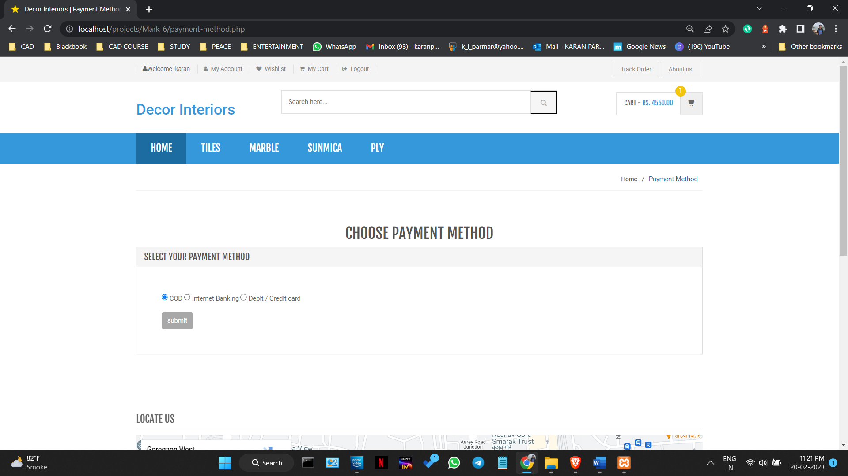

Figure 5.2.4.23

**Track-order.php**

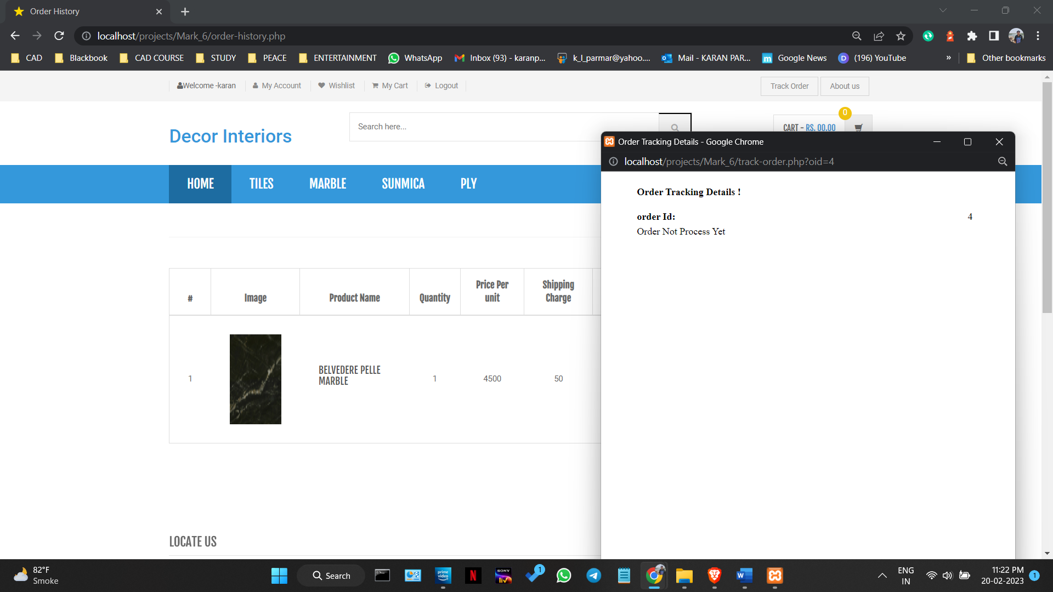

Figure 5.2.4.24

##### b. Code Efficiency

**Décor Interiors -** Website

The efficiency of the code depends on several factors such as the size of the code, the logic used, and the design patterns. The code in this project is designed to be efficient by following best practices in software development. To optimize the PHP code, the following techniques were used:

* Using modular code to make it easier to maintain and update the website.
* Implementing caching techniques to reduce the number of database queries and improve website performance.
* Minimizing the use of global variables to reduce the risk of naming conflicts and improve code readability.
* Using appropriate design patterns and algorithms to minimize the number of database queries and improve website performance.
* Using appropriate database indexing to improve query performance.

**Visual Basic for Applications -** VBA

The VBA code in this project is designed to be effective and efficient by using built-in Excel functions and optimizing loops and conditional statements. The code is in the optimum form and does not contain unnecessary loops or redundant code. To optimize the code, the following techniques were used:

* Using built-in Excel functions such as VLOOKUP and SUMIF to minimize the number of loops and conditional statements needed.
* Using variables to store frequently used values and reduce the number of repeated calculations.
* Avoiding the use of unnecessary loops and conditional statements to minimize the runtime and improve performance.
* Optimizing code logic to minimize the number of API calls and database queries and improve the efficiency of the code.

**Power BI**

The Power BI report in this project is designed to be effective and efficient by using appropriate visualizations, filters, and data models. The report is in the optimum form and does not contain unnecessary visualizations or redundant data models. To optimize the report, the following techniques were used:

* Using appropriate visualizations to represent data in an easily understandable manner.
* Using filters to allow users to easily filter and explore the data.
* Using an efficient data model to ensure fast load times and easy maintenance.

**Jmeter**

The JMeter test script in this project is designed to be effective and efficient by using appropriate test scenarios and parameters. The script is in the optimum form and does not contain unnecessary test scenarios or redundant parameters. To optimize the script, the following techniques were used:

* Using appropriate test scenarios to simulate real-world traffic and ensure that the website can handle high loads.
* Using appropriate parameters such as number of users, ramp-up time, and think time to accurately simulate user behaviour.
* Minimizing the use of unnecessary HTTP requests and adding assertions to ensure that the website is functioning correctly.

##### 5.3 Testing Approach

#### A. Functional Testing

1. User Acceptance Testing or Beta Testing

This will involve testing the entire e-commerce website, including the ordering process, payment gateway, product search, and inventory management. It will also involve testing the VBA-powered Excel form used for offline sales and inventory management. The aim of this testing is to ensure that all functional requirements have been met and that the system is easy to use for end-users.

1. Unit Testing

This will involve testing each unit of code, including modules and classes, to ensure that they are functioning correctly and producing the expected output. This will include testing the VBA macros used in the Excel form and Power BI reports used for data visualization.

1. Integration Testing

This will involve testing the integration of different modules of the e-commerce website and offline sales system, as well as the integration of Power BI reports and JMeter performance testing results. The aim of this testing is to ensure that all the components of the system are working together as expected.

#### b. Non-Functional Testing

1. Performance Testing

This will involve using JMeter to simulate multiple user requests and test the website's response time, throughput, and resource utilization under different loads. The aim of this testing is to identify performance bottlenecks and optimize the system for better performance.

1. Scalability Testing

This will involve testing the ability of the system to handle increased load and scale up or down as per the demand. This will include testing the database, server, and network scalability.

1. Portability Testing

This will involve testing the compatibility of the system with different platforms, devices, and browsers. This will include testing the website and offline sales system on different operating systems, mobile devices, and web browsers.

c. Black Box Testing

This will involve testing the e-commerce website and offline sales system without any knowledge of the internal workings of the system. This will include testing the website's user interface, functionality, and usability.

##### d. White Box Testing

This will involve testing the internal workings of the e-commerce website and offline sales system, including the code, database, and server configurations. This will include testing the VBA macros used in the Excel form, Power BI reports, and JMeter scripts.

Write comparison between black box and white box testing

Black box testing is effective in identifying issues related to the user interface, functionality, and usability of the system. It is useful in testing the system from the perspective of end-users and ensuring that the system meets their requirements.

White box testing is effective in identifying issues related to the internal workings of the system, including the code, database, and server configurations. It is useful in testing the system from the perspective of developers and ensuring that the system is optimized for performance, scalability, and maintainability.

Both black box and white box testing are important in ensuring that the e-commerce website and offline sales system are of high quality, reliable, and easy to use for end-users.

##### 5.4 Test Cases

Table no 5.4.1

|  |  |  |  |  |  |  |
| --- | --- | --- | --- | --- | --- | --- |
| Test ID | Test Case Description | Test Case Input | Expected Output | Actual Output | Date | Result |
| User Module | | | | | | |
| 1 | Incorrect Fullname | User123 | Only alphabets allowed | Invalid username | 10-01-23 | Success |
| 2 | Correct Fullname | User | Username can be accepted | Valid username | 10-01-23 | Success |
| 3 | Incorrect password | 34 | 8 characters, atleast 1 number, 1 uppercse and 1 lowercase | Invalid Password | 10-01-23 | Success |
| 4 | Correct password | User1234, User1234# | Password can be accepted | Valid password | 10-01-23 | Success |
| 5 | Incorrect confirm password | User123 | Confirm password should match with password | Invalid confirm password | 10-01-23 | Success |
| 6 | Correct confirm password | User1234, User1234# | Confirm password can be accepted | Valid confirm password | 11-01-23 | Success |
| 7 | Incorrect email | user.mail.com | "@"and "." should be included | Invalid Email | 11-01-23 | Success |
| -8 | Correct email | user@mail.com, user123@mail.com | Email can be accepted | Valid Email | 11-01-23 | Success |
| 9 | Incorrect contact | 124a543678, 3453124 | 10-digit number allowed | Invalid Contact | 11-01-23 | Success |
| 10 | Correct contact | 1234567890 | Contact can be accepted | Valid Contact | 11-01-23 | Success |
| 11 | Empty input field | ""(empty string) | All field should be | Can’t be submitted | 11-01-23 | Success |
| 12 | Filled field | ""(any string ) | All fields can be accepted | Can’t be submitted | 12-01-23 | Success |
| 13 | Quantity | 1 to 10 | Maximum 10 quantities only allowed | Can proceed | 12-01-23 | Success |

Table no 5.4.2

|  |  |  |  |  |  |  |
| --- | --- | --- | --- | --- | --- | --- |
| Test ID | Test Case Description | Test Case Input | Expected Output | Actual Output | Date | Result |
| Admin Module | | | | | | |
| 1 | Incorrect username | User | Only admin can login | Invalid username | 12-01-2023 | Success |
| 2 | Correct username | admin | Username can be accepted | Valid username | 13-01-2023 | Success |
| 3 | Incorrect password | user1234 | Only admin can login | Invalid password | 13-01-2023 | Success |
| 4 | Correct password | [Test@123](mailto:Test@123) | Password can be accepted | Valid password | 13-01-2023 | Success |
| 5 | Incorrect product price | Abc | Only valid price allowed(numbers) | Invalid Price | 13-01-2023 | Success |
| 6 | Correct product price | 2999 | Price can be accepted | Valid Price | 14-01-2023 | Success |
| 7 | Incorrect discounted product price | Abc | Only valid price allowed(numbers) | Invalid price | 14-01-2023 | Success |
| 8 | Correct discounted product price | 1999 | Price can be accepted | Valid Price | 14-01-2023 | Success |
| 9 | Invalid product quantity | abc, 11.5 | Only valid quantity allowed | Invalid product quantity | 14-01-2023 | Success |
| 10 | Valid product quantity | 500 | Product quantity can be accepted | Valid product quantity | 15-01-2023 | Success |
| 11 | Invalid product image | abc, 10 | Only valid rating allowed (1-5) | Invalid Rating | 15-01-2023 | Success |
| 12 | Valid product image | 4, 3.5 | Rating can be accepted | Valid Rating | 15-01-2023 | Success |
| 13 | Invalid product image | .txt, .dox, .docx, pdf (extension) |  | Invalid product image | 15-01-2023 | Success |
| 14 | Valid product image | .png, .jpg, .jpeg | Product image can be accepted | Valid Product Image | 15-01-2023 | Success |

##### 5.5 Modification and Expected Improvements

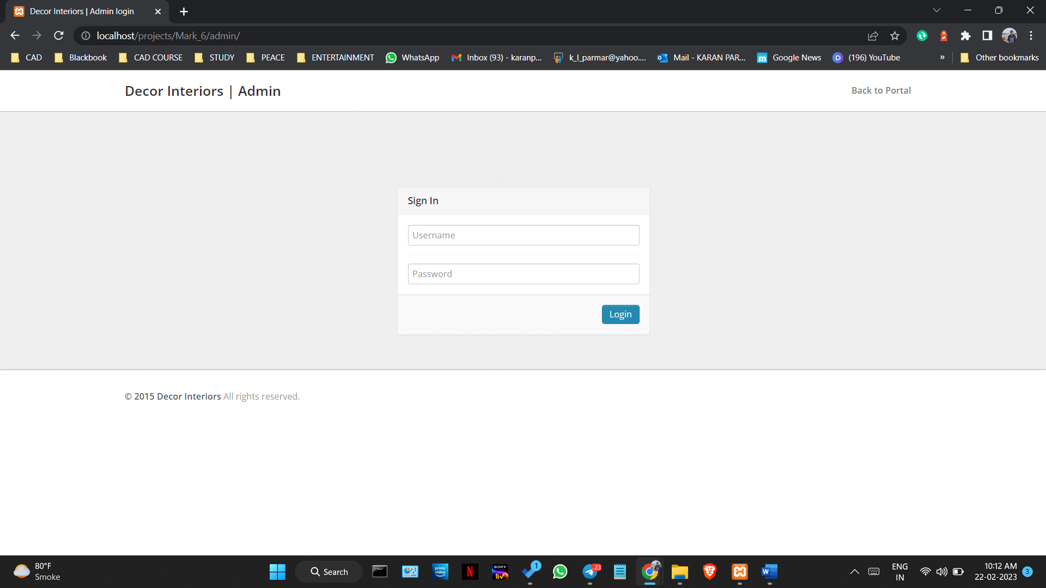

Figure 5.5.1

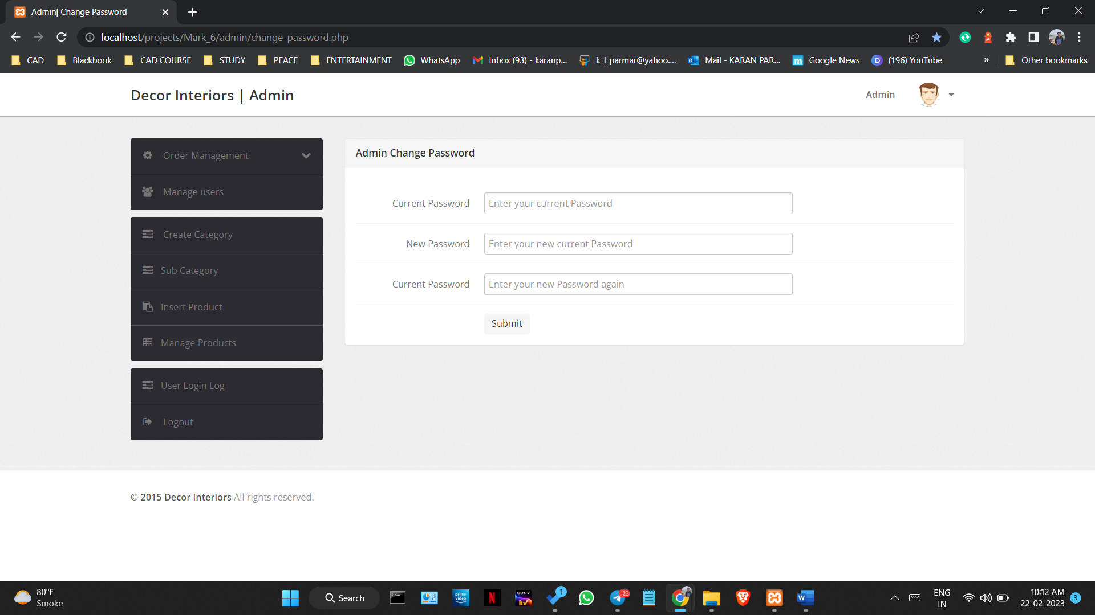

Figure 5.5.2

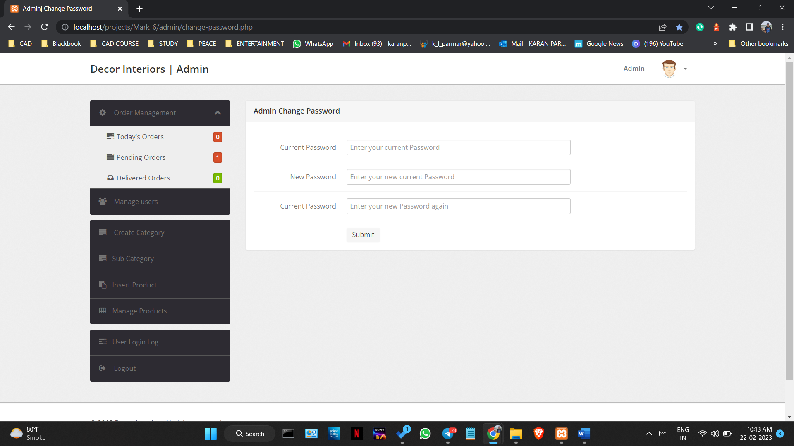

Figure 5.5.3

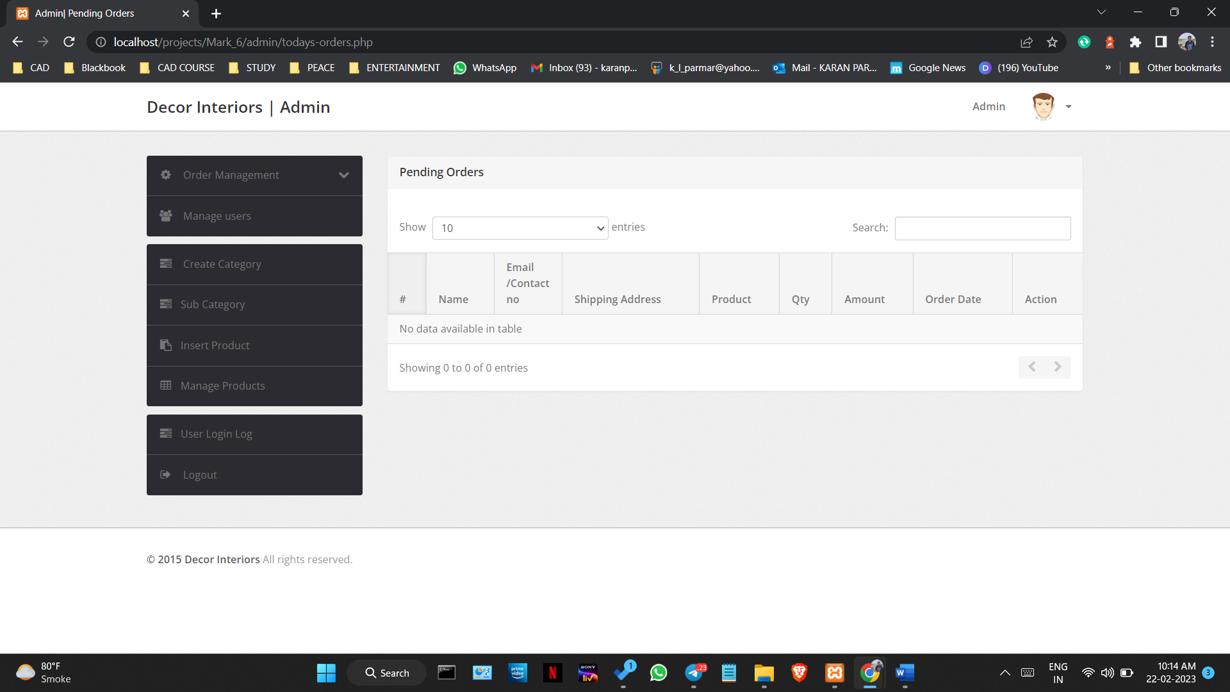

Figure 5.5.4

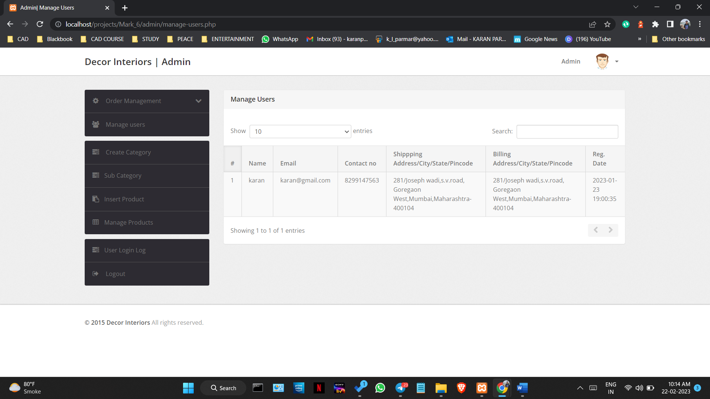

Figure 5.5.5

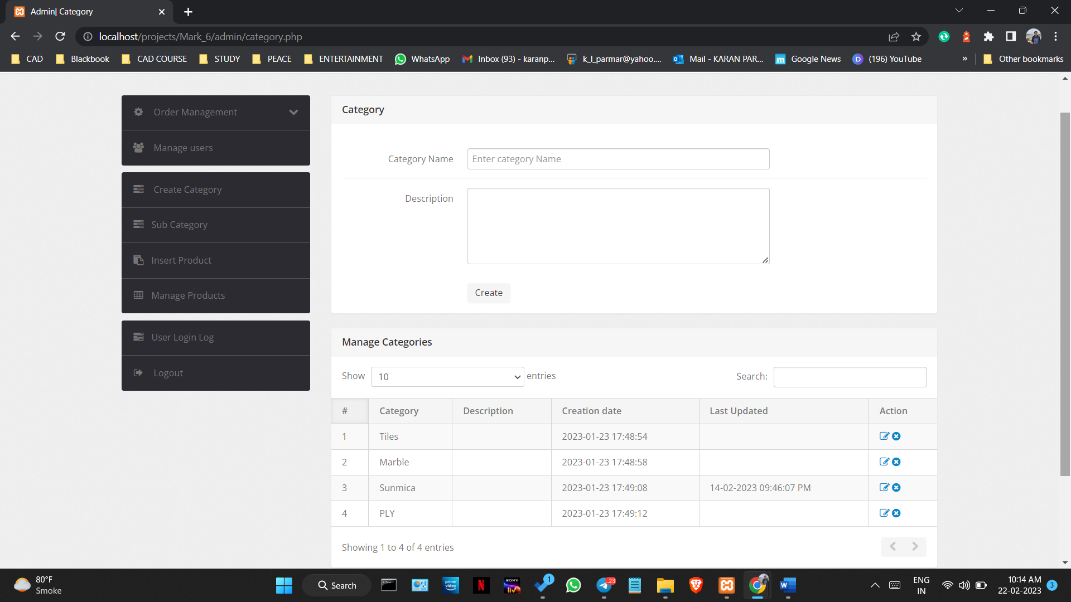

Figure 5.5.6

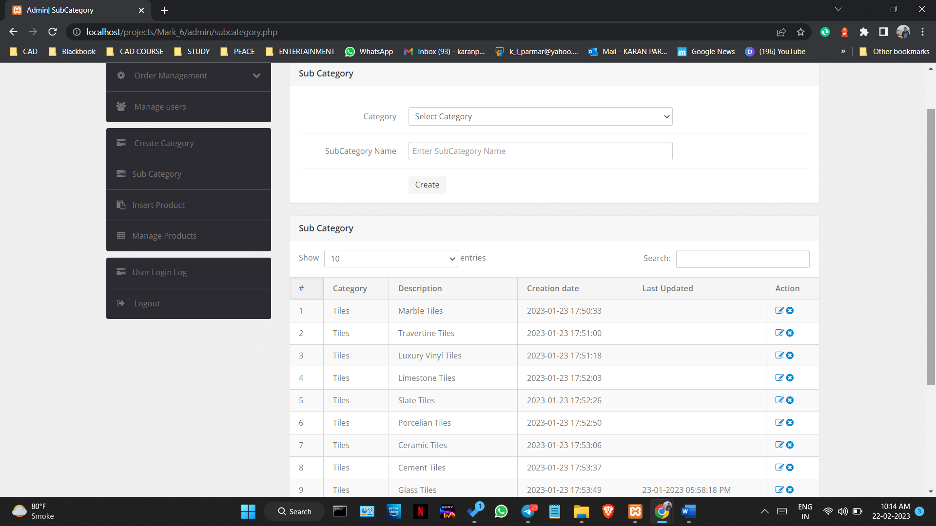

Figure 5.5.7

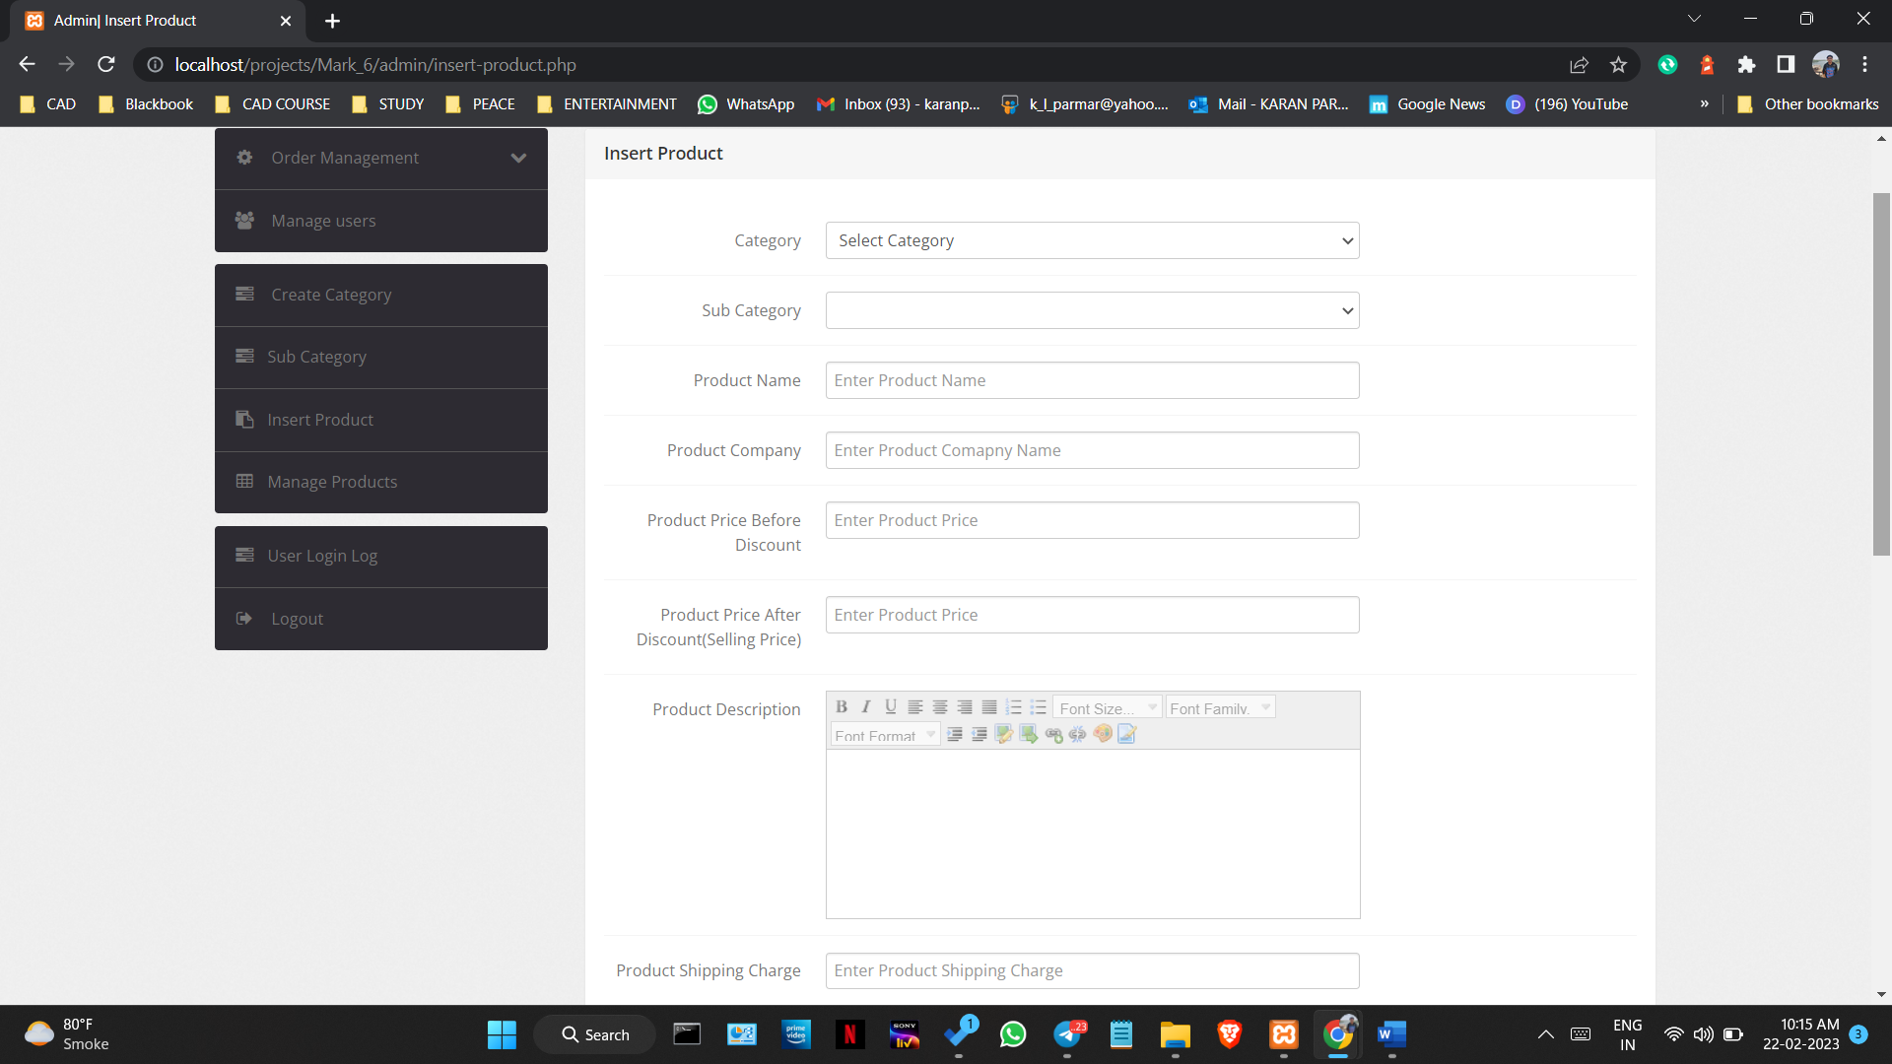

Figure 5.5.8

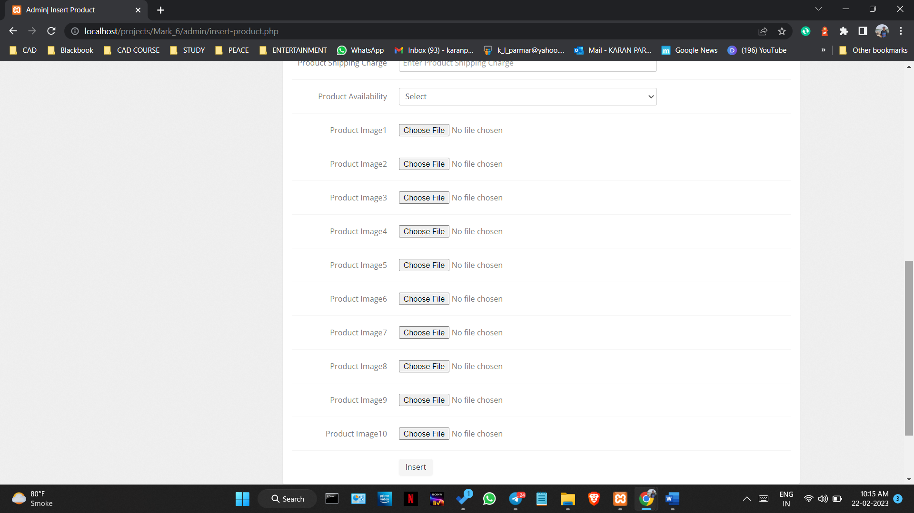

Figure 5.5.9

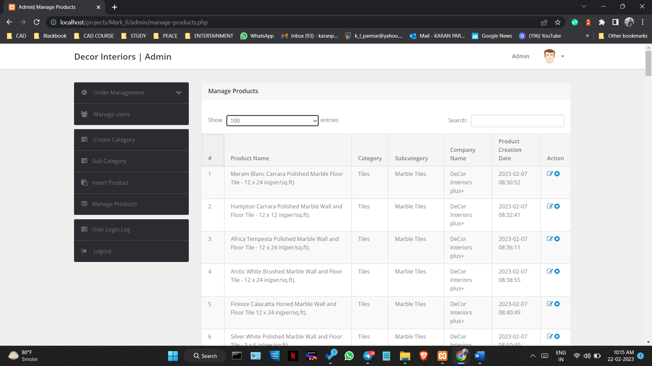

Figure 5.5.10

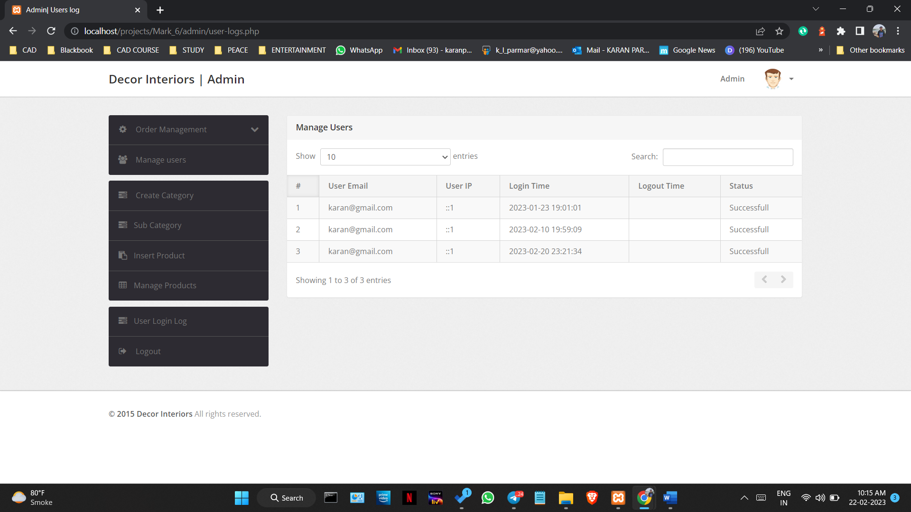

Figure 5.5.11

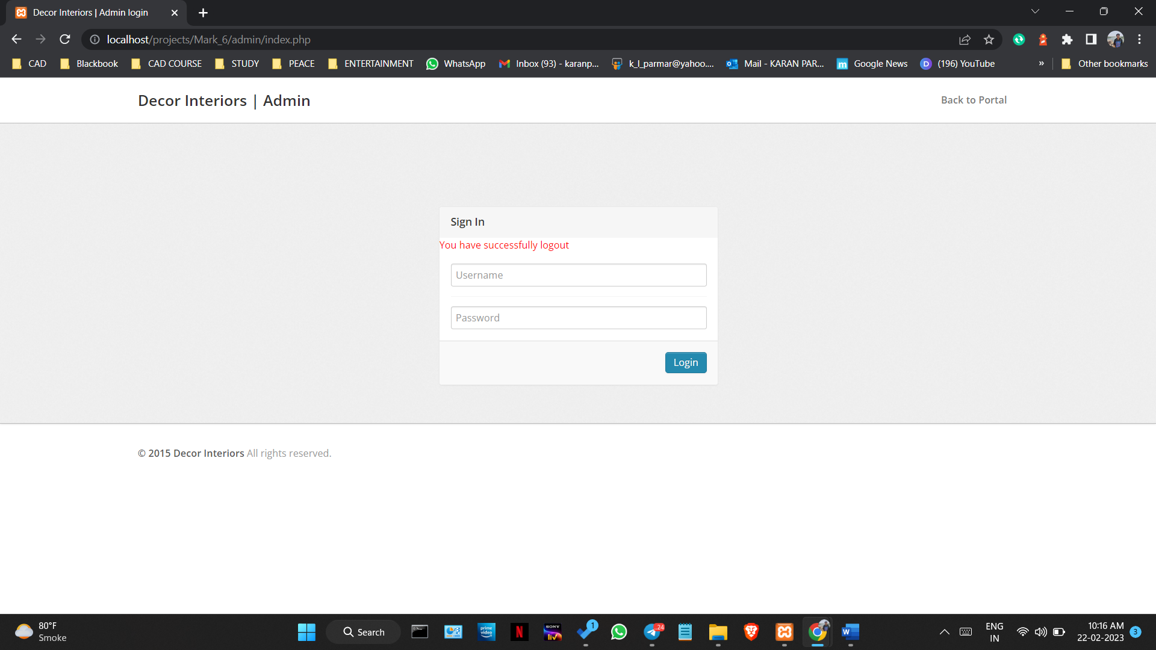

Figure 5.5.12

#### CHAPTER 6: RESULTS AND DISCUSSIONS

##### 6.1. Test Reports

Table no 6.1.1

|  |  |  |
| --- | --- | --- |
| Test Scenario Description | Outcome | Result |
| Home Page Report, Registration Page Report & Login Page Report | | |
| Clicking on Tiles categories option | Redirect to the Tiles category page (all tiles related products are displayed for purchase) | Pass |
| Clicking on Tiles subcategories option | Redirect to the tiles subcategory page (all tiles related products are displayed for purchase) | Pass |
| Clicking on Marble categories option | Redirected to the marble category page (all Marble related products are displayed for purchase) | Pass |
| Clicking on Marble subcategories option | Redirected to the marble subcategory page (all Marble related products are displayed for purchase) | Pass |
| Clicking on Sunmica categories option | Redirect to the Sunmica category page (all Sunmica related products are displayed for purchase) | Pass |
| Clicking on Sunmica subcategories option | Redirect to the Sunmica subcategory page (all Sunmica related products are displayed for purchase) | Pass |
| Clicking on PLY categories option | Redirect to the PLY category page (all PLY related products are displayed for purchase) | Pass |
| Clicking on PLY subcategories option | Redirect to the PLY subcategory page ( all PLY related products are displayed for purchase ) | Pass |
| the credentials entered in each field are valid | the user is successfully registered in the database and the new user is logged in | Pass |
| click the register button | Redirected to the login page | Pass |
| credentials entered are valid | the user is logged in | Pass |
| click the login button | Redirected to the login and log out page | Pass |
| click the log out button | Redirected again to login page and the user is logged out | Pass |

Table no 6.1.2

|  |  |  |  |
| --- | --- | --- | --- |
|  | Executed | Passed | Failed |
| No. of Test Cases | 44 | 44 | 0 |

##### 6.2 User Documentation

Here is a step-by-step guide on how to use your e-commerce website and the offline form:

1. Accessing the website: To access the website, open your web browser and enter the website's URL in the address bar. The website's homepage will appear, providing you with a list of available products. You can browse the products, add them to your cart, and proceed to checkout.
2. Searching for products: You can use the search bar to search for products by typing the product name, category, or any keyword related to the product.
3. Adding products to the cart: To add a product to the cart, click on the "Add to cart" button located on the product's page. The product will be added to your cart, and you can view the items in your cart by clicking on the "Cart" icon located in the top right corner of the page.
4. Updating the cart: You can update your cart by changing the quantity of a product or removing a product from the cart. To change the quantity, click on the plus or minus button next to the product's quantity, and the total price will be updated automatically. To remove a product from the cart, click on the "Remove" button located next to the product's name.
5. Proceeding to checkout: Once you have added all the desired products to your cart, click on the "Checkout" button located in the cart page. You will be prompted to enter your personal information, shipping address, and payment details.
6. Making payment: To make payment, select your preferred payment method and enter your payment details. The website supports various payment options, including credit/debit card and PayPal. After entering your payment details, click on the "Place Order" button. The website will process your order, and you will receive a confirmation email with the order details and delivery information.
7. Using the offline form: In case you buy a product from the physical store, the seller will provide you with an offline form to record your purchase. To record your purchase, fill in the details such as product name, price, quantity, and customer name in the respective columns of the offline form.
8. Integrating the data: The offline data will be integrated with the online data using PowerBI, which will provide a detailed report on the sales and revenue generated by the website and the physical store.
9. Analyzing the data: The data can be analyzed using the various visualizations and reports generated by PowerBI. The reports will provide insights into the sales trends, customer behaviour, and revenue generated by the online website and the physical store.
10. Testing the website: The website's performance can be tested using JMeter, which will check the website's speed and responsiveness under different traffic conditions.

##### 6.3 Cost Estimation

The project involves the development of an e-commerce website that sells tiles, marble, ply, sunmica online, and an offline Visual Basic Form using Excel for recording data from the physical store. In addition, the project also involves the integration of data from both online and offline sources using PowerBI for data analysis and representation. Lastly, JMeter will be used to test the performance of the website.

* **Key Parameter** 
  + 1. Efforts - measured in person months units
       1. Total Effort Applied = 2 x 4 = 8 person-months
    2. Schedule - measured in span of months or weeks
       1. project was completed by a team of 2 people and took 4 months

To estimate the effort and development time, COCOMO uses the same equations but with different coefficients (a, b, c, d in the effort and schedule equations) for each development mode. Types are as follows:

* Organic System
* Semi - detached System
* Embedded System

The coefficient ab, bb, cb and db are given in the following table: 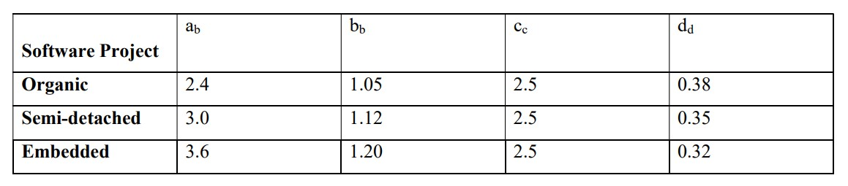

The basic COCOMO equations take the form

* Effort Applied (E) = ab (KLOC) bb [person-months]
* Development Time (D) = cb (Effort Applied) db [months]
* People Required (P) = Effort Applied / Development time [count]
* Where, KLOC is the estimated number of delivered lines (expressed in thousands) of code for a project.
  1. Effort Applied (E) = 2.4 x (1000) ^1.05 = 3,307 person-months
  2. Development Time (D) = 2.5 x (3,307) ^0.38 = 10.57 months
  3. People Required (P) = 3,307 / 10.57 = 313 people

**COCOMO Model for “Business Intelligence solutions – Décor interiors”**

Size of project = 1500 lines of code / 1000 = 1.5 KLOC

Effort = 2 staff

Development Efforts = 10,000

months’ Time for development = 4 months Cost per Month = Rs.5000/-

Total Cost of the Project = Cost per Month * Time required for the development project + Development Efforts

= 3000 * 4 + 10000

= Rs. 25,00/-

#### 

#### CHAPTER 7: CONCLUSIONS

##### 7.1 Conclusion

In conclusion, the project successfully developed an integrated e-commerce and offline solution for the building materials industry. The project aims to provide customers with an easy and convenient way to purchase building materials while also supporting traditional brick-and-mortar stores. The website developed as part of the project allows customers to browse and purchase building materials online, while the offline component of the project enables traditional stores to manage their inventory and sales.

The project was developed by utilizing various software tools and technologies, including Excel, SQL Server, HTML, and JavaScript. The website was designed with user-friendliness in mind and features an intuitive interface that enables customers to browse products, place orders, and make payments with ease. The offline component of the project was designed to be easily integrated with existing store systems, enabling store owners to manage their inventory and sales with minimal disruption.

One of the key benefits of the project is that it enables traditional stores to reach a wider audience by offering an online platform for customers to browse and purchase products. At the same time, the project supports traditional stores by enabling them to manage their inventory and sales using existing systems. This approach allows traditional stores to continue to operate in the same manner they always have, while also taking advantage of the benefits of e-commerce.

While the project has been successful in achieving its objectives, there are several areas in which it could be improved in the future. For example, the project could be expanded to include a wider range of building materials and related products, thereby increasing the range of products available to customers. Additionally, the project could be improved by incorporating more advanced data analysis and reporting tools, which could provide greater insights into customer behaviour and preferences.

In terms of future prospects, the project has the potential to be a game-changer in the building materials industry. The project has already attracted interest from various stakeholders in the industry, and there is significant potential for the project to be further developed and enhanced with additional research and funding. The project could also be extended to other related industries, such as interior design and home décor.

In conclusion, the project has successfully developed an integrated e-commerce and offline solution for the building materials industry. The project has the potential to transform the way in which customers purchase building materials and support traditional brick-and-mortar stores. While there are some limitations and areas for improvement, the project has laid the foundation for further research and development in the future. Overall, the project represents a significant step forward in the development of e-commerce and offline solutions for the building materials industry.

##### 7.2 Limitations

* Limitation 1: Limited Market Reach
* Description: The e-commerce website and offline market solution developed in this project may have limited market reach, especially in areas where internet connectivity is limited. This limitation can affect the number of potential customers and the overall growth of the business.
* Limitation 2: Limited Product Range
* Description: The project focuses on a specific set of products such as tiles, marble, ply, and sunmica. This limitation may affect the overall success of the project as potential customers may be looking for other related products that are not currently available on the website or in the offline market.
* Limitation 3: Integration with third-party platforms
* Description: The project does not integrate with third-party e-commerce platforms, which limits its usability for businesses already using such platforms.
* Limitation 4: Lack of mobile responsiveness
* Description: The current version of the online website is not optimized for mobile devices, which may affect user experience for a large portion of potential customers.
* Limitation 5: Limited offline data analysis capabilities
* Description: While the project includes an offline component for recording data, the analysis of this data is limited by the capabilities of Excel. Implementing a more robust data analysis system could enhance the usefulness of this data.
* Limitation 6: Limited payment options
* Description: The project offers limited payment options to customers, which may limit its appeal to potential customers who prefer other payment methods.
* Limitation 7: Limited marketing strategy
* Description: The project does not have a robust marketing strategy in place, which may limit its ability to reach potential customers and grow the business.
* Limitation 8: Limited customer support
* Description: The project currently has limited customer support options, which may affect its ability to retain customers and provide quality service.

##### 7.3 Future Scope of the Project

What is the future of your project?

The future of this project is promising, given the growing demand for online marketplaces and the need for a more streamlined approach to the construction industry. With further development and marketing efforts, the project has the potential to expand its customer base and gain a significant share of the market.

What is it that you have not included in the project but can be done at a later date?

There are several areas that were not included in the project but can be explored at a later date. For example, integrating the platform with more advanced technologies such as artificial intelligence and machine learning can improve the accuracy of data analysis and prediction of consumer behaviour. Additionally, expanding the product range to include other building materials and services, such as interior design and landscaping, could increase the scope of the project.

How can this project be extended with more research and funding maybe?

The project can be extended with more research and funding to enhance its features and capabilities. For example, incorporating a feature for virtual reality visualization of the products and designs can provide customers with a more immersive and engaging experience. Furthermore, investing in digital marketing and search engine optimization can improve the visibility and reach of the platform, resulting in increased sales and revenue.

List the factors from your project that you think can be modified for enhancement and future research

* Improving the user interface and user experience of the website to make it more intuitive and user-friendly.
* Incorporating a more robust and scalable data analysis system to provide better insights and intelligence on customer behaviour and preferences.
* Adding a feature for user-generated reviews and ratings of products and services to enhance trust and credibility.
* Developing a mobile application for the platform to cater to the growing number of users accessing the internet through mobile devices.
* Establishing partnerships with other businesses and service providers in the construction industry to offer a more comprehensive solution for customers.

### REFERENCES

1. "Building an E-Commerce Website: 8 Technical Aspects You Need to Know" by Pratik Shah (https://www.entrepreneur.com/article/295574): This article provides an overview of the technical aspects of building an e-commerce website, including selecting the right platform, designing a user-friendly interface, and implementing payment and shipping solutions.
2. "How to Build an E-Commerce Website: A Step-by-Step Guide" by Rameez Ramzan (https://www.hostinger.com/tutorials/how-to-build-an-ecommerce-website): This article provides a detailed step-by-step guide to building an e-commerce website, including selecting a domain name, choosing a platform, designing the website, and optimizing for search engines.
3. "Creating an E-Commerce Website with Visual Basic" by Kevin Roebuck (https://www.codeguru.com/csharp/csharp/cs_network/sockets/article.php/c19681/Creating-an-ECommerce-Website-with-Visual-Basic.htm): This article provides a tutorial for using Visual Basic to create an e-commerce website, including managing orders, inventory, and customer accounts.
4. "Power BI Tutorial: A Complete Overview for Beginners" by Guru99 (https://www.guru99.com/power-bi-tutorial.html): This tutorial provides an overview of using Power BI to visualize and analyze data, including connecting to data sources, creating dashboards, and sharing reports.
5. "JMeter Tutorial: How to Load Test a Web Application" by Guru99 (https://www.guru99.com/jmeter-tutorial.html): This tutorial provides an overview of using JMeter to test the performance of a web application, including configuring test plans, generating load, and analyzing results.

### ANNEXURE I

### Coding

Power BI Code:

Revenue = (‘Data (2)'[Sale Price] * 'Data (2)'[Order Quantity])

StatusD = IF( 'Data (2)'[Status] == "Delivered", "True", "False")

Measures: -

Avg. Star Ratings = AVERAGE (‘Data (2)'[Rating])

Delivery Time = (CALCULATE(COUNTROWS('Calendar'), DATESBETWEEN('Calendar'[Date], 'Data (2)'[OrderDate],'Data (2)'[Delivery Date] -1)))

Star Rating = REPT (UNICHAR (11088), [Avg. Star Ratings])

Calendar Table Formulas

Calendar = CALENDARAUTO ()

Day = FORMAT('Calendar'[Date], "DDD")

Day No = DAY('Calendar'[Date])

Measure 2 = SELECTEDVALUE ('Data (2)'[Status]) & UNICHAR (10) & SELECTEDVALUE ('Data (2)'[Status])

Month = FORMAT('Calendar'[Date], "MMM")

Month No = MONTH('Calendar'[Date])

Year = YEAR('Calendar'[Date])

Visual Basic for Applications (VBA) Code:

Option Explicit

'''''''''''''''''''''Initialization'''''''''''''''

Private Sub UserForm_Initialize()

cmbClass.List = Array("Express", "Standard Delivery", "Shipped Abroad")

cmbPreClass.List = Array(1, 2, 3, 4, 5)

txtLastResults.List = Array("ONLINE", "OFFLINE")

Me.txtDate.Value = Format(Date, "YYYY-MMM-D")

With txtRN

.Value = Format(Val(Range("B" & Rows.Count).End(xlUp)) + 1, "0000")

.Enabled = True

End With

Me.txtDOD.Value = "YYYY-MMM-D"

Me.txtDOD.ForeColor = RGB(217, 217, 217)

Me.txtSearch.Value = "Enter ID"

Me.txtSearch.ForeColor = RGB(217, 217, 217)

txtSname.SetFocus

End Sub

Private Sub txtDOD_Enter()

If Me.txtDOD.Value = "YYYY-MMM-D" Then

Me.txtDOD.Value = ""

Me.txtDOD.ForeColor = RGB(0, 0, 0)

End If

End Sub

Private Sub txtDOD_Exit(ByVal Cancel As MSForms.ReturnBoolean)

If Me.txtDOD.Value = "" Then

Me.txtDOD.Value = "YYYY-MMM-D"

Me.txtDOD.ForeColor = RGB(217, 217, 217)

End If

End Sub

Private Sub txtSearch_Enter()

If Me.txtSearch.Value = "Enter ID" Then

Me.txtSearch.Value = ""

Me.txtSearch.ForeColor = RGB(0, 0, 0)

End If

End Sub

Private Sub txtSearch_Exit(ByVal Cancel As MSForms.ReturnBoolean)

If Me.txtSearch.Value = "" Then

Me.txtSearch.Value = "Enter R.N."

Me.txtSearch.ForeColor = RGB(217, 217, 217)

End If

End Sub

'''''''''''''''''Validation'''''''''''''''''

Private Sub txtSname_KeyPress(ByVal KeyAscii As MSForms.ReturnInteger)

If (KeyAscii >= 65 And KeyAscii <= 90 Or KeyAscii >= 97 And KeyAscii <= 122 Or KeyAscii = 32) Then

KeyAscii = KeyAscii

Else

KeyAscii = 0

End If

End Sub

Private Sub txtPhone1_KeyPress(ByVal KeyAscii As MSForms.ReturnInteger)

If (KeyAscii >= 48 And KeyAscii <= 57) Then

KeyAscii = KeyAscii

Else

KeyAscii = 0

End If

End Sub

Private Sub txtPhone2_KeyPress(ByVal KeyAscii As MSForms.ReturnInteger)

If (KeyAscii >= 48 And KeyAscii <= 57) Then

KeyAscii = KeyAscii

Else

KeyAscii = 0

End If

End Sub

''''''''Reset Function''''''''''''''

Function Reset()

Dim ctl As Control

For Each ctl In Me.Controls

Select Case TypeName(ctl)

Case "TextBox"

ctl.Value = ""

Case "OptionButton"

ctl.Value = False

Case "ComboBox"

ctl.ListIndex = -1

End Select

Next ctl

Me.imgCustomer.Picture = LoadPicture("")

End Function

''''''''''''''''''''' Upload Photo''''''''''''''''

Private Sub cmdUpload_Click()

Dim Pic_Path As String

Pic_Path = Application.GetOpenFilename(FileFilter:="JPG images, *.jpg, Bitmap Files, *.bmp", _

Title:="Please select an image", MultiSelect:=False)

If Dir(Pic_Path) <> "" Then

Me.txtImageURL.Value = Pic_Path

Me.imgCustomer.Picture = LoadPicture(Pic_Path)

End If

End Sub

'''''''''''''''''''' Save Button '''''''''''''''''''

Private Sub cmdSave_Click()

Dim sh As Worksheet

Set sh = ThisWorkbook.Sheets("Registration")

Dim lr As Long

lr = sh.Range("B" & Rows.Count).End(xlUp).Row

'''''''''''''''Validation'''''''''''''''

If Me.txtSname.Value = "" Then

MsgBox "Please enter the Cutomer name", vbOKOnly + vbInformation

Exit Sub

End If

If Me.cmbClass.Value = "" Then

MsgBox "Please enter the Class", vbOKOnly + vbInformation

Exit Sub

End If

If Application.WorksheetFunction.CountIf(sh.Range("B:B"), Me.txtRN.Text) > 0 Then

MsgBox "Data already exist!!!", vbOKOnly + vbInformation, "Error"

Exit Sub

End If

'''''''''''''''''Add Data in Excel Sheet'''''''''''''

If MsgBox("Do you want to add data to worksheet?", vbYesNo + vbQuestion, "Question") = vbNo Then

Exit Sub

End If

With sh

.Cells(lr + 1, "B").Value = Me.txtRN.Value

.Cells(lr + 1, "C").Value = Me.txtDate.Value

.Cells(lr + 1, "D").Value = Me.txtSname.Value

.Cells(lr + 1, "E").Value = Me.txtDOD.Value

If optMale.Value = True Then

.Cells(lr + 1, "F").Value = "Male"

End If

If optFemale.Value = True Then

.Cells(lr + 1, "F").Value = "Female"

End If

.Cells(lr + 1, "G").Value = Me.cmbClass.Value

.Cells(lr + 1, "H").Value = Me.txtReligion.Value

.Cells(lr + 1, "I").Value = Me.txtSkills.Value

.Cells(lr + 1, "J").Value = Me.txtFname.Value

.Cells(lr + 1, "K").Value = Me.txtFQ.Value

.Cells(lr + 1, "L").Value = Me.txtFO.Value

.Cells(lr + 1, "M").Value = Me.txtMname.Value

.Cells(lr + 1, "N").Value = Me.txtMQ.Value

.Cells(lr + 1, "O").Value = Me.txtMO.Value

.Cells(lr + 1, "P").Value = Me.txtProductName.Value

.Cells(lr + 1, "Q").Value = Me.cmbPreClass.Value

.Cells(lr + 1, "R").Value = Me.txtLastResults.Value

.Cells(lr + 1, "S").Value = Me.txtTA.Value

.Cells(lr + 1, "T").Value = Me.txtPA.Value

.Cells(lr + 1, "U").Value = Me.txtPhone1.Value

.Cells(lr + 1, "V").Value = Me.txtPhone2.Value

.Cells(lr + 1, "W").Value = Me.txtEmail1.Value

.Cells(lr + 1, "X").Value = Me.txtEmail2.Value

End With

'''''''''''''''Add Image''''''''''''''''

On Error Resume Next

Dim img As String

If Dir(ThisWorkbook.Path & Application.PathSeparator & "Student_Images", vbDirectory) = "" Then

MkDir (ThisWorkbook.Path & Application.PathSeparator & "Student_Images")

End If

img = ThisWorkbook.Path & Application.PathSeparator & "Student_Images" & _

Application.PathSeparator & Format(Me.txtRN.Value) & ".jpg"

FileCopy Me.txtImageURL, img

sh.Cells(lr + 1, "Y").Value = img

Call Reset

Call UserForm_Initialize

End Sub

''''''''''''''''Reset Button''''''''''''''''''''''''

Private Sub cmdReset_Click()

If MsgBox("Do you want to Reset this form?", vbYesNo + vbQuestion + vbDefaultButton1, "Question") = vbYes Then

Call Reset

Call UserForm_Initialize

txtSname.SetFocus

End If

End Sub

''''''''''''''''''''''Exit Button''''''''''''''''''''''

Private Sub cmdExit_Click()

If MsgBox("Do you want to exit this form?", vbYesNo + vbQuestion + vbDefaultButton1, "Question") = vbYes Then

Unload Me

End If

End Sub

'''''''''''''''''''''''''SearchButton''''''''''''''''''''''

Private Sub cmdSearch_Click()

Dim sh As Worksheet

Set sh = ThisWorkbook.Sheets("Registration")

Dim lr As Long

lr = sh.Range("B" & Rows.Count).End(xlUp).Row

Dim i As Long

If Application.WorksheetFunction.CountIf(sh.Range("B:B"), Me.txtSearch.Text) = 0 Then

MsgBox "No match found!!!", vbOKOnly + vbInformation, "Error"

Call Reset

Call UserForm_Initialize

txtSearch.SetFocus

Exit Sub

End If

For i = 4 To lr

If sh.Cells(i, "B").Value = txtSearch.Text Then

txtRN = sh.Cells(i, "B").Value

txtDate = sh.Cells(i, "C").Value

txtSname = sh.Cells(i, "D").Value

txtDOD = sh.Cells(i, "E").Value

If sh.Cells(i, "F").Value = "Male" Then

optMale.Value = True

End If

If sh.Cells(i, "F").Value = "Female" Then

optFemale.Value = True

End If

cmbClass = sh.Cells(i, "G").Value

txtReligion = sh.Cells(i, "H").Value

txtSkills = sh.Cells(i, "I").Value

txtFname = sh.Cells(i, "J").Value

txtFQ = sh.Cells(i, "K").Value

txtFO = sh.Cells(i, "L").Value

txtMname = sh.Cells(i, "M").Value

txtMQ = sh.Cells(i, "N").Value

txtMO = sh.Cells(i, "O").Value

txtProductName = sh.Cells(i, "P").Value

cmbPreClass = sh.Cells(i, "Q").Value

txtLastResults = sh.Cells(i, "R").Value

txtTA = sh.Cells(i, "S").Value

txtPA = sh.Cells(i, "T").Value

txtPhone1 = sh.Cells(i, "U").Value

txtPhone2 = sh.Cells(i, "V").Value

txtEmail1 = sh.Cells(i, "W").Value

txtEmail2 = sh.Cells(i, "X").Value

txtImageURL = sh.Cells(i, "Y").Value

If Dir(Me.txtImageURL.Value) <> "" Then

Me.imgCustomer.Picture = LoadPicture(Me.txtImageURL.Value)

End If

End If

Next i

Me.txtDOD.ForeColor = RGB(0, 0, 0)

End Sub

'''''''''''''''''''''Update Button'''''''''''''''''''''''''

Private Sub cmdUpdate_Click()

Dim sh As Worksheet

Set sh = ThisWorkbook.Sheets("Registration")

Dim lr As Long

lr = sh.Range("B" & Rows.Count).End(xlUp).Row

Dim i As Long

'''''''''''''''' Validation '''''''''''''''''''''''''''''

If Me.txtSname.Value = "" Then

MsgBox "Please enter the Customer's name", vbOKOnly + vbInformation

Exit Sub

End If

If Me.cmbClass.Value = "" Then

MsgBox "Please enter the Class", vbOKOnly + vbInformation

Exit Sub

End If

'''''''''''''''Update data to excel file '''''''''''''''''''''

If MsgBox("Do you want to update the data?", vbYesNo + vbQuestion, "Question") = vbNo Then

Exit Sub

End If

For i = 4 To lr

If sh.Cells(i, "B").Value = txtSearch.Text Then

With sh

.Cells(i, "C").Value = Me.txtDate.Value

.Cells(i, "D").Value = Me.txtSname.Value

.Cells(i, "E").Value = Me.txtDOD.Value

If optMale.Value = True Then

.Cells(i, "F").Value = "Male"

End If

If optFemale.Value = True Then

.Cells(i, "F").Value = "Female"

End If

.Cells(i, "G").Value = Me.cmbClass.Value

.Cells(i, "H").Value = Me.txtReligion.Value

.Cells(i, "I").Value = Me.txtSkills.Value

.Cells(i, "J").Value = Me.txtFname.Value

.Cells(i, "K").Value = Me.txtFQ.Value

.Cells(i, "L").Value = Me.txtFO.Value

.Cells(i, "M").Value = Me.txtMname.Value

.Cells(i, "N").Value = Me.txtMQ.Value

.Cells(i, "O").Value = Me.txtMO.Value

.Cells(i, "P").Value = Me.txtProductName.Value

.Cells(i, "Q").Value = Me.cmbPreClass.Value

.Cells(i, "R").Value = Me.txtLastResults.Value

.Cells(i, "S").Value = Me.txtTA.Value

.Cells(i, "T").Value = Me.txtPA.Value

.Cells(i, "U").Value = Me.txtPhone1.Value

.Cells(i, "V").Value = Me.txtPhone2.Value

.Cells(i, "W").Value = Me.txtEmail1.Value

.Cells(i, "X").Value = Me.txtEmail2.Value

End With

'''''''''''''''Update Image''''''''''''''''

On Error Resume Next

Dim img As String

If Dir(ThisWorkbook.Path & Application.PathSeparator & "Student_Images", vbDirectory) = "" Then

MkDir (ThisWorkbook.Path & Application.PathSeparator & "ImagesStudent_Images")

End If

img = ThisWorkbook.Path & Application.PathSeparator & "Student_Images" & Application.PathSeparator _

& Format(Me.txtRN.Value) & ".jpg"

FileCopy Me.txtImageURL, img

sh.Cells(i, "Y").Value = img

End If

Next i

Call Reset

Call UserForm_Initialize

End Sub

'''''''''''''Delete Button''''''''''''''''''''''''

Private Sub cmdDelete_Click()

Dim sh As Worksheet

Set sh = ThisWorkbook.Sheets("Registration")

Dim lr As Long

lr = sh.Range("B" & Rows.Count).End(xlUp).Row

Dim i As Long

If MsgBox("Do you want to delete the data?", vbYesNo + vbQuestion, "Question") = vbNo Then

Exit Sub

End If

For i = 4 To lr

If sh.Cells(i, "B").Value = txtSearch.Text Then

Rows(i).Delete

End If

Next i

Call Reset

Call UserForm_Initialize

End Sub

**Config.php**

<?php

define('DB_SERVER','localhost');

define('DB_USER','root');

define('DB_PASS' ,'');

define('DB_NAME', 'mark_6');

$con = mysqli_connect(DB_SERVER,DB_USER,DB_PASS,DB_NAME);

// Check connection

if (mysqli_connect_errno())

{

 echo "Failed to connect to MySQL: " . mysqli_connect_error();

}

?>

**Index.php**

<!-- php to see products -->

<?php

session_start();

error_reporting(0);

include('includes/config.php');

if (isset($_GET['action']) && $_GET['action'] == "add") {

    $id = intval($_GET['id']);

    if (isset($_SESSION['cart'][$id])) {

        $_SESSION['cart'][$id]['quantity']++;

    } else {

        $sql_p = "SELECT * FROM products WHERE id={$id}";

        $query_p = mysqli_query($con, $sql_p);

        if (mysqli_num_rows($query_p) != 0) {

            $row_p = mysqli_fetch_array($query_p);

            $_SESSION['cart'][$row_p['id']] = array("quantity" => 1, "price" => $row_p['productPrice']);

        } else {

            $message = "Product ID is invalid";

        }

    }

    echo "<script>alert('Product has been added to the cart')</script>";

    echo "<script type='text/javascript'> document.location ='my-cart.php'; </script>";

}

?>

<!-- html code -->

<!DOCTYPE html>

<html lang="en">

<head>

    <!-- Meta -->

    <meta charset="utf-8">

    <meta name="viewport" content="width=device-width, initial-scale=1.0">

    <meta http-equiv="Content-Type" content="text/html; charset=UTF-8">

    <meta name="description" content="">

    <meta name="author" content="">

    <meta name="keywords" content="MediaCenter, Template, eCommerce">

    <meta name="robots" content="all">

    <link rel="shortcut icon" href="assets/images/star-on.png">

    <title>Decor Interiors Home Page</title>

    <!--CSS for alignmet of page and more-->

    <link rel="stylesheet" href="assets/css/bootstrap.min.css">

    <link rel="stylesheet" href="assets/css/main.css">

    <link rel="stylesheet" href="assets/css/blue.css">

    <link rel="stylesheet" href="assets/css/owl.carousel.css">

    <link rel="stylesheet" href="assets/css/owl.transitions.css">

    <link rel="stylesheet" href="assets/css/owl.theme.css">

    <link href="assets/css/lightbox.css" rel="stylesheet">

    <link rel="stylesheet" href="assets/css/animate.min.css">

    <link rel="stylesheet" href="assets/css/rateit.css">

    <link rel="stylesheet" href="assets/css/bootstrap-select.min.css">

    <link rel="stylesheet" href="assets/css/font-awesome.min.css">

    <link href='http://fonts.googleapis.com/css?family=Roboto:300,400,500,700' rel='stylesheet' type='text/css'>

    <link rel="stylesheet" href="https://kit.fontawesome.com/48f8c8cfec.css" crossorigin="anonymous">

</head>

<body class="cnt-home">

    <!-- HEADER -->

    <header class="header-style-1">

        <?php include('includes/top-header.php'); ?>

        <?php include('includes/main-header.php'); ?>

        <?php include('includes/menu-bar.php'); ?>

    </header>

    <!-- HEADER : END -->

    <div class="body-content outer-top-xs" id="top-banner-and-menu">

        <div class="container">

            <div class="Ply-container homepage-container">

                <div class="row">

                    <!-- side menu(categories) -->

                    <div class="col-xs-12 col-sm-12 col-md-3 sidebar">

                        <?php include('includes/side-menu.php'); ?>

                    </div><!-- /.sidemenu-holder -->

                    <!-- Sliders -->

                    <div class="col-xs-12 col-sm-12 col-md-9 homebanner-holder">

                        <!-- Sliders -->

                        <div id="hero" class="homepage-slider3">

                            <?php include('slider_bar.php'); ?>

                        </div><!-- /.homebanner-holder -->

                    </div><!-- /.row -->

                    <br>

                    <!-- product (3) -->

                    <?php include('index/product-slider.php'); ?>

                    <?php include('index/fashion.php'); ?>

                    <!-- product (2) -->

                    <?php include('index/product-slider2.php'); ?>

                    <!-- TABS : END -->

                    <?php include('index/offers-bar.php'); ?>

                    <?php include('includes/GoogleMap.php'); ?>

                </div>

            </div>

            <?php include('includes/footer.php'); ?>

            <script src="assets/js/jquery-1.11.1.min.js"></script>

            <script src="assets/js/bootstrap.min.js"></script>

            <script src="assets/js/bootstrap-hover-dropdown.min.js"></script>

            <script src="assets/js/owl.carousel.min.js"></script>

            <script src="assets/js/echo.min.js"></script>

            <script src="assets/js/jquery.easing-1.3.min.js"></script>

            <script src="assets/js/bootstrap-slider.min.js"></script>

            <script src="assets/js/jquery.rateit.min.js"></script>

            <script type="text/javascript" src="assets/js/lightbox.min.js"></script>

            <script src="assets/js/bootstrap-select.min.js"></script>

            <script src="assets/js/wow.min.js"></script>

            <script src="assets/js/scripts.js"></script>

</body>

</html>